Decision Support System (DSS)
FY 2015 Extracts

User Manual



Software Version 3.0
Revised: October 2014

Department of Veterans Affairs
Office of Information and Technology (OIT)
Product Development

Revision History
Date | Description (Patch # if applicable) | Author
07/22/2014 | Manual updated for FY15 changes in Patch ECX*3.0*149 | Charlie Wilbur  Radha Sivasamy
10/31/2013 | Manual updated for FY13 changes in Patch ECX*3.0*144 | Megan Lucas
11/1/2012 | Manual updated for FY13 changes in Patch ECX*3.0*136 | Megan Lucas
08/01/2011 | Manual updated for FY12 changes in Patch ECX*3.0*132 | Megan Lucas
10/15/2010 | Manual updated for FY2011 changes based upon the following Patches: ECX*3.0*127, LR*5.2*403 and SD*5.3*568 | Tavia Leonard
9/30/2010 | Updated formatting for this document based upon OED National Documentation Standards | Tavia Leonard
11/05/09 | Updates for FY10 changes | K Peacock
11/01/09 | Manual updated for FY10 changes in Patch ECX*3.0*120 | Corinne Bailey
11/01/08 | Manual updated for FY09 changes in Patch ECX*3.0*112 | Tom Rochford
11/01/07 | Manual updated for FY08 changes in Patch ECX*3.0*105 | Berry Anderson  Corinne Bailey
11/08/2006 | Manual updated for FY07 changes in Patch ECX*3.0*92 | Berry Anderson
11/18/2005 | Manual updated to include changes due to Patch ECX*3.0*84 | Berry Anderson
03/17/2005 | Manual updated to include changes due to Patch ECX*3.0*72  See sections:  Enter/Edit DSS Stop Codes for Clinics  DSS Identifier Non-Conforming Clinics Report | Berry Anderson
03/09/2005 | Manual updated to include Patch ECX*3.0*78 | Mary Ellen Gray
12/17/2004 | Manual updated to include changes due to Patch ECX*3.0*71 | Berry Anderson
11/15/2004 | Manual updated to comply with SOP 192-352 Displaying Sensitive Data | Corinne Bailey

1 Introduction 1
1.1 Related DSS Manuals 1
2 Orientation 2
2.1 Components of this User Manual 2
2.2 User Responses 2
2.3 Online Help 2
3 Before You Start Using the Software 2
3.1 Setup Required DSS Information 2
3.2 Setup QUASAR 3
4 Using the Software - Extract Manager’s Menu 5
4.1 The Security Keys Structure 5
4.2 Logon / Accessing DSS Options 5
4.3 Maintenance – Extract Manager’s Menu 6
4.3.1. Maintenance Menu 6
4.3.1.1. CBOC Activity Report 7
4.3.1.2. CPT Inquiry 8
4.3.1.3. DSS Department Management 8
4.3.1.3.1 Enter/Edit DSS Ward 9
4.3.1.4 Event Capture 9
4.3.1.4.1 Unusual Volume Report for Event Capture 9
4.3.1.5 Laboratory 11
4.3.1.5.1 Add/Edit Lab Results Translation Table 12
4.3.1.5.2 Lab Results Extract Untranslatable Results Report 13
4.3.1.5.3 Lab Results DSS LOINC® Code Report 14
4.3.1.6 Pharmacy 16
4.3.1.6.1 Pharmacy Edit and Edit Log 16
4.3.1.6.1.1 Pharmacy Volume Edit 16
4.3.1.6.1.2 Pharmacy Volume Edit Log 19
4.3.1.6.2 Pharmacy Extracts Incomplete Feeder Key Report 19
4.3.1.6.2.1 PRE Extracts Incomplete Feeder Key Report 21
4.3.1.6.2.2 IVP Extracts Incomplete Feeder Key Report 22
4.3.1.6.2.3 UDP Extracts Incomplete Feeder Key Report 23
4.3.1.6.3 Pharmacy Extracts Unusual Cost Report 24
4.3.1.6.3.1 PRE Unusual Cost Report 25
4.3.1.6.3.2 IVP Unusual Cost Report 26
4.3.1.6.3.3 UDP Unusual Cost Report 27
4.3.1.6.3.4 BCM Unusual Cost Report 28
4.3.1.6.4 Pharmacy Extracts Unusual Volume Report 29
4.3.1.6.4.1 PRE Unusual Volume Report 29
4.3.1.6.4.2 IVP Unusual Volume Report 31
4.3.1.6.4.3 UDP Unusual Volume Report 32
4.3.1.6.4.4 BCM Unusual Volume Report 34
4.3.1.6.5 UDP/IVP Source Audit Report 35
4.3.1.7 Print Feeder Keys 37
4.3.1.8 Print Feeder Locations 38
4.3.1.9 Prosthetics 39
4.3.1.9.1 Cost by PSAS HCPC Report 39
4.3.1.9.2 Prosthetic Extracts Unusual Cost Report 41
4.3.1.9.3 Prosthetics (PRO) YTD HCPCS Report 42
4.3.1.9.4 Prosthetics (PRO) YTD Laboratory Report 44
4.3.2.0 Setup for DSS Clinic Information 46
4.3.2.0.1 National Clinic Codes for DSS List 47
4.3.2.0.2 Create DSS Clinic Stop Code File 47
4.3.2.0.2.1 New Clinic Entries 48
4.3.2.1.0.2 Existing Clinic Entries 49
4.3.2.0.3 Clinics and DSS Stop Codes Print 49
4.3.2.0.3.1 All Clinics Option 51
4.3.2.0.3.2 All Active Clinics Option 52
4.3.2.0.3.3 Duplicate Clinics Option 52
4.3.2.0.3.4 All Inactive Clinics Option 52
4.3.2.0.3.5 Unreviewed Clinics Option 53
4.3.2.0.3.6 Export Clinic Review Report Option 53
4.3.2.0.4 Enter/Edit DSS Stop Codes for Clinics 55
4.3.2.0.5 Approve Reviewed DSS Clinic Worksheet 56
4.3.2.0.6 DSS Identifier Non-Conforming Clinics Report 56
4.3.2.0.6.1 DSS Identifier Non-Conforming Active Clinics 57
4.3.2.0.6.2 DSS Identifier Non-Conforming Inactive Clinics 58
4.3.2.0.6.3 DSS Identifier Non-Conforming Both Active and Inactive Clinics 59
4.3.2.0.7 DSS Clinic & Stop Codes Validity Report 61
4.3.2.0.8 Clinic Edit Log Report 63
4.3.2.1 Setup for Inpatient Census Information 63
4.3.2.1.1 Trial for Setup Extract 63
4.3.2.1.2 Generate the Inpatient Setup Extract 64
4.3.2.1.3 Active MAS Wards for Fiscal Year Print 65
4.3.2.1.4 Primary Care Team Print 66
4.3.2.2 Setup for Inpatient Medications Information 66
4.3.2.2.1 Print IV Room Worksheet 67
4.3.2.2.2 Enter/Edit IV Room Division 67
4.3.2.2.3 Pharmacy NDC Lookup 68
4.3.2.3 Surgery 69
4.3.2.3.1 SUR Volume Report 69
4.3.2.3.2 Surgery Extracts Unusual Volume Report 70
4.4 Package Extracts 72
4.4.1. Admissions Extract (ADM) 73
4.4.2. BCMA Extract (BCM) 73
4.4.3. Clinic Visit Extract (CLI) 73
4.4.4. Event Capture Extract (ECS) 74
4.4.5. IV Extract (IVP) 74
4.4.6. Lab Extract (LAB) 74
4.4.7. Lab Results Extract (LAR) 74
4.4.8. Prescription Extract (PRE) 75
4.4.9. QUASAR Extract (ECQ) 75
4.4.10. Prosthetics Extract (PRO) 75
4.4.11. Radiology Extract (RAD) 76
4.4.12. Surgery Extract (SUR) 76
4.4.13. Transfer and Discharge Extract (MOV) 76
4.4.14. Treating Specialty Change Extract (TRT) 76
4.4.15. Unit Dose Extract (UDP) 76
4.4.16. Blood Bank Extract (LBB) 77
4.4.17. Fiscal Year Logic – DSS Testing Only 77
4.5 SAS Extract Audit Reports 78
4.5.1 SAS Extracts Audit Reports Menu 78
4.5.2 SAS Prescription Audit Report 79
4.5.3 SAS Radiology Audit Report 79
4.5.4 SAS Surgery Audit Report 80
4.6 Extract Audit Reports 81
4.6.1 Extract Audit Reports Menu 81
4.6.2 Admission (ADM) Extract Audit 83
4.6.3 QUASAR (ECQ) Extract Audit 83
4.6.4 Event Capture (ECS) Extract Audit 84
4.6.5 Laboratory (LAB) Extract Audit 86
4.6.6 Laboratory Results (LAR) Extract Audit 87
4.6.7 Laboratory Blood Bank (LBB) Audit Reports 88
4.6.7.1 Laboratory Blood Bank (LBB) Comparative Report 88
4.6.7.2 Laboratory Blood Bank (LBB) Pre-Extract Audit 89
4.6.8 Physical Movement (MOV) Extract Audit 90
4.6.9 Prosthetics (PRO) Extract Audit 91
4.6.10 Radiology (RAD) Extract Audit 94
4.6.11 Surgery (SUR) Extract Audit 95
4.6.12 Treating Specialty Change (TRT) Extract Audit 96
4.7 Transmission Management 97
4.7.1. Review a Particular Extract for Transmission 97
4.7.2. Transmit Data from Extract Files 98
4.7.3. Summary Report of Extract Logs 100
4.7.4. Delete Extract Files 101
4.7.5. Purge Extract Holding Files 101
4.7.6. Recreate Extract Holding Files 103
5 Glossary 105
6 Index 107
Appendix A - Feeder Key Transmission 108
Appendix B - Create a LAR Translation Table 109
Appendix C – Exporting a Report to a Spreadsheet 111

Introduction

Decision Support System Extracts (DSS) Version 3.0 provides a means of exporting data from selected Veterans Health Information Systems and Technology Architecture (VistA) modules to a Decision Support System (DSS) resident in the Department of Veterans Affairs (VA) Austin Information Technology Center (AITC).

This transfer is accomplished through a set of extract routines, intermediate files, audit reports, a transmission routine, and a purge routine. Data from VistA packages is stored by the extract routines in the intermediate files, where it is temporarily available for local use and auditing. The data is then transmitted to the AITC where it is formatted and uploaded into commercial software. After the data has been successfully uploaded into the commercial software, it is purged from the intermediate files.

The DSS Extracts software includes the following functionalities:
- DSS Extract field additions and modifications
- DSS Menu additions, modifications and deletions
- New DSS reports and report modifications
- Implementation of the new and/or deleted extracts

Related DSS Manuals

Listed below are the following DSS Extract manuals that are available to view on the VA Software Document Library at the following address http://www.va.gov/vdl/application.asp?appid=35

File Name | Manual Name | Description
DSS_3_FY2015_DD | DSS Extracts V3.0 Data Definitions Guide | Provides detailed information on formatting and defines the data terminology.
DSS_3_FY2015_TM | DSS Extract FY2015 Technical Manual | Describes the DSS Extract technical (high level) terminology
DSS_3_FY2015_UM | DSS Extracts V3.0 Extracts User Manual | Provides an overview of the functionality and enhancements.
DSS_3_FY2015_RN | DSS Extract FY2015 Release Notes | Provides detailed information on the DSS extracts and DSS reports modified for this patch release

The DSS web site is located at the following address: http://vaww.dss.med.va.gov/.

Orientation

Components of this User Manual

The “Using the Software -Extract Manager’s Menu” section of this manual is designed to serve as reference to the user, covering vital aspects of this tool. It is broken into five components.
- Maintenance
- Package Extracts
- SAS Extract Audit Reports
- Extract Audit Reports
- Transmission Management

User Responses

In this manual, user responses are shown in bold type. In most cases, you need only enter the first few letters to increase speed and accuracy. Press the Return or Enter key (which is indicated by the symbol <RET>) after each response. This symbol is not shown, but is implied, following bold type entries.

Enter a caret, indicated by the symbol (^), at almost any prompt to terminate the line of questioning and return to the previous level in the routine. Continue entering up-arrows (carets) to exit the system.

Online Help

Online help is available at almost any prompt in the software by entering a single question mark (?). This will provide information to help the user answer the prompt. In some instances, entering double (??) or triple (???) question marks will provide more detailed information.

Before You Start Using the Software

Setup Required DSS Information

Use the options in the submenus of the Maintenance submenu of the Extract Manager's Options menu listed below to setup information required for using the DSS Extracts software. Refer to the section titled "Using the Software - Extract Manager's Options" for information about using the options. Refer to the DSS Extracts Version 3.0 Installation Guide for information about installing and implementing the software.
- Setup for DSS Clinic Information
- Setup for DSS Lab Results Information
- Setup for Inpatient Medications Information
- Setup for Inpatient Census Information

Setup QUASAR

If your facility uses the Quality: Audiology and Speech Pathology Audit & Review (QUASAR) Version 2.0 software, and you wish to send Audiology and Speech Pathology data to DSS, take the following steps:

- The DSS Site Manager, in conjunction with the Event Capture and QUASAR ADPACs, should use the Event Capture option DSS Units for Event Capture (Enter/Edit) to create two entries in the DSS UNIT file (#724). These two entries are to be used exclusively for the QUASAR/DSS extract. One entry should be created for Audiology (e.g., Audiology DSS Extract), the other for Speech Pathology (e.g., Speech Pathology DSS Extract) as shown in the following example.

Example: Entries Made for QUASAR

Select Event Capture Management Menu Option: DSS Units for Event
Capture (Enter/Edit)

Select DSS Unit: AUDIOLOGY DSS EXTRACT
Are you adding 'AUDIOLOGY DSS EXTRACT' as a new DSS UNIT
(the 54TH)? YES
DSS UNIT Service: AUDIOLOGY AND SPEECH PATHOLOGY
DSS UNIT Cost Center: 822800 Audiology & Speech Pathology
DSS UNIT Medical Specialty: AUDIOLOGY
DSS UNIT Number: <RET>
ASSOCIATED STOP CODE: 203
CATEGORY (Y/N): NO
DATA ENTRY DATE/TIME DEFAULT: <RET>
Select DSS Unit: SPEECH PATHOLOGY DSS EXTRACT

Are you adding 'SPEECH PATHOLOGY DSS EXTRACT' as a new DSS UNIT (the 55TH)? YES
DSS UNIT Service: AUDIOLOGY AND SPEECH PATHOLOGY
DSS UNIT Medical Specialty: SPEECH PATHOLOGY
DSS UNIT Number: <RET>
ASSOCIATED STOP CODE: 204
CATEGORY (Y/N): NO
DATA ENTRY DATE/TIME DEFAULT: <RET>

- In the above process, the Event Capture software automatically answers YES to the USE FOR EVENT CAPTURE field in the DSS UNIT file (#724). Use the VA FileMan Enter or Edit File Entries option to change the answer to NO for the USE FOR EVENT CAPTURE field for the two entries created in Step 1 above.

- The QUASAR ADPAC, coordinating with the DSS Site Manager, should use the QUASAR option A&SP Site Parameters [ACKQAS SITE PARAMS] to enter data for the following two new fields in the A&SP SITE PARAMETER file (#509850.8) as shown in the example below.

AUDIOLOGY DSS UNIT LINK field – Answer with the Audiology DSS Unit created in Step 1 above.
SPEECH PATHOLOGY DSS UNIT LINK field – Answer with the Speech Pathology DSS Unit created in Step 1 above.

Example: Setup/Maintenance on A&SP Supervisor Menu

Select A&SP Supervisor Menu Option: SET Up/Maintenance

Select Set Up/Maintenance Option: A&SP Site Parameters
This option allows you to configure the QUASAR package to meet
facility needs.

Select A&SP SITE PARAMETERS SITE NAME: [Select your site name.]
SITE NAME: [Your site name is here.]// <RET>
USE ASP CLINIC FILE NUMBER: NO// <RET>
USE MODIFIERS: NO// <RET>
USE C&P: YES// <RET>
BYPASS AUDIOMETRICS: YES// <RET>
Select CLINIC LOCATION: SPEECH PATHOLOGY // <RET>
CLINIC LOCATION: SPEECH PATHOLOGY // <RET>
Select CLINIC LOCATION: <RET>
AUDIOLOGY DSS UNIT LINK: ?
Enter the name of the DSS unit to be used for audiology.
AUDIOLOGY DSS UNIT LINK: AUDIOLOGY DSS EXTRACT
SPEECH PATHOLOGY DSS UNIT LINK: ?
Enter the name of the DSS unit to be used for
speech pathology
SPEECH PATHOLOGY DSS UNIT LINK: SPEECH PATHOLOGY DSS EXTRACT

Using the Software - Extract Manager’s Menu

The Security Keys Structure

This KEY functionality is a function of the Kernel's Key Management functions. These simple adjustments make it possible to assign the [ECXMGR] Extract Manager's Options to a user so that they can view all DSS reporting functionality with the assignment of a single option. The security key then controls only those options that actually create/change data and as such should not be available to all DSS employees.

The ECXMGR key has been removed from the following menus:
[ECX MAINTENANCE] Maintenance
[ECX TRANSMISSION] Transmission Management

The ECXMGR key has been assigned to the following menus:
[ECXSCLOAD] Create DSS Clinic Stop Code File
[ECXSCEDIT] Enter/Edit DSS Stop Codes for Clinics
[ECXSCAPPROV] Approve Reviewed DSS Clinic Worksheet
[ECX IV DIV EDIT] Enter/Edit IV Room Division
[ECX LAB RESULTS TRANS EDIT] Add/Edit Lab Results Translation Table
[ECXLABRS] Link DSS Selected Lab Tests to Local Lab Tests

The ECXPVE key has been assigned to the following menu:
[ECX PHA VOL EDIT] Pharmacy Volume Edit

The ECX DSS TEST Security Key has been assigned for the following option:
[ECX FISCAL YEAR EXTRACT] Fiscal Year Logic – DSS Testing Only

Logon / Accessing DSS Options
Depending on your setup and permissions, you may have a short cut to the DSS menu.
This is one method for reaching the DSS Menu:
- Logon to VistA.
- On the Systems Manager Menu, select option: Core Applications
- On the Core Applications Menu, select option: Administrative Services Menus
- On the Administrative Services Menus, select option: Extract Manager's Options
View the choices that are on the Extract Manager’s Menu and select an option.

Maintenance – Extract Manager’s Menu

The Extract Manager’s Menu [ECXMGR] is the main menu for the DSS. The options listed can vary based on the user’s Security Keys settings, as described above.

Each option expands to a sub-menu giving detailed options for that area.

The remainder of this manual is organized according to the options shown on this menu and its sub-menus.

Example: Extract Manager’s Menu

M Maintenance
P Package Extracts
S SAS Extract Audit Reports
E Extract Audit Reports Menu
T Transmission Management

Maintenance Menu

Choosing the Maintenance option from the Extract Managers Menu will display the following menu and options. Many of these will then display sub-menus and additional options.

Example: Maintenance Menu Options

Select Extract Manager's Options Option: M Maintenance

1 CBOC Activity Report
2 CPT Inquiry
3 DSS Department Management
4 Event capture
5 Laboratory
7 Pharmacy
8 Print Feeder Keys
9 Print Feeder Locations
10 Prosthetics
11 Setup for DSS Clinic Information
12 Setup for DSS Lab Results Information
**> Out of Order: MENU OPTION NO LONGER USED
13 Setup for Inpatient Census Information
14 Setup for Inpatient Medications Information
- Surgery

CBOC Activity Report

This report includes information from every Clinical (CLI) record (by extract #) which has a Community Based Outpatient Clinic (CBOC) status of YES. The report is grouped by feeder key, division, and clinic. It lists Patient Name, Social Security Number (SSN) and Date of Visit. Totals for unique SSNs and Visits will be printed with each clinic, division, and feeder key with an overall total for the station.

When purging a CLI extract, a check will be made to determine if the CBOC activity report has been run. If the report has not been run, the user will be told that the report has not been run and asked if they still wish to purge the data. If the report has been run, no additional prompts will be seen.

Example: CBOC Activity Report

Selectable Clinic Extracts for CBOC Activity Report Page: 1
Extract # Run Date Rec Count Date Range of Extract Division
------------------------------------------------------------------------------
1863 03/20/2003 10065 01/01/2003 - 01/31/2003 442
1881 04/03/2003 9519 02/01/2003 - 02/28/2003 442
1899 04/23/2003 9444 03/01/2003 - 03/31/2003 442
1917 08/04/2003 9546 03/01/2003 - 03/31/2003 442
Generate the CBOC Activity Report for the following extract: (1863-2104): 2104

CBOC Activity Report Page: 001
MAR 01, 2002 – MAR 31, 2002 Run Date: NOV 26, 2002
Feeder Key: ############## Division: ####### Clinic: ####################
Patient SSN VISIT DATE/TIME
------------------------------------------------------------------------------
DSSPATIENT,ONE 000456789 OCT 12, 2002 @ 10:30:01
DSSPATIENT,TWO 666456789 OCT 14, 2002 @ 10:30:01
DSSPATIENT,THREE 666543009 OCT 12, 2002 @ 10:30:01
DSSPATIENT,FOUR 000768777 OCT 14, 2002 @ 10:30:01
Total Unique for Clinic: 3 4
Total Unique for Division: ########## ############ <- When applicable
Total Unique for Feeder Key: ########## ############ <- When applicable
Total Unique (entire report): ########## ############ <- At end of report
<** Form feed on clinic, division, and feeder key **>
Use division number not name (ex: 528AB)
Truncate clinic name to 20 characters

Example: Exported CBOC Activity Report

FEEDER KEY | DIVISION | CLINIC | PATIENT NAME | SSN | VISIT DATE/TIME
102000030NONC0 | 674GA | P NUR DISPOSITION | XXXXXXXX,XXXXXXXX | XXXXXXXXX | Feb 26, 2014@16:15
102000030NONC0 | 674GA | P NUR DISPOSITION | XXXXXXXX,XXXXXXXX | XXXXXXXXX | Feb 25, 2014@17:30
 |  |  | Total Unique SSNs for Clinc | 2 | Clinic Visits | 2
 |  |  | Total Unique SSNs for Division | 2 | Division Visits | 2
 |  |  | Total Unique SSNs for Feeder Key | 2 | Feeder Key Visits | 2

CPT Inquiry

This inquiry allows the user to select a CPT code. It then displays the Short Name, Category, and Description for the selected code.

Example: CPT Inquiry

Select CPT: ??

Choose from:
10000 DRAINAGE OF SKIN LESION INACTIVE CODE
10001 DRAINAGE OF 2ND SKIN LESION INACTIVE CODE
10002 DRAINAGE OF SKIN LESIONS INACTIVE CODE
10003 DRAIN & TREAT SKIN LESION INACTIVE CODE
10020 DRAINAGE OF BOIL INACTIVE CODE
10021 FNA W/O IMAGE
10022 FNA W/IMAGE
10040 ACNE SURGERY
10060 DRAINAGE OF SKIN ABSCESS
10061 DRAINAGE OF SKIN ABSCESS
10080 DRAINAGE OF PILONIDAL CYST
10081 DRAINAGE OF PILONIDAL CYST
10100 DRAINAGE OF INFECTED NAIL INACTIVE CODE
10101 DRAINAGE OF INFECTED NAIL(S) INACTIVE CODE
10120 REMOVE FOREIGN BODY
10121 REMOVE FOREIGN BODY
10140 DRAINAGE OF HEMATOMA/FLUID
10141 DRAINAGE OF HEMATOMA INACTIVE CODE
10160 PUNCTURE DRAINAGE OF LESION

Select CPT: 10160 PUNCTURE DRAINAGE OF LESION

CPT Inquiry Date: OCT 07, 2003
------------------------------------------------------------------------------
CPT Code: 10160 Short Name: PUNCTURE DRAINAGE OF LESION
Category: INTEGUMENTARY SYSTEM
Description: PUNCTURE ASPIRATION OF ABSCESS, HEMATOMA, BULLA, OR CYST

DSS Department Management

Choosing the DSS Department Management option from the Maintenance Menu will display the following sub-menu and options.

Example: DSS Department Management Menu

Select DSS Department Management Option: ?
Enter/Edit DSS Ward

4.3.1.3.1 Enter/Edit DSS Ward

This option should only be used by the DSS Site Manager.

Use this option to enter or edit the DSS Department for Ward and suffix, if needed, associated with each medical center ward within your division. If the ward you selected exists in the DSS WARD file (#727.4), the DSS Department Code is displayed and the software asks if you want to edit it. If the ward you selected does not exist in the DSS WARD file (#727.4), the software prompts you to enter a DSS Department for Ward and suffix to complete the DSS Department Code. The suffix must have at least one character, no more than three characters and must not contain an embedded up-arrow. The hyphen character < - > should not be used unless this DSS Department code was previously established in DSS/Austin. After you enter or edit information, the new DSS Department code is displayed and you are asked to verify its accuracy.

Example: DSS Department Management

Select WARD LOCATION NAME: C MEDICINE
Ward: C MEDICINE
Ward Bedsection: MEDICINE
Ward Specialty: GENERAL(ACUTE MEDICINE)
Ward Service: MEDICINE
Division: CHEYENNE VAMROC/442
DSS Department for Ward:

4.3.1.4 Event Capture

4.3.1.4.1 Unusual Volume Report for Event Capture

The Unusual Volume Report for Event Capture is a tool used by managers to validate the EC volume data similar to the use of the Surgery or Pharmacy Unusual Volume Report. It can be used to identify - volumes above a user selectable threshold, thus avoiding tedious work by the user. The report should be run prior to information being sent to the DSS database.

The example listed below depicts an example of a report when run for all DSS Units:

Example: Unusual Volume Report for All DSS Units

Select Maintenance Option: Event Capture

Unusual Volume Report for Event Capture

Select Event Capture Option: Unusual Volume Report for Event Capture

ECS Extract Unusual Volume Report

This report prints a listing of unusual volumes that would be
generated by the Event Capture extract (ECS) as determined by
a user-defined threshold value. It should be run prior to
the generation of an actual extract to identify and fix, as
necessary, any volumes determined to be erroneous.

Unusual volumes are those in excess of the threshold value
defined by the user. The threshold value is 20 by default.

Note: You may set a different threshold if you opt to continue.

Run times will vary depending upon the size of the EVENT CAPTURE
PATIENT file (#721) and the date range selected, but may be at
least several minutes. Queuing to a printer is recommended.

The running of this report has no effect on the actual extracts
and can be run as needed.

You may select one or all DSS Units. If you select one unit,
the report is sorted by descending volume. If you select all DSS
Units, the report is sorted by DSS Unit, then by descending volume.

Enter RETURN to continue or '^' to exit: <RET>

The default threshold volume for unusual volumes in Event Capture is 20.
Would you like to change the threshold? NO// <RET>

Do you want ALL DSS UNITs? YES//<RET>

Enter the date range for which you would like to scan the
Event Capture records.

Starting with Date: 6/1/10 (JUN 01, 2010)
Ending with Date: 6/30/10 (JUN 30, 2010)

Do you want the output in exportable format? NO//

This report is formatted for 132-column line width.

Enter 'Q' to queue report to TaskManager, then select printer.
DEVICE: HOME//

Example: CS Extract Unusual Volume Report

CS Extract Unusual Volume Report Page: 1
Start Date: JUN 01, 2010
Report Run Date: SEP 14, 2010
End Date: JUN 05, 2010
Threshold Value: 20

SSN FACILITY DSS UNIT DATE/TIME PROCEDURE VOLUME PROVIDER
--------------------------------------------------------------------------------------

XXXXXXXXX 442 AU61 Chronic Hmls HCHV 6/5/2010@16:57 HM002N 28 Provider,One
XXXXXXXXX 442 AU61 Chronic Hmls HCHV 6/5/2010@16:57 HM002N 28 Provider,One
XXXXXXXXX 442 AU61 Chronic Hmls HCHV 6/5/2010@16:57 HM002N 28 Provider,One
XXXXXXXXX 442 AU61 Chronic Hmls HCHV 6/5/2010@16:57 HM002N 28 Provider,One
XXXXXXXXX 442 AU61 Chronic Hmls HCHV 6/5/2010@16:57 HM002N 28 Provider,One
XXXXXXXXX 442 AUB1 CHYSNH 6/28/2010@10:00 SN001N 28 Provider,Two
XXXXXXXXX 442 AUB1 CHYSNH 6/28/2010@10:00 SN001N 28 Provider,Two

Example: Exported CS Extract Unusual Volume Report

The following example listed below depicts an example of a report when run for a single DSS Units.
Example: Event Capture Report for a Single DSS Unit

The default threshold volume for unusual volumes in Event Capture is 20.
Would you like to change the threshold? NO// <RET>
Do you want ALL DSS UNITs? NO
Select DSS UNIT NAME: AU
1 AU41 Alc/Drug Halfway AU41
2 AU61 Chronic Hmls HCHV AU61
3 AUA1 CHYCNH AUA1
4 AUB1 CHYSNH AUB1
5 AUC1 CHYSD AUC1
CHOOSE 1-5: 4 AUB1 CHYSNH AUB1

Starting with Date: 6/1/2010 (JUN 01, 2010)
Ending with Date: 6/30/2010 (JUN 30, 2010)

Example: ECS Extract Unusual Volume Report

ECS Extract Unusual Volume Report Page: 1
Start Date: JUN 01, 2010
Report Run Date: SEP 14, 2010
End Date: JUN 30, 2010
Threshold Value: 20

SSN FACILITY DSS UNIT DATE/TIME PROCEDURE VOLUME PROVIDER
-------------------------------------------------------------------------------------
XXXXXXXXX 442 AUB1 CHYSNH 6/28/2010@10:00 SN001N 28 Provider,Two
XXXXXXXXX 442 AUB1 CHYSNH 6/28/2010@10:00 SN001N 28 Provider,Two
XXXXXXXXX 442 AUB1 CHYSNH 6/28/2010@10:00 SN001N 28 Provider,Two
XXXXXXXXX 442 AUB1 CHYSNH 6/28/2010@10:00 SN001N 28 Provider,Two

Example: Exported CS Extract Unusual Volume Report Single Unit

4.3.1.5 Laboratory

Choosing the Laboratory option from the Maintenance Menu will display the following sub-menu and options.

Example: Laboratory Menu Options

Select Laboratory Option: ?

1 Add/Edit Lab Results Translation Table
2 Lab Results Extract Untranslatable Results Report
3 Lab Results LOINC Code Report

4.3.1.5.1 Add/Edit Lab Results Translation Table

This option allows the editing of existing entries or the addition of new entries in the LAB RESULTS TRANSLATION file (#727.7). Free text results (non-numeric) are stored in this file with their corresponding translation codes.

See Appendix B for further information, if necessary.

Example: Add/Edit Results Transition Table

Select Maintenance Option: Add/Edit Lab Results Translation Table

ADD/EDIT LAB RESULTS TRANSLATION TABLE

This option allows the editing of existing entries or the addition of new
entries in the LAB RESULTS TRANSLATION file (#727.7). Free text results(non-numeric) are stored in this file with their corresponding translation codes

Select LAB RESULTS TRANSLATION: ?
Answer with LAB RESULTS TRANSLATION, or NUMBER
Do you want the entire 65-Entry LAB RESULTS TRANSLATION List? Y (Yes)
Choose from:
1 NEG
2 POS
3 N
4 POSITIVE
5 NE
6 P
7 NEGATIV
8 NEGATIVE
9 NEG.
10 ND
11 NEG#
12 NONREACT
13 NR
14 NRE
15 NONREATIVE
16 NONREACTIVE
17 NON REAC
18 NOTDET
19 NON-REACT
20 POS#
21 POS.
22 WK.POS
23 R
24 REAC
25 REACT
26 REACTIVE
27 REACTIVE*
28 WK.POS.
29 WK POS
30 DETEC
31 DETECTED.
32 EQUIV
33 EQUIVOCAL
34 BDL
35 BRDLNE
36 BRDLINE
37 BORDERLINE
38 REPEAT
39 NRG
40 LSG
41 DONE
42 NEH
43 MEG
44 NGE
45 REM
46 NREACT
47 SEE COM
48 SEE RPT
49 TYPE 1
50 2B
51 3A
52 BAS
53 POD
54 N-I
55 PEND
56 RPC
57 QNS
58 FFT
59 **POS
60 ***POS
61 +/-=POS
62 =+POS
63 INCONC.
64 +
65 -
You may enter a new LAB RESULTS TRANSLATION, if you wish
Answer must be 1-30 characters in length

Select LAB RESULTS TRANSLATION: pend
...OK? Yes// <RET> (Yes)

RESULT: PEND// <RET>
TRANSLATION CODE: Result cannot be translated// ??
Numeric Translation Code that the Result will be translated to.
Choose from:
0 Negative, Non-Reactive
1 Positive, Reactive
2 Borderline, Indeterminate
3 Test Not Performed, Qty not sufficient or other reason
5 Result cannot be translated
TRANSLATION CODE: Result cannot be translated// <RET>
Select LAB RESULTS TRANSLATION:

4.3.1.5.2 Lab Results Extract Untranslatable Results Report

This report prints a listing of results that are not translatable (have no entry in the Lab Results Translation file (#727.7)). It is a pre-extract type audit report and should be run prior to the generation of the actual extract. Running this report has no effect on the actual extract.

You will be prompted for the date range for which you would like to scan the LAR Extract records. Beginning and ending dates must be in the same month and year.

See Appendix B for further information, if necessary.

Example: Lab Results Extract Untranslatable Results Report

Select Maintenance Option: Lab Results Extract Untranslatable Results Report

This report prints a listing of results that are not translatable i.e. have
no entry in the Lab Results Translation File (#727.7).

This report is a pre-extract type audit report and should be run prior to the
generation of the actual extract. Running this report has no effect on the
actual extract.

**WARNING: This report can take a long time to process. You are encouraged
to queue this report for processing during the evening if possible.**

Enter the date range for which you would like to scan the LAR Extract records.

Starting with Date: 2/1/2011 (FEB 01, 2011)
Ending with Date: 2/28/2011 (FEB 29, 2011)

Do you want the output in exportable format? NO//<RET>

LAR Extract Untranslatable Results Audit Report Page: 1
Start Date: FEB 01, 2011
End Date: FEB 28, 2011
Report Run Date: FEB 02, 2012

Pat. SSN Date/Time Test Test Name Result
Name Collected Code
------------------------------------------------------------------------------

DSS1 XXXXXXXXX 2/24/11@19:50 32 MICROALBUMIN <0.3
DSS2 XXXXXXXXX 2/6/11@02:21 2 POTASSIUM (SERUM) canc
DSS3 XXXXXXXXX 2/7/11@08:04 27 LDLC comment
DSS4 XXXXXXXXX 2/13/11@04:58 25 FOLATE >20
DSS5 XXXXXXXXX 2/12/11@17:37 19 PSA (PROSTATIC SPECIFI >100
DSS6 XXXXXXXXX 2/26/11@00:11 25 FOLATE >20
DSS7 XXXXXXXXX 2/25/11@12:55 32 MICROALBUMIN <0.3

Example: Exported Lab Results Extract Untranslatable Results Report

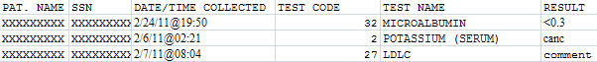

4.3.1.5.3 Lab Results DSS LOINC® Code Report

This report prints a listing showing the DSS LOINC® Codes file (#727.29) and its definitions of LAR Test Numbers and the local tests assigned to them. It also compares the LOINC Code assigned by DSO for a LAR Test to the LOINC Codes found on the local database. The latter is based on the linking of Workload Codes to LOINC Codes at the particular location. Differences are marked with an asterisk following the Local LOINC Code column and must be resolved. DSO can guide the location in this.

The report displays all workload codes associated with the DSS desired LOINC code. The report prints the values in those columns even if there is no matching workload code found in file #60. The intent of the modification is to identify inexact matches and to display all workload codes associated with a DSS desired LOINC code.

The report process attempts to find a matching LOINC code between the DSS LOINC file (#727.29) and the WKLD Code file (#64). If a match is not found, an ‘*’ (asterisk) displays in the FLG column to indicate there is no local workload setup for the desired DSS LOINC code. None of the ‘local’ fields (those fields coming from file #60 or #64) will be populated.

Select Laboratory Option: 3 Lab Results DSS LOINC Code Report

Do you want the output in exportable format? NO// y YES
NOTE: Appendix C contains instructions for exporting a report into an external spreadsheet.

Gathering data for export...

To ensure all data is captured during the export:

1. Select 'Logging...' from the File Menu. Select your file, and where to save.
2. On the Setup menu, select 'Display...',then 'screen' tab and modify 'columns'
setting to at least 225 characters.
3. The DEVICE input for the columns should also contain a large enough
parameter (e.g. 225). The DEVICE prompt is defaulted to 0;225;99999 for you.
You may change it if need be.
Example: DEVICE: 0;225;99999 *Where 0 is your screen, 225 is the margin width
and 99999 is the screen length.

NOTE: In order for all number fields, such as SSN and Feeder Key, to be
displayed correctly in the spreadsheet, these fields must be formatted as Text
when importing the data into the spreadsheet.

DEVICE: 0;225;99999//

Example: Exported Lab Results DSS LOINC Report

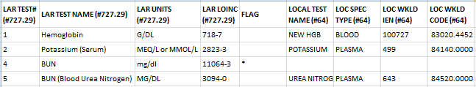

Example: Lab Results DSS LOINC Report Screen Print

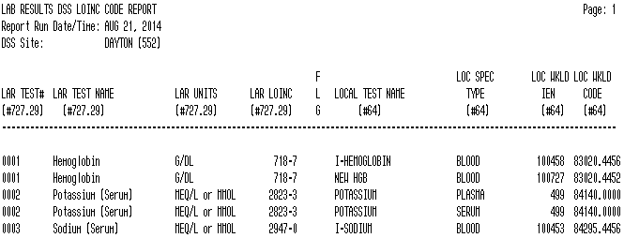

4.3.1.6 Pharmacy

Choosing the Pharmacy option from the Maintenance Menu will display the following sub-menu and options.

Example: Pharmacy Options Menu

Select Pharmacy Option: ?

1 Pharmacy Edit and Edit Log
2 Pharmacy Extracts Incomplete Feeder Key Report
3 Pharmacy Extracts Unusual Cost Report
4 Pharmacy Extracts Unusual Volume Report
5 UDP/IVP Source Audit Report

4.3.1.6.1 Pharmacy Edit and Edit Log

The option consists of Pharmacy Volume Edit and Pharmacy Volume Edit Log.
NOTE: The ECXPVE security key is required.

4.3.1.6.1.1 Pharmacy Volume Edit

This option allows authorized users to edit the Pharmacy Extracts (IVP, PRE and UDP). Corrections may be made to the:
- Quantity field for IVP, PRE, UDP
- Unit of Issue field for PRE
- Total Doses per Day field for IVP
NOTE: Extract must be rerun if changes need to be made after the extract is transmitted. Please contact the DSO CSHD.

Example: Pharmacy Volume Edit for PRE

1 Pharmacy Volume Edit
2 Pharmacy Volume Edit Log

Select Pharmacy Edit and Edit Log Option: 1 Pharmacy Volume Edit
Select one of the following:
P PRE
I IVP
U UDP

Which extract do you need to edit?: PRE

Select PRE EXTRACT NUMBER: ?

Select from one of the following extract numbers:
If no numbers appear then there are no extracts that can
be edited.

3741
3863
3882

Select PRE EXTRACT NUMBER: 3741
Enter patient's SSN, if known, or press ENTER to continue: ??

Enter patient's SSN, if known. The SSN will be used to find sequence numbers associated with this patient. Enter 9 digits or 9 digits and P, no hyphens or spaces. Entry is optional.
Select PRE EXTRACT SEQUENCE NUMBER:
This is a required response. Enter '^' to exit
Select PRE EXTRACT SEQUENCE NUMBER: ?
NOTE: If a patient’s SSN is entered and a question mark (?) is entered for the extract sequence number, only records including that patient’s SSN will appear in the results.

Select from one of the following sequence numbers:
SEQUENCE # SSN FILL DT QUANTITY UNIT OF ISSUE
----------------------------------------------------------------
3938879 XXXXXXXXX FEB 01, 2012 90 TAB
3938880 XXXXXXXXX FEB 01, 2012 90 TAB
3938881 XXXXXXXXX FEB 01, 2012 15 TAB
3938882 XXXXXXXXX FEB 01, 2012 30 TAB
3938883 XXXXXXXXX FEB 01, 2012 90 CAP
3938884 XXXXXXXXX FEB 01, 2012 30 TAB
3938885 XXXXXXXXX FEB 01, 2012 270 TAB
3938886 XXXXXXXXX FEB 01, 2012 90 TAB
3938887 XXXXXXXXX FEB 01, 2012 120 TAB
3938888 XXXXXXXXX FEB 01, 2012 30 ML
3938889 XXXXXXXXX FEB 01, 2012 227 GM
3938890 XXXXXXXXX FEB 01, 2012 120 ML
3938891 XXXXXXXXX FEB 01, 2012 80 GM
3938892 XXXXXXXXX FEB 01, 2012 270 TAB

Example: Pharmacy Volume Edit for IVP

Which extract do you need to edit?: IVP
Select IVP EXTRACT NUMBER: ??

Select from one of the following extract numbers:
If no numbers appear then there are no extracts that can
be edited.

2908
3570

Select IVP EXTRACT NUMBER: 3570
Enter patient's SSN, if known, or press ENTER to continue: ??

Enter patient's SSN, if known. The SSN will be used to find sequence numbers
associated with this patient. Enter 9 digits or 9 digits and P, no
hyphens or spaces. Entry is optional.

Enter patient's SSN, if known, or press ENTER to continue:
Select IVP EXTRACT SEQUENCE NUMBER: ?
NOTE: If a patient’s SSN is entered and a question mark (?) is entered for the extract sequence number, only records including that patient’s SSN will appear in the results.

Select from one of the following sequence numbers:
SEQUENCE # SSN DISPENSE DT QUANTITY TOTAL DOSES/DAY
----------------------------------------------------------------
202327 XXXXXXXXX JUN 01, 2010 1 100 ML
202328 XXXXXXXXX JUN 01, 2010 1 1 GM
202329 XXXXXXXXX JUN 01, 2010 1 1000 ML
202330 XXXXXXXXX JUN 01, 2010 1 100 ML
202331 XXXXXXXXX JUN 01, 2010 1 3.375 GM
202332 XXXXXXXXX JUN 01, 2010 1 250 ML
202333 XXXXXXXXX JUN 01, 2010 1 1000 MG
202334 XXXXXXXXX JUN 01, 2010 1 100 ML
202335 XXXXXXXXX JUN 01, 2010 1 3.375 GM
202336 XXXXXXXXX JUN 01, 2010 1 100 ML
202337 XXXXXXXXX JUN 01, 2010 1 40 MG
202338 XXXXXXXXX JUN 01, 2010 1 1000 ML
202339 XXXXXXXXX JUN 01, 2010 1 250 ML
202340 XXXXXXXXX JUN 01, 2010 1 1000 MG
202341 XXXXXXXXX JUN 01, 2010 1 500 MG

Example: Pharmacy Volume Edit for UDP

Which extract do you need to edit?: UDP
Select UDP EXTRACT NUMBER: ??

Select from one of the following extract numbers:
If no numbers appear then there are no extracts that can
be edited.

2024
2921
3581

Select UDP EXTRACT NUMBER: 3581
Enter patient's SSN, if known, or press ENTER to continue: ??

Enter patient's SSN, if known. The SSN will be used to find sequence numbers
associated with this patient. Enter 9 digits or 9 digits and P, no
hyphens or spaces. Entry is optional.

Enter patient's SSN, if known, or press ENTER to continue:
Select UDP EXTRACT SEQUENCE NUMBER: ?
NOTE: If a patient’s SSN is entered and a question mark (?) is entered for the extract sequence number, only records including that patient’s SSN will appear in the results.

Select from one of the following sequence numbers:
SEQUENCE # SSN DISPENSE DT QUANTITY
------------------------------------------------
1364046 XXXXXXXXX JUN 01, 2010 1
1364047 XXXXXXXXX JUN 01, 2010 1
1364048 XXXXXXXXX JUN 01, 2010 1
1364049 XXXXXXXXX JUN 01, 2010 1
1364050 XXXXXXXXX JUN 01, 2010 1
1364051 XXXXXXXXX JUN 01, 2010 1
1364052 XXXXXXXXX JUN 01, 2010 4
1364053 XXXXXXXXX JUN 01, 2010 2
1364054 XXXXXXXXX JUN 01, 2010 1
1364055 XXXXXXXXX JUN 01, 2010 1
1364056 XXXXXXXXX JUN 01, 2010 2
1364057 XXXXXXXXX JUN 01, 2010 4
1364058 XXXXXXXXX JUN 01, 2010 4

4.3.1.6.1.2 Pharmacy Volume Edit Log

The Pharmacy Volume Edit Log requires a 132-column output. (The sample report was modified to fit into the space below)

Example: Pharmacy Volume Edit Log for IVP

PHARMACY VOLUME EDIT LOG FOR IVP Page 1
Printed on Oct 24, 2006@13:15:13 for 10/20/06 to 10/24/06
USER NAME DATE/TIME CHANGED SEQUENCE # EXTRACT # FIELD NAME OLD VALUE NEW VALUE
--------------------------------------------------------------------------------------
DSS,USER1 OCT 24,2006 13:11 120583 2609 QUANTITY 1 2
DSS,USER2 OCT 24,2006 13:11 120584 2609 QUANTITY 1 5
DSS,USER3 OCT 24,2006 13:11 120585 2609 QUANTITY 1 5
DSS,USER4 OCT 24,2006 13:11 120586 2609 QUANTITY 1 5
DSS,USER5 OCT 24,2006 13:11 120587 2609 QUANTITY 1 5

4.3.1.6.2 Pharmacy Extracts Incomplete Feeder Key Report

This report prints listing of Drug file entries that have incomplete Feeder Key based on one of the following conditions:
- No PSNDF VA Product Name Entry (first 5 digits are zero)
- No National Drug Code (NDC) (last 12 digits are zero)
- No PSNDF VA Product Name Entry or NDC (all 17 digits are zero)

This report is designed to be run before the extract for a specified date range and can be used as a tool to identify and fix DRUG file (#50) entries that have incomplete Feeder Keys. Only those drugs that would be included on the Extract for the specified date range are listed on the report for the Pharmacy Extract selected (PRE, IVP or UDP). The following columns are included on the report:

- Drug Entry - INTERNAL ENTRY NUMBER (IEN) for the drug from the DRUG file (#50).
- Generic Name - The GENERIC NAME field (#.01) of the drug from the DRUG file (#50).
- Feeder Key - The Feeder Key for the drug, which is the first 5 characters of the PSNDF VA PRODUCT NAME ENTRY field (#22) concatenated with the 12 characters NDC field (#31) from the DRUG file (#50).
- Number of Records - The number of Extract records that would contain this drug for the date range specified if the extract were run.
- Total Quantity - The sum of the quantities of the drug from all of the Extract records. This is the same as the QUANTITY field for the PRE and UDP Extracts. For the IVP Extract the Total Quantity is the sum of the values taken from the ADDITIVE STRENGTH field (#7) or SOLUTION VOLUME field (#9) of the IV EXTRACT DATA file (#728.113).
- Unit Price - The PRICE PER DISPENSE UNIT field (#16) from the DRUG file (#50) for the PRE and UDP Extracts. For the IVP Extract Unit Price is the COST field (#12) of the IV EXTRACT DATA file (#728.13).
- Total Cost - The total cost of the drug for the Extract (Total Quantity x Unit Price). For all three Pharmacy Extracts, the Total Cost is the same as the sum of the COST filed from all Extract records containing the drug.

This report requires a 132-column output.

Select Maintenance Option: Pharmacy Extracts Incomplete Feeder Key Report

This report prints a listing of Drug File (#50) entries that will generate
incomplete Feeder keys in the three Pharmacy Extracts. This listing
can be used to identify and fix Drug File entries. The number of extract
records, total, quantity, unit price and total cost for each drug are
included to aid in determining the impact of the incomplete Feeder Keys.

This report is broken into 3 sections as follows:

Section 1: No PSNDF VA Product Name Entry (first 5 digits are zero).

Section 2: No National Drug Code (NDC) (last 12 digits are zero) or the NDC
is prefixed with an 'S', indicating possible supply item number
or UPC.

Section 3: No PSNDF VA Product Name Entry, and
a. no NDC (all 17 digits are zero), or
b. The NDC is prefixed with an 'S', indicating possible supply
item number or UPC.
Section 3: No PSNDF VA Product Name Entry or NDC.

Run times for this report will vary depending upon the size of the extract and
could take as long as 30 minutes or more to complete. This report has no effect
on the actual extracts and can be run as needed.

4.3.1.6.2.1 PRE Extracts Incomplete Feeder Key Report

Choose the report you would like to run.

Select one of the following:

1 PRE
2 IVP
3 UDP

Selection: 1// 1 PRE

Enter the date range for which you would like to scan the Prescription
Extract records.
Starting with Date: 2/1 (FEB 01, 2013)
Ending with Date: 2/28 (FEB 28, 2013)

Do you want the output in exportable format? NO// y YES
NOTE: Appendix C contains instructions for exporting a report into an external spreadsheet.

Gathering data for export...

To ensure all data is captured during the export:

1. Select 'Logging...' from the File Menu. Select your file, and where to save.
2. On the Setup menu, select 'Display...',then 'screen' tab and modify 'columns'
setting to at least 225 characters.
3. The DEVICE input for the columns should also contain a large enough
parameter (e.g. 225). The DEVICE prompt is defaulted to 0;225;9999 for you.
You may change it if need be.
Example: DEVICE: 0;225;99999 *Where 0 is your screen, 225 is the margin width
and 99999 is the screen length.

NOTE: In order for all number fields, such as SSN and Feeder Key, to be
displayed correctly in the spreadsheet, these fields must be formatted as Text
when importing the data into the spreadsheet.

DEVICE: 0;225;99999//

Example: Exported PRE Extracts Incomplete Feeder Key Report

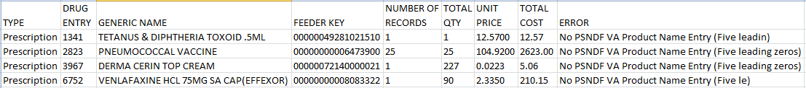

Example: PRE Extracts Incomplete Feeder Key Report Screen Print

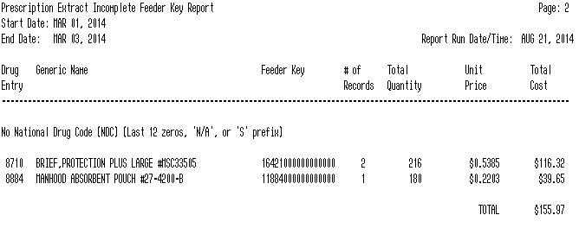

4.3.1.6.2.2 IVP Extracts Incomplete Feeder Key Report

Choose the report you would like to run.

Select one of the following:

1 PRE
2 IVP
3 UDP

Selection: 1// 2 IVP

Enter the date range for which you would like to scan the IV Detail
Extract records.

Starting with Date: 2/1 (FEB 01, 2013)
Ending with Date: 2/28 (FEB 28, 2013)

Do you want the output in exportable format? NO// y YES

NOTE: Appendix C contains instructions for exporting a report into an external spreadsheet.

Gathering data for export...

To ensure all data is captured during the export:

1. Select 'Logging...' from the File Menu. Select your file, and where to save.
2. On the Setup menu, select 'Display...',then 'screen' tab and modify 'columns'
setting to at least 225 characters.
3. The DEVICE input for the columns should also contain a large enough
parameter (e.g. 225). The DEVICE prompt is defaulted to 0;225;9999 for you.
You may change it if need be.
Example: DEVICE: 0;225;99999 *Where 0 is your screen, 225 is the margin width
and 99999 is the screen length.

NOTE: In order for all number fields, such as SSN and Feeder Key, to be
displayed correctly in the spreadsheet, these fields must be formatted as Text
when importing the data into the spreadsheet.

DEVICE: 0;225;99999//

Example: IVP Extracts Incomplete Feeder Key Report Screen Print

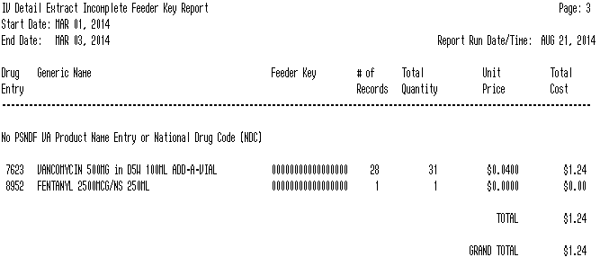

Example: Exported IVP Extracts Incomplete Feeder Key Report

4.3.1.6.2.3 UDP Extracts Incomplete Feeder Key Report

Choose the report you would like to run.

Select one of the following:

1 PRE
2 IVP
3 UDP

Selection: 1// 3 UDP

Enter the date range for which you would like to scan the Unit Dose Local
Extract records.

Starting with Date: 2/1 (FEB 01, 2013)
Ending with Date: 2/28 (FEB 28, 2013)

Do you want the output in exportable format? NO// y YES

NOTE: Appendix C contains instructions for exporting a report into an external spreadsheet.

Gathering data for export...

To ensure all data is captured during the export:

1. Select 'Logging...' from the File Menu. Select your file, and where to save.
2. On the Setup menu, select 'Display...',then 'screen' tab and modify 'columns'
setting to at least 225 characters.
3. The DEVICE input for the columns should also contain a large enough
parameter (e.g. 225). The DEVICE prompt is defaulted to 0;225;9999 for you.
You may change it if need be.
Example: DEVICE: 0;225;99999 *Where 0 is your screen, 225 is the margin width
and 99999 is the screen length.

NOTE: In order for all number fields, such as SSN and Feeder Key, to be
displayed correctly in the spreadsheet, these fields must be formatted as Text
when importing the data into the spreadsheet.

DEVICE: 0;225;99999//
Example: Exported UDP Extracts Incomplete Feeder Key Report

Example: UDP Extracts Incomplete Feeder Key Report Screen Print
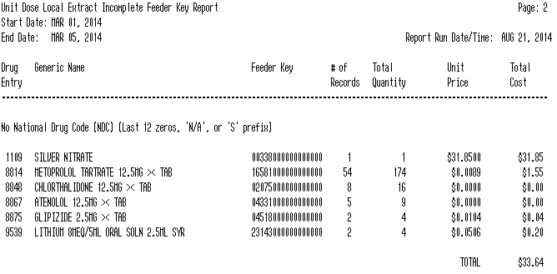

4.3.1.6.3 Pharmacy Extracts Unusual Cost Report

Users with the ECXMGR security key can export the data for all reports on the Pharmacy Extracts Unusual Cost Report option into an external spreadsheet. Users also have the option to view the report on the screen.

This report prints a listing of unusual costs that would be
generated by the pharmacy extracts (PRE, IVP, UDP and BCM) as
determined by a user defined threshold value. It should be run
prior to the generation of the actual extract(s) to identify and
fix as necessary any costs determined to be erroneous.

Note: The threshold can be set after a report is selected.

Run times for this report will vary depending upon the size of
the extract and could take as long as 30 minutes or more to
complete. This report has no effect on the actual extracts and
can be run as needed.

The report is sorted by Feeder Key, Descending Cost, and SSN.

Enter RETURN to continue or '^' to exit:

Example: Pharmacy Extracts Unusual Cost Report

Choose the report you would like to run.

Select one of the following:

1 PRE
2 IVP
3 UDP
4 BCM

Selection: 1//

4.3.1.6.3.1 PRE Unusual Cost Report

The default threshold cost for the Prescription extract is $50.
Would you like to change the threshold? NO// n NO

Enter the date range for which you would like to scan the Prescription
Extract records.
Starting with Date: 2/1/12 (FEB 01, 2012)
Ending with Date: 2/28/12 (FEB 28, 2012)

Do you want the output in exportable format? NO// YES
NOTE: Appendix C contains instructions for exporting a report into an external spreadsheet.

Gathering data for export...

To ensure all data is captured during the export:

1. Select 'Logging...' from the File Menu. Select your file, and where to save.
2. On the Setup menu, select 'Display...',then 'screen' tab and modify 'columns'
setting to at least 225 characters.
3. The DEVICE input for the columns should also contain a large enough
parameter (e.g. 225). The DEVICE prompt is defaulted to 0;225;9999 for you.
You may change it if need be.

Example: DEVICE: 0;225;99999 *Where 0 is your screen, 225 is the margin width
and 99999 is the screen length.

NOTE: In order for all number fields, such as SSN and Feeder Key, to be
displayed correctly in the spreadsheet, these fields must be formatted as Text
when importing the data into the spreadsheet.

DEVICE: 0;225;99999//

Example: Exported PRE Unusual Cost Report

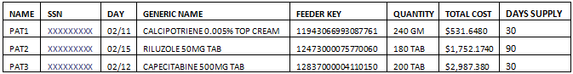

Example: PRE Unusual Cost Report Displayed on Screen

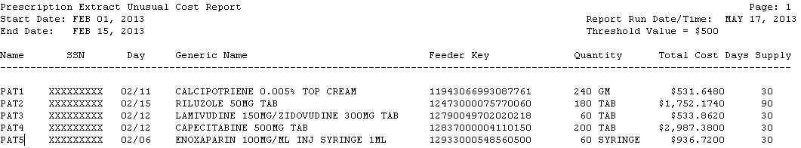

4.3.1.6.3.2 IVP Unusual Cost Report

The default threshold cost for the IV Detail extract is $100.
Would you like to change the threshold? NO// n NO

Enter the date range for which you would like to scan the IV Detail
Extract records.
Starting with Date: 2/1/13 (FEB 01, 2013)
Ending with Date: 2/28/13 (FEB 28, 2013)

Do you want the output in exportable format? NO// y YES
NOTE: Appendix C contains instructions for exporting a report into an external spreadsheet.

Gathering data for export...

To ensure all data is captured during the export:

1. Select 'Logging...' from the File Menu. Select your file, and where to save.
2. On the Setup menu, select 'Display...',then 'screen' tab and modify 'columns'
setting to at least 225 characters.
3. The DEVICE input for the columns should also contain a large enough
parameter (e.g. 225). The DEVICE prompt is defaulted to 0;225;9999 for you.
You may change it if need be.
Example: DEVICE: 0;225;99999 *Where 0 is your screen, 225 is the margin width
and 99999 is the screen length.

NOTE: In order for all number fields, such as SSN and Feeder Key, to be
displayed correctly in the spreadsheet, these fields must be formatted as Text
when importing the data into the spreadsheet.

DEVICE: 0;225;99999//

Example: Exported IVP Unusual Cost Report

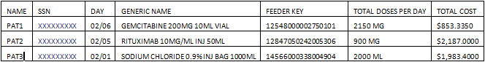

Example: IVP Unusual Cost Report Displayed on Screen

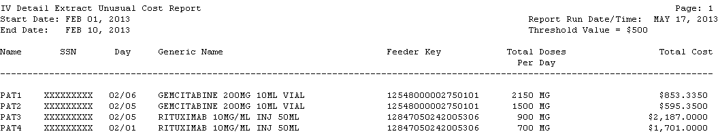

4.3.1.6.3.3 UDP Unusual Cost Report

The default threshold cost for the Unit Dose Local extract is $20.
Would you like to change the threshold? NO// n NO
Include SIG/Order Direction on line 2 of report? NO// n NO

Enter the date range for which you would like to scan the Unit Dose Local
Extract records.
Starting with Date: 5/1/13 (MAY 01, 2013)
Ending with Date: 5/31/13 (MAY 31, 2013)

Do you want the output in exportable format? NO// y YES
NOTE: Appendix C contains instructions for exporting a report into an external spreadsheet.

Gathering data for export...

To ensure all data is captured during the export:

1. Select 'Logging...' from the File Menu. Select your file, and where to save.
2. On the Setup menu, select 'Display...',then 'screen' tab and modify 'columns'
setting to at least 225 characters.
3. The DEVICE input for the columns should also contain a large enough
parameter (e.g. 225). The DEVICE prompt is defaulted to 0;225;9999 for you.
You may change it if need be.
Example: DEVICE: 0;225;99999 *Where 0 is your screen, 225 is the margin width
and 99999 is the screen length.

NOTE: In order for all number fields, such as SSN and Feeder Key, to be
displayed correctly in the spreadsheet, these fields must be formatted as Text
when importing the data into the spreadsheet.

DEVICE: 0;225;99999//

Example: Exported UDP Unusual Cost Report

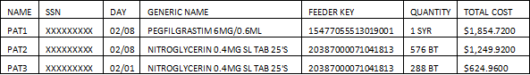

Example: UDP Unusual Cost Report Displayed on Screen

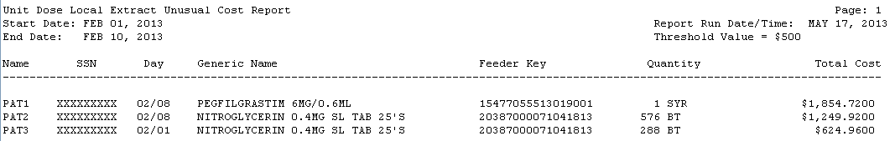

4.3.1.6.3.4 BCM Unusual Cost Report

Select one of the following:

I IV
N NON-IV

Select type of BCM record: n NON-IV

The default threshold cost for the BCM-NON IV Entries extract is $20.
Would you like to change the threshold? NO//
Include SIG/Order Direction on line 2 of report? NO// y YES
NOTE: Users can choose to add the SIG/Order Directions on the second line of this report.

Enter the date range for which you would like to scan the BCM-NON IV Entries
Extract records.
Starting with Date: 2/1 (FEB 01, 2013)
Ending with Date: 2/28 (FEB 28, 2013)

Do you want the output in exportable format? NO// y YES

NOTE: Appendix C contains instructions for exporting a report into an external spreadsheet.

Gathering data for export...

To ensure all data is captured during the export:

1. Select 'Logging...' from the File Menu. Select your file, and where to save.
2. On the Setup menu, select 'Display...',then 'screen' tab and modify 'columns'
setting to at least 225 characters.
3. The DEVICE input for the columns should also contain a large enough
parameter (e.g. 225). The DEVICE prompt is defaulted to 0;225;9999 for you.
You may change it if need be.
Example: DEVICE: 0;225;99999 *Where 0 is your screen, 225 is the margin width
and 99999 is the screen length.

NOTE: In order for all number fields, such as SSN and Feeder Key, to be
displayed correctly in the spreadsheet, these fields must be formatted as Text
when importing the data into the spreadsheet.

DEVICE: 0;225;99999//
Example: Exported BCM Unusual Cost Report (Non- IV)

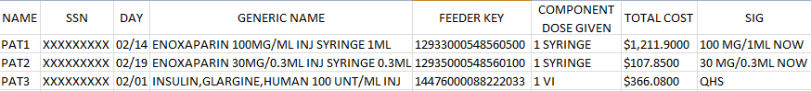

Example: BCM Unusual Cost Report Displayed on Screen (IV)

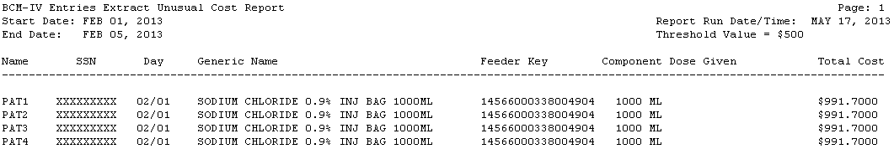

4.3.1.6.4 Pharmacy Extracts Unusual Volume Report

This report prints a listing of unusual volumes that would be generated by the pharmacy extracts (PRE, IVP, UDP and BCM) as determined by a user defined threshold value. It should be run prior to the generation of the actual extract(s) to identify and fix as necessary any volumes determined to be erroneous.

Unusual volumes are defined as follows:

PRE Extract: Quantity field greater than the threshold value.
IVP Extract: Total Doses Per Day field greater than the threshold
or less than the negative of the threshold value.
UDP Extract: Quantity field greater than threshold value.
BCM Extract: Component Dose Given field greater than threshold value.

Note: The threshold can be set after a report is selected.

Run times for this report will vary depending upon the size of the extract and could take as long as 30 minutes or more to complete. This report has no effect on the actual extracts and can be run as needed.

The report is sorted by Feeder Key, Descending Volume, and SSN.

Enter RETURN to continue or '^' to exit: <RET>

4.3.1.6.4.1 PRE Unusual Volume Report

Choose the report you would like to run.

Select one of the following:

1 PRE
2 IVP
3 UDP
4 BCM

Selection: 1// 1 PRE

The default threshold volume for the Prescription extract is 500.
Would you like to change the threshold?? NO//

Enter the date range for which you would like to scan the Prescription
Extract records.
Starting with Date: 02012013 (FEB 01, 2013)
Ending with Date: 02282013 (FEB 28, 2013)

Do you want the output in exportable format? NO// Y
NOTE: Appendix C contains instructions for exporting a report into an external spreadsheet.

Gathering data for export...

To ensure all data is captured during the export:

1. Select 'Logging...' from the File Menu. Select your file, and where to save.
2. On the Setup menu, select 'Display...',then 'screen' tab and modify 'columns'
setting to at least 225 characters.
3. The DEVICE input for the columns should also contain a large enough
parameter (e.g. 225). The DEVICE prompt is defaulted to 0;225;9999 for you.
You may change it if need be.
Example: DEVICE: 0;225;99999 *Where 0 is your screen, 225 is the margin width
and 99999 is the screen length.

NOTE: In order for all number fields, such as SSN and Feeder Key, to be
displayed correctly in the spreadsheet, these fields must be formatted as Text
when importing the data into the spreadsheet.

DEVICE: 0;225;99999//

Example: Export Prescription Extract Unusual Volume Report

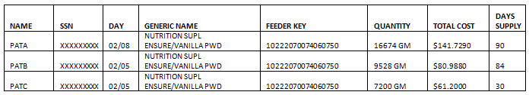

Example: Prescription Extract Unusual Volume Report Displayed on Screen

Prescription Extract Unusual Volume Report
Page: 1
Start Date: JAN 01, 2002
Report Run Date/Time: JAN 02, 2003
End Date: JAN 31, 2002
Threshold Value = 500

Name SSN Day Generic Name Feeder Key Quantity Total Cost Days Supply
------------------------------------------------------------------------------

DSS1 XXXXXXXXX 03/06 NUTRITION SUPL ENSURE/VANILLA PWD 10222070074607504 7560 $37.80 30

DSS2 XXXXXXXXX 03/10 NUTRITION SUPL ENSURE/VANILLA PWD 10222070074607504 7140 $35.70 30

DSS3 XXXXXXXXX 03/06 NUTRITION SUPL ENSURE/VANILLA PWD 10222070074607504 5460 $27.30 90

4.3.1.6.4.2 IVP Unusual Volume Report

Choose the report you would like to run.

Select one of the following:

1 PRE
2 IVP
3 UDP
4 BCM

Selection: 1// 2 IVP

The default threshold volume for the IV Detail extract is 1000.
Would you like to change the threshold? NO// n NO

Enter the date range for which you would like to scan the IV Detail
Extract records.
Starting with Date: 02012013 (FEB 01, 2013)
Ending with Date: 02282013 (FEB 28, 2013)

Do you want the output in exportable format? NO// Y
NOTE: Appendix C contains instructions for exporting a report into an external spreadsheet.

Gathering data for export...

To ensure all data is captured during the export:

1. Select 'Logging...' from the File Menu. Select your file, and where to save.
2. On the Setup menu, select 'Display...',then 'screen' tab and modify 'columns'
setting to at least 225 characters.
3. The DEVICE input for the columns should also contain a large enough
parameter (e.g. 225). The DEVICE prompt is defaulted to 0;225;9999 for you.
You may change it if need be.
Example: DEVICE: 0;225;99999 *Where 0 is your screen, 225 is the margin width
and 99999 is the screen length.

NOTE: In order for all number fields, such as SSN and Feeder Key, to be
displayed correctly in the spreadsheet, these fields must be formatted as Text
when importing the data into the spreadsheet.

DEVICE: 0;225;99999//

Example: Exported IV Detail Extract Unusual Volume Report

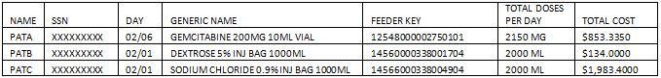

NOTE: The Total Cost Per Day column displays 4 decimal places and is calculated by multiplying the Average Drug Cost per Unit times Total Doses per Day.

Example: IV Detail Extract Unusual Volume Report

IV Detail Extract Unusual Volume Report Page: 1
Start Date: FEB 01, 2012 Report Run Date/Time: MAY 29, 2012
End Date: FEB 29, 2012 Threshold Value = 20
Total Total
Name SSN Day Generic Name Feeder Key Doses Cost Per Day
--------------------------------------------------------------------------------------
DSS1 666551982 02/21 VINORELBINE 10MG/ML 12374000703418301 50 MG $6.0364
DSS2 000986514 02/28 VINORELBINE 10MG/ML 12374000703418301 50 MG $6.0364
DSS3 000762783 02/01 VINORELBINE 10MG/ML 12374000703418301 25 MG $6.0364
DSS4 666229182 02/08 VINORELBINE 10MG/ML 12374000703418301 25 MG $6.0364

4.3.1.6.4.3 UDP Unusual Volume Report
NOTE: Users can choose to add the SIG/Order Directions on the second line of this report. SIG/Order Direction information is produced by combining Prescription Unit Dose and Schedule information. This field will assist pharmacists that are responsible for audits to distinguish dispensing errors.

Choose the report you would like to run.

Select one of the following:

1 PRE
2 IVP
3 UDP

Selection: 1// 3 UDP

The default threshold volume for the Unit Dose Local extract is 500.
Would you like to change the threshold? NO// Y YES

Quantity > threshold
Enter the new threshold volume: (0-100000): 20
Include SIG/Order Direction on line 2 of report? NO// YES

Enter the date range for which you would like to scan the Unit Dose Local
Extract records.
Starting with Date: February 1, 2012 (FEB 01, 2012)
Ending with Date: February 29, 2012 (FEB 29, 2012)

Do you want the output in exportable format? NO// Y
NOTE: Appendix C contains instructions for exporting a report into an external spreadsheet.

Gathering data for export...

To ensure all data is captured during the export:

1. Select 'Logging...' from the File Menu. Select your file, and where to save.
2. On the Setup menu, select 'Display...',then 'screen' tab and modify 'columns'
setting to at least 225 characters.
3. The DEVICE input for the columns should also contain a large enough
parameter (e.g. 225). The DEVICE prompt is defaulted to 0;225;9999 for you.
You may change it if need be.
Example: DEVICE: 0;225;99999 *Where 0 is your screen, 225 is the margin width
and 99999 is the screen length.

NOTE: In order for all number fields, such as SSN and Feeder Key, to be
displayed correctly in the spreadsheet, these fields must be formatted as Text
when importing the data into the spreadsheet.

DEVICE: 0;225;99999//

Example: Exported UDP Detail Extract Unusual Volume Report with SIG/Order Directions Added

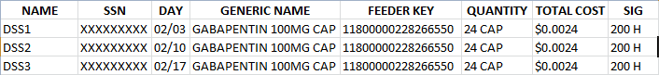

Example: UDP Detail Extract Unusual Volume Report with SIG/Order Directions Added Displayed on Screen

Unit Dose Local Extract Unusual Volume Report Page: 1
Start Date: FEB 01, 2012 Report Run Date/Time: MAY 24, 2012
End Date: FEB 29, 2012 Threshold Value = 20

Name SSN Day Generic Name Feeder Key Quantity Total Cost
--------------------------------------------------------------------------------------
DSS1 000118721 02/03 GABAPENTIN 300MG CAP 11801000228266650 36 CAP $2.6712
SIG: 900 MG QID/FOOD

DSS2 000779855 02/01 GABAPENTIN 300MG CAP 11801000228266650 24 CAP $1.7808
SIG: 900 MG QID/FOOD

DSS3 000912671 02/06 GABAPENTIN 300MG CAP 11801000228266650 24 CAP $1.9224
SIG: 900 MG QID/FOOD

DSS4 000528727 02/24 TRAMADOL 50MG TAB 12380016714011106 24 TAB $0.4224
SIG: 100 MG QID

Example: Exported UDP Detail Extract Unusual Volume Report without SIG/Order Directions Added

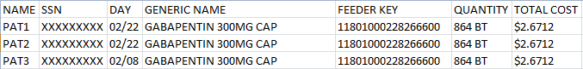

Example: UDP Detail Extract Unusual Volume Report without SIG/Order Directions Added Displayed on Screen

Unit Dose Local Extract Unusual Volume Report Page: 1
Start Date: FEB 01, 2012 Report Run Date/Time: MAY 24, 2012
End Date: FEB 29, 2012 Threshold Value = 20

Name SSN Day Generic Name Feeder Key Quantity Total Cost
--------------------------------------------------------------------------------------
DSS1 000118721 02/03 GABAPENTIN 300MG CAP 11801000228266650 36 CAP $2.6712
DSS2 000779855 02/01 GABAPENTIN 300MG CAP 11801000228266650 24 CAP $1.7808
DSS3 000912671 02/06 GABAPENTIN 300MG CAP 11801000228266650 24 CAP $1.9224
DSS4 000528727 02/24 TRAMADOL 50MG TAB 12380016714011106 24 TAB $0.4224

4.3.1.6.4.4 BCM Unusual Volume Report

Choose the report you would like to run.

Select one of the following:

1 PRE
2 IVP
3 UDP
4 BCM

Selection: 1// 4 BCM

Select one of the following:

I IV
N NON-IV

Select type of BCM record: N

The default threshold volume for the BCM-NON IV Entries extract is 5.
Would you like to change the threshold? NO// n NO
Include SIG/Order Direction on line 2 of report? NO// y YES

Enter the date range for which you would like to scan the BCM-NON IV Entries
Extract records.
Starting with Date: 02012013 (FEB 01, 2013)
Ending with Date: 02282013 (FEB 28, 2013)

Do you want the output in exportable format? NO// N
NOTE: Appendix C contains instructions for exporting a report into an external spreadsheet.

Example: Exported BCM Detail Extract Unusual Volume Report with SIG/Order Directions Added (Non-IV)

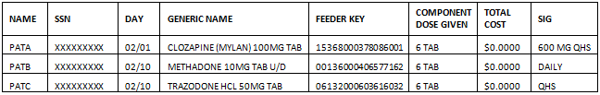

Example: BCM Detail Extract Unusual Volume Report with SIG/Order Directions Added Displayed on Screen (Non-IV)

BCM-NON IV Entries Extract Unusual Volume Report
Page: 1
Start Date: FEB 01, 2013
Report Run Date/Time: JUL 11, 2013
End Date: FEB 28, 2013
Threshold Value = 5

Name SSN Day Generic Name Feeder Key Component Dose Given Total Cost
-----------------------------------------------------------------------------------------------------

PAT1 XXXXXXXXX 02/01 CLOZAPINE (MYLAN) 100MG TAB 15368000378086005 7 TAB $2.9281

SIG: 700 MG DAILY AT-1800

Example: Exported BCM Detail Extract Unusual Volume Report without SIG/Order Directions Added (IV)

Example: BCM Detail Extract Unusual Volume Report without SIG/Order Directions Added Displayed on Screen (IV)

BCM-NON IV Entries Extract Unusual Volume Report
Page: 1
Start Date: FEB 01, 2013
Report Run Date/Time: AUG 23, 2013
End Date: FEB 28, 2013
Threshold Value = 1000
Threshold Value = 1000

Name SSN Day Generic Name Feeder Key Component Dose Given Total Cost
--------------------------------------------------------------------------------

PAT1 XXXXXXXXX 02/28 SODIUM CHLORIDE 0.9% INJ BAG 1000ML 14566000338004904 2000 $1,983.4000

4.3.1.6.5 UDP/IVP Source Audit Report

The Source Audit Reports provide a record count for each Division and Date combination chosen. The reports pull information from the UDP and IVP Intermediate source files within the DSS name space: UNIT DOSE EXTRACT DATA file (#728.904) and the IV EXTRACT DATA file (#728.113).

Example: UDP Source Audit Report

Select Maintenance Option: 22 UDP/IVP Source Audit Report
Select one of the following:
1 UDP
2 IVP

Select Source Audit Report: 1 UDP
Select division: ALL//
Enter Report Start Date: Oct 24, 2006// 04012006 (APR 01, 2006)
Enter Report End Date: Oct 24, 2006// 04302006 (APR 30, 2006)
Do you want the output in exportable format? NO//<RET>
DEVICE: HOME// ;132

UDP Source Audit Report
PAGE: 1
Run Date: Oct 24, 2006
Start Date: Apr 01, 2006
End Date: Apr 30, 2006
Division Date Record Count
==============================================================================
442 Apr 01, 2006 6
442 Apr 02, 2006 11
442 Apr 03, 2006 387
442 Apr 04, 2006 388
UNKNOWN Apr 04, 2006 1
442 Apr 05, 2006 418
442 Apr 06, 2006 423
442 Apr 07, 2006 434
442 Apr 08, 2006 247
UNKNOWN Apr 08, 2006 14

Example: Exported UDP Source Audit Report

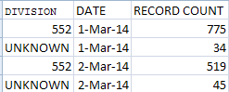

Example: IVP Source Audit Report

Select Maintenance Option: 22 UDP/IVP Source Audit Report
Select one of the following:
1 UDP
2 IVP

Select Source Audit Report: 2 IVP
Select division: ALL//
Enter Report Start Date: Oct 24, 2006// 03012006 (MAR 01, 2006)
Enter Report End Date: Oct 24, 2006// 03302006 (MAR 30, 2006)
Do you want the output in exportable format? NO//<RET>
DEVICE: HOME// ;132
IVP Source Audit Report PAGE: 1
Run Date: Oct 24, 2006
Start Date: Mar 01, 2006
End Date: Mar 30, 2006

Division Date Record Count
==============================================================================
442 Mar 01, 2006 47
UNKNOWN Mar 01, 2006 17
442 Mar 02, 2006 32
442 Mar 03, 2006 21
442 Mar 04, 2006 17
442 Mar 05, 2006 29
442 Mar 06, 2006 40
442 Mar 07, 2006 63
UNKNOWN Mar 07, 2006 1
442 Mar 08, 2006 48
UNKNOWN Mar 08, 2006 3

Example: Exported IVP Source Audit Report

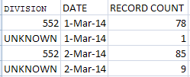

Print Feeder Keys

Refer to Appendix A for information about feeder key transmission.

Use this option to print a list of feeder keys for a selected individual feeder system or a range of feeder systems. For some feeder systems, you will be prompted to select the sort method (old or new). All feeder systems prompt for a device. The output will vary slightly, depending on the version of National Drug File (NDF) your site is running.

Example: Print Feeder Keys

Select Maintenance Option: Print Feeder Keys

Do you want the output in exportable format? NO//<RET>

Print list of Feeder Keys:

Select : 1. CLI
2. ECS
3. LAB
4. PHA
5. RAD
6. SUR
7. PRO

Enter a list or range of numbers (1-7): 7

Feeder Key List For Feeder System PRO Page: 1

Feeder Key Description
-----------------------------------------------------------------------------

A4230NC INFUS INSULIN PUMP NON NEEDL/New/COM
A4265NC PARAFFIN/New/COM
A4301NC IMPLANTABLE ACCESS SYST PERC/New/COM
A4364NC ADHESIVE, LIQUID OR EQUAL/New/COM
A4465NC NON-ELASTIC EXTREMITY BINDER/New/COM
A4466NC ELASTIC GARMENT/COVERING/New/COM
A4500NC BELOW KNEE SURGICAL STOCKING/New/COM
A4556NC ELECTRODES, PAIR/New/COM
A4557NC LEAD WIRES, PAIR/New/COM
A4565NC SLINGS/New/COM
A4565NV SLINGS/New/VA

Example: Exported Print Feeder Keys - PRO

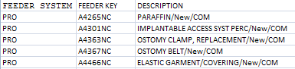

Print Feeder Locations
Use this option to print a list of feeder locations for all feeder systems. The output is sorted by feeder location within each feeder system. This report could be lengthy, so you might want to queue to print during non-peak hours. The only prompt is for a device.

Example: Print List of Feeder Locations

Select Maintenance Option: print
1 Print Feeder Keys
2 Print Feeder Locations

CHOOSE 1-2: 2 Print Feeder Locations

Print list of feeder locations.

Do you want the output in exportable format? NO//<RET>

DEVICE: HOME//

Feeder Location List For Feeder System PRO Page: 7

FEEDER LOCATION DESCRIPTION
--------------------------------------------------------------------------------
552HO2 DAYTON Home Oxygen
552LAB DAYTON Prosthetics Lab
552NONL DAYTON Non Lab Location
552ORD DAYTON Ordering Location

Example: Exported Print List of Feeder Locations

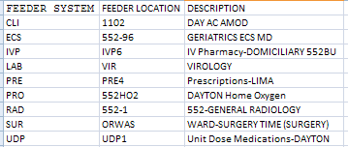

(To save space, only a portion of the above reports and exports are shown)

Prosthetics
Choosing the Prosthetics option from the Maintenance Menu will display the following sub-menu and options.

Example: Prosthetics Menu Options

Select Prosthetics Option: ?

1 Cost by PSAS HCPC Report
2 Prosthetic Extracts Unusual Cost Report
3 Prosthetics (PRO) YTD HCPCS Report
4 Prosthetics (PRO) YTD Laboratory Report

4.3.1.9.1 Cost by PSAS HCPC Report

This menu option creates a report named Cost by PSAS HCPC REPORT. The Cost by PSAS HCPC is a prosthetics report that includes expenditures for a given time frame.

Option Name File New/Modified
Cost by PSAS HCPC Report 660 New

The Cost by PSAS HCPC Report consists of the following fields:
- PSAS HCPC - DSS Field (#30)/VistA Field (#32) on PRO extract
- Description (Free text field of 64 characters)
- HCPC
- QTY
- Unit of issue
- Cost
- Grand Total

Select Prosthetics Option: Cost by PSAS HCPC Report
Enter Report Start Date: 2/1/13 (FEB 01, 2013)
Enter Report Ending Date: (2/1/2013 - 8/26/2013): 2/28/13 (FEB 28, 2013)

Do you want the output in exportable format? NO// y YES
NOTE: Appendix C contains instructions for exporting a report into an external spreadsheet.

Gathering data for export...

To ensure all data is captured during the export:

1. Select 'Logging...' from the File Menu. Select your file, and where to save.
2. On the Setup menu, select 'Display...',then 'screen' tab and modify 'columns'
setting to at least 225 characters.
3. The DEVICE input for the columns should also contain a large enough
parameter (e.g. 225). The DEVICE prompt is defaulted to 0;225;99999 for you.
You may change it if need be.
Example: DEVICE: 0;225;99999 *Where 0 is your screen, 225 is the margin width
and 99999 is the screen length.

NOTE: In order for all number fields, such as SSN and Feeder Key, to be
displayed correctly in the spreadsheet, these fields must be formatted as Text
when importing the data into the spreadsheet.

DEVICE: 0;225;99999// HOME (CRT)

Example: Exported Cost by PSAS HCPC Report

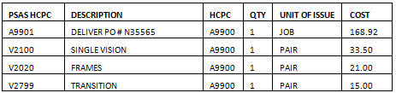

Example: Cost by PSAS HCPC Report Screen Print

Report for Jan 01, 2004 thru Jan 15, 2004
PSAS HCPC DESCRIPTION HCPC QTY Unit of Issue Cost
-----------------------------------------------------------------------------------
C1875 STENT L8699 1 EACH $ 2696.00
C1875 STENT L8699 1 EACH $ 2696.00
C1875 STENT L8699 1 EACH $ 2696.00
C2621 PACEMAKER L8699 1 EACH $ 5075.00
C2621 PACEMAKER L8699 1 EACH $ 4575.00
L3060 FOOT ARCH SUPP LONGITUD/META L3060 1 $ 22.00
L3060 FOOT ARCH SUPP LONGITUD/META L3060 1 $ 22.00
E0730 TENS FOUR LEAD E0730 1 $ 49.00
A4556 ELECTRODES A4556 5 $ 24.70
L3700 ELBOW ORTHOSES ELAS W STAYS L3700 1 $ 14.50
E0730 TENS FOUR LEAD E0730 1 $ 49.00
A4556 ELECTRODES A4556 4 $ 19.76
A9300 EXERCISE EQUIPMENT A9300 1 $ 38.50
A4556 ELECTRODES A4556 5 $ 24.70
A4556 ELECTRODES A4556 5 $ 24.70
E0116 CRUTCH UNDERARM EACH NO WOOD E0116 1 $ 14.25
E0116 CRUTCH UNDERARM EACH NO WOOD E0116 1 $ 14.02
DL175 GLOVES, WHEELCHAIR K0108 1 $ 25.11
A4670 AUTO BLOOD PRESSURE MONITOR A4670 1 $ 29.70

Grand Total $ 19805.00

4.3.1.9.2 Prosthetic Extracts Unusual Cost Report

Select Prosthetics Option: Prosthetic Extract Unusual Cost Report

This report prints a listing of unusual costs that would be
generated by the Prosthetic extract (PRO) as determined by a
user-defined threshold value. It should be run prior to the
generation of the actual extract(s) to identify and fix, as
necessary, any costs determined to be erroneous.

Unusual costs are those where the Cost of Transaction is
greater than the threshold value.

Note: The threshold can be set after a report is selected.

Run times for this report will vary depending upon the size of
the extract and could take as long as 30 minutes or more to
complete. This report has no effect on the actual extracts and
can be run as needed.

The report is sorted by Feeder Key, then by descending Cost of
Transaction and SSN.

Enter RETURN to continue or '^' to exit:

The default threshold cost for the Prosthetic extract is $500.00.
Would you like to change the threshold?? NO// n NO

Enter the date range for which you would like to scan the Prosthetic
Extract records.

Starting with Date: 2/1 (FEB 01, 2013)
Ending with Date: 2/8 (FEB 08, 2013)

Do you want the output in exportable format? NO// y YES
NOTE: Appendix C contains instructions for exporting a report into an external spreadsheet.

Gathering data for export...

To ensure all data is captured during the export:

1. Select 'Logging...' from the File Menu. Select your file, and where to save.
2. On the Setup menu, select 'Display...',then 'screen' tab and modify 'columns'
setting to at least 225 characters.
3. The DEVICE input for the columns should also contain a large enough
parameter (e.g. 225). The DEVICE prompt is defaulted to 0;225;99999 for you.
You may change it if need be.
Example: DEVICE: 0;225;99999 *Where 0 is your screen, 225 is the margin width
and 99999 is the screen length.

NOTE: In order for all number fields, such as SSN and Feeder Key, to be
displayed correctly in the spreadsheet, these fields must be formatted as Text
when importing the data into the spreadsheet.

DEVICE: 0;225;99999// HOME (CRT)

Example: Export Prosthetic Extracts Unusual Cost Report

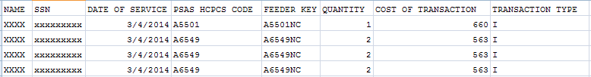

Example: Prosthetic Extracts Unusual Cost Report Screen Print

Prosthetic Extract Unusual Cost Report Page: 1
Start Date: MAR 01, 2014 Report Run Date/Time: AUG 21, 2014
End Date: MAR 03, 2014 Threshold Value: 500

Date of PSAS Cost of Tran
Name SSN Service HCPCS CODE Feeder Key Quantity Transaction Type
----------------------------------------------------------------------------------------------------
XXXX xxxxxxxxx 03/04/14 A5501 A5501NC 1 $660.00 I
XXXX xxxxxxxxx 03/04/14 A6549 A6549NC 2 $563.00 I
XXXX xxxxxxxxx 03/04/14 A6549 A6549NC 2 $563.00 I

4.3.1.9.3 Prosthetics (PRO) YTD HCPCS Report

The Prosthetics YTD HCPCS Report displays data from Prosthetics extracts from the beginning of the fiscal year to the ending data of the last extract. Data from current or previous fiscal year may be selected for the report. The report is divided into three sections: New (i.e., Initial, Replacement or Spare items), Repairs, and Rentals.

Sites that are multidivisional prosthetics sites must specify the Primary Prosthetics Division for the report. The user may then choose to generate a specific report for one division or a combined report for all divisions. The report is sorted by PSAS HCPCS Code. A print device capable of displaying a 132-character line is needed for output.

Setup for PRO Extract YTD HCPCS Report --

If you belong to more than one Primary Division, you must
select a Primary Division for the report.

NOTE: You will see the following prompt if you need to select a division:

Select Prosthetic Division: ?
Answer with INSTITUTION NAME, or *STATION NAME, or STATION NUMBER, or
OFFICIAL VA NAME, or CURRENT LOCATION
Do you want the entire INSTITUTION List? Y (Yes)
Choose from:
ALBANY ISC NY VAMC 11000
HINES ISC IL VAMC 14000

Select Prosthetic Division: ALBANY ISC VAMC 11000

You may select ONE or ALL of the following:

(1) 11000 ALBANY
(2) 11000B TROY

Select O(ne) or A(ll): ALL// ONE

Which one?: 2

Do you want the output in exportable format? NO// n NO

Select C(urrent) or P(revious) Fiscal Year: CURRENT// c CURRENT

Do you want the output in exportable format? NO// y YES
NOTE: Appendix C contains instructions for exporting a report into an external spreadsheet.

Gathering data for export...

To ensure all data is captured during the export:

1. Select 'Logging...' from the File Menu. Select your file, and where to save.
2. On the Setup menu, select 'Display...',then 'screen' tab and modify 'columns'
setting to at least 225 characters.
3. The DEVICE input for the columns should also contain a large enough
parameter (e.g. 225). The DEVICE prompt is defaulted to 0;225;99999 for you.
You may change it if need be.
Example: DEVICE: 0;225;99999 *Where 0 is your screen, 225 is the margin width
and 99999 is the screen length.

NOTE: In order for all number fields, such as SSN and Feeder Key, to be
displayed correctly in the spreadsheet, these fields must be formatted as Text
when importing the data into the spreadsheet.

DEVICE: 0;225;99999// HOME (CRT)

Please note: The PRO Extract YTD HCPCS Report requires 132 columns.
Select an appropriate device for output.

Example: Exported PRO Extract YTD HCPCS Report

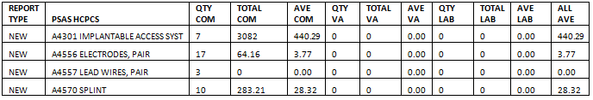

Example: PRO Extract YTD HCPCS Report Screen Print

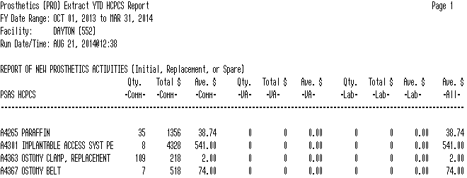

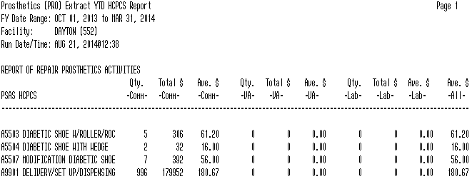

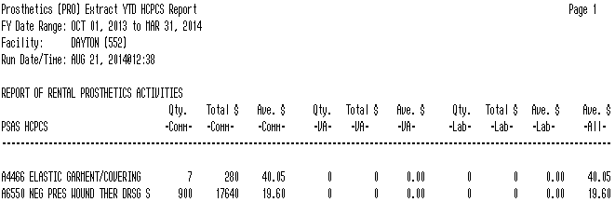

4.3.1.9.4 Prosthetics (PRO) YTD Laboratory Report

The Prosthetics YTD Laboratory Report displays data from Prosthetics extracts from the beginning of the fiscal year to the ending data of the last extract. It is intended for use by sites that have on-site prosthetics laboratories. Data from current or previous fiscal year may be selected for the report. The report is divided into three sections: New (i.e., Initial, Replacement, or Spare items), Repairs and Rentals. Sites that are multidivisional prosthetics sites must specify the Primary Prosthetics Division for the report.

The report is sorted by PSAS HCPCS Code. It shows quantity and labor and material costs for items within each PSAS HCPCS Code. Two sets of totals are displayed on each line: totals for items produced for use at the local site and totals for items produced for other VA stations.

Select Prosthetics Option: Prosthetics (PRO) YTD Laboratory Report

Setup for PRO Extract YTD Laboratory Report --

If you belong to more than one Primary Division, you must
select a Primary Division for the report.

Select C(urrent) or P(revious) Fiscal Year: CURRENT// c CURRENT

Do you want the output in exportable format? NO// y YES
NOTE: Appendix C contains instructions for exporting a report into an external spreadsheet.

Gathering data for export...

To ensure all data is captured during the export:

1. Select 'Logging...' from the File Menu. Select your file, and where to save.
2. On the Setup menu, select 'Display...',then 'screen' tab and modify 'columns'
setting to at least 225 characters.
3. The DEVICE input for the columns should also contain a large enough
parameter (e.g. 225). The DEVICE prompt is defaulted to 0;225;99999 for you.
You may change it if need be.
Example: DEVICE: 0;225;99999 *Where 0 is your screen, 225 is the margin width
and 99999 is the screen length.

NOTE: In order for all number fields, such as SSN and Feeder Key, to be
displayed correctly in the spreadsheet, these fields must be formatted as Text
when importing the data into the spreadsheet.

DEVICE: 0;225;99999//

Example: Exported PRO Extract YTD Laboratory Report

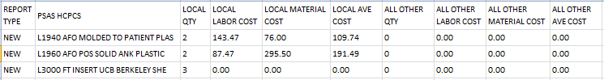

Example: PRO Extract YTD Laboratory Report Screen Print

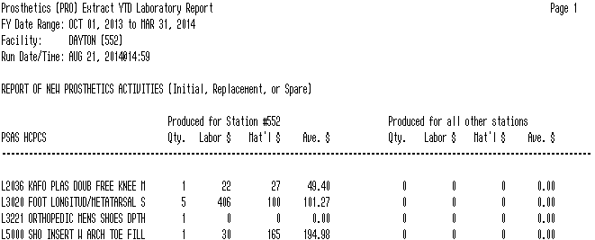

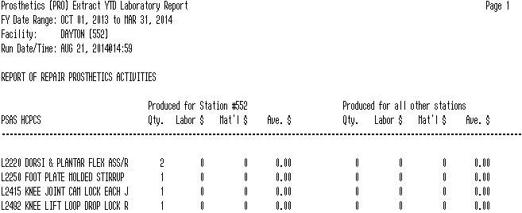

Setup for DSS Clinic Information

Choosing the Setup for DSS Clinic Information option from the Maintenance Menu will display the following sub-menu and options.

Example: DSS Clinic Information Menu Options

Select Setup for DSS Clinic Information Option: ?

1 NATIONAL CLINIC CODES FOR DSS LIST
2 CREATE DSS CLINIC STOP CODE FILE
3 CLINICS AND DSS STOP CODES PRINT
4 ENTER/EDIT DSS STOP CODES FOR CLINICS
5 APPROVE REVIEWED DSS CLINIC WORKSHEET
6 DSS IDENTIFIER NON-CONFORMING CLINICS REPORT
7 DSS CLINIC & STOP CODES VALIDITY REPORT
8 CLINIC EDIT LOG REPORT

NOTE: The “CLINIC EDIT LOG REPORT” requires the use of the SD SUPERVISOR Security key.

4.3.2.0.1 National Clinic Codes for DSS List

Use this option to print a list of the national clinic codes with short descriptions from the NATIONAL CLINIC file (#728.441). The only prompt is for a device. You might want to use the output generated by this option as a reference guide when using the following options:
- Approve Reviewed DSS Clinic Worksheet
- Enter/Edit DSS Stop Codes For Clinics
- Clinics And DSS Stop Codes Print
- Create DSS Clinic Stop Code File

Example: National Clinic List

NATIONAL CLINIC LIST NOV 18,1997 13:54 PAGE 1
CODE SHORT DESCRIPTION
------------------------------------------------------------------------------
AETC Ambulatory Evaluation and Treatment Center
AFCC AFC Clinic
AGTO Agent Orange
AOTH A Other
ASOR Ambulatory Surgery Performed in an OR
ASOT Ambulatory Surgery Performed in Area Other than OR
ATEM A Team
BARA Bar 203-450 Audio
BOTH B Other
[This output has been abbreviated to save space.]

Example: Exported National Clinic List
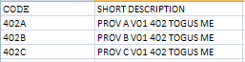

4.3.2.0.2 Create DSS Clinic Stop Code File

- You can run this option at any time to add new clinics created by MAS.
- Running this option does not affect existing data in the CLINICS AND STOP CODES file (#728.44). This file includes the RECORD LAST SYNCHED field that holds the last date that the Create DSS Clinic Stop Code File option was run.
- It is recommended that this option be run on a recurrent monthly basis. The suggested time is prior to generating the Clinic Visit Extract.

Use this option to create local entries in the CLINICS AND STOP CODES file (#728.44).

Select Setup for DSS Clinic Information Option: 2 Create DSS Clinic Stop Code File

This option creates local entries in the DSS CLINIC AND STOP CODES
file (#728.44).

The CREATE option last ran on 8/27/13.

Do you want to run the CREATE option? N// y YES

Running CREATE..................................................................

The CREATE option has completed on Aug 28, 2013@09:11:17.

Proceed to DSS Clinic and Stop Code Print menu? NO// y YES

This option produces a worksheet of (A) All Clinics, (C) Active, (D) Duplicate, (I) Inactive, or only the (U) Unreviewed Clinics that are awaiting approval.

Clinics that were defined as "inactive" by MAS the last time the option
"Create DSS Clinic Stop Code File" was run will be indicated with an "*".

Choose (X) for exporting the CLINICS AND STOP CODES FILE to a text file for
spreadsheet use.

**REMINDER - The CREATE option last ran on 8/28/13.
If the most recent clinic changes from the HOSPITAL LOCATION file #44
are desired, run the CREATE option before running a report.**

Select one of the following:

A ALL CLINICS
C ALL ACTIVE CLINICS
D DUPLICATE CLINICS
I ALL INACTIVE CLINICS
U UNREVIEWED CLINICS
X EXPORT TO TEXT FILE FOR SPREADSHEET USE

Enter "A", "C", “D”, "I", "U", or "X":

The software uses the following logic to create entries in the CLINICS AND STOP CODES file (#728.44).

4.3.2.0.2.1 New Clinic Entries

The software searches the HOSPITAL LOCATION file (#44) for all clinics. It does not create entries for clinics that are currently inactive.

New clinic entries are added to the CLINICS AND STOP CODES file (#728.44) with the following field defaults.

Field # | Field Name | Default value
1 | STOP CODE | STOP CODE NUMBER field (#8) in the HOSPITAL LOCATION file (#44)
2 | CREDIT STOP CODE | CREDIT STOP CODE field (#2503) in HOSPITAL LOCATION file (#44)
3 | DSS STOP CODE | STOP CODE NUMBER field (#8) in HOSPITAL LOCATION file (#44)
4 | DSS CREDIT STOP CODE | CREDIT STOP CODE field (#2503) in HOSPITAL LOCATION file (#44)
5 | ACTION TO SEND | 1: SEND STOP CODE  4: SEND BOTH AS ONE RECORD WITH NATIONAL  CODE  5: SEND BOTH AS ONE RECORD WITHOUT NATIONAL  CODE  6: DO NOT SEND

4.3.2.1.0.2 Existing Clinic Entries

All preexisting clinics are checked against their counterparts in the HOSPITAL LOCATION file (#44) to be sure that the STOP CODE field (#1) in the CLINICS AND STOP CODES file (#728.44) matches the STOP CODE NUMBER field (#8) in the HOSPITAL LOCATION file (#44). The same check is made on the CREDIT STOP CODE field (#2) to be sure that it matches the CREDIT STOP CODE field (#2503) in the HOSPITAL LOCATION file (#44).

Any preexisting clinic that is currently marked as inactive in the HOSPITAL LOCATION file (#44) is flagged as inactive in the CLINICS AND STOP CODES file (#728.44). This inactive indicator will be displayed as an asterisk (*) beside the clinic name on the worksheet generated by the Clinics and DSS Stop Codes Print option. Inactive clinics may still have valid past data for DSS.

Any Stop Code changes to preexisting clinics will delete the “Last Approved” date in the CLINICS AND STOP CODES file (#728.44). This will ensure that the edited clinics print out as “unreviewed” the next time the clinic worksheet is generated using the Clinics and DSS Stop Codes Print option.

4.3.2.0.3 Clinics and DSS Stop Codes Print

Use this option to produce the Worksheet for DSS Clinic Stops showing one of the following:
- All DSS Clinic Stops
- Active Clinic Stops
- Duplicate Clinic Stops
- Inactive Clinic Stops
- Unreviewed Clinic Stops

A clinic will be reported as “unreviewed” if it is newly established or if there is a change to stop code/credit stop or count/non-count clinic status or active/inactive clinic status.

The columns included on the spreadsheet are:

- IEN
- Clinic
- Stop Code
- Credit Stop Code
- DSS Stop Code
- DSS Credit Stop Code
- Action
- Last Review Date
- CHAR4 Code
- Inact Date
- React Date
- Clinic Type
- App Len
- Div
- App Type
- Non Cnt
- Occasion of Service (OOS)
- OOS Calling Pkg
- Variable Length Appt
- DSS Prod Dept

Columns listed in the Worksheet for DSS Clinic Stops printed from the screen include:

- Last approved date
- Print Date
- Clinic (followed by * if inactive)
- Stop Code
- Credit Stop Code
- DSS Stop Code
- DSS Credit Stop Code
- Action
- CHAR4 Code
- C/N

Column C / N, captures changes to a clinic’s Count / Non Count status. Values in the column will be “C” for count or “N” for non-count on the printed report and “YES” and “NO” on the exported report.
Only changes to the Stop Code and Credit Stop Code fields in the HOSPITAL LOCATION file (#44) are noted.
The clinic name is truncated so that there is at least one space between the clinic name and stop code columns.
Clinics that are inactive have an asterisk “*” after the clinic name on the printed reports only. On the exported reports, the date the clinic was inactivated is shown. (Note: if an inactive clinic was reactivated the reactivation date is shown.)

Select Setup for DSS Clinic Information Option: 3 Clinics and DSS Stop Codes Print

This option produces a worksheet of (A) All Clinics, (C) Active, (D) Duplicate,
(I) Inactive, or only the (U) Unreviewed Clinics that are awaiting approval.

Clinics that were defined as "inactive" by MAS the last time the option
"Create DSS Clinic Stop Code File" was run will be indicated with an "*".

Choose (X) for exporting the CLINICS AND STOP CODES FILE to a text file for
spreadsheet use.

**REMINDER - The CREATE option last ran on 8/28/13.
If the most recent clinic changes from the HOSPITAL LOCATION file #44
are desired, run the CREATE option before running a report.**

Select one of the following:

A ALL CLINICS
C ALL ACTIVE CLINICS
D DUPLICATE CLINICS
I ALL INACTIVE CLINICS
U UNREVIEWED CLINICS
X EXPORT TO TEXT FILE FOR SPREADSHEET USE

4.3.2.0.3.1 All Clinics Option

WORKSHEET FOR DSS CLINIC STOPS Page: 1
(last approved on 07/09/2013) Print Date:08/28/13

CLINIC STOP CREDIT DSS DSS ACTION CHAR4 C/N
CODE STOP STOP CREDIT CODE
CODE CODE STOP
( * - currently inactive) CODE
-------------------------------------------------------------------------------

000 ADMIN SCHEDULING (NC) 674 674 _____ 1 ____ N

000-EYE NON TREATMENT-X 407 485 407 485 4 NONC N

000-MH NON TREATMENT-X 674 674 _____ 1 ____ N

000-NON TREATMENT-X 301 485 301 485 4 NONC N

3S D/C CLINIC DAYS-X 674 674 _____ 4 NONC N

DAY MH PRRC GRP SST* 583 117 583 117 5 ____ C
-------------------------------------------------------------------------------

4.3.2.0.3.2 All Active Clinics Option

WORKSHEET FOR DSS CLINIC STOPS Page: 1
(last approved on 07/09/2013) Print Date:08/28/13

CLINIC STOP CREDIT DSS DSS ACTION CHAR4 C/N
CODE STOP STOP CREDIT CODE
CODE CODE STOP
( * - currently inactive) CODE
-------------------------------------------------------------------------------

000 ADMIN SCHEDULING (NC) 674 674 _____ 1 ____ N

000-EYE NON TREATMENT-X 407 485 407 485 4 NONC N

000-MH NON TREATMENT-X 674 674 _____ 1 ____ N

000-NON TREATMENT-X 301 485 301 485 4 STAT N

3S D/C CLINIC DAYS-X 674 674 _____ 4 NONC N

3S D/C CLINIC EVE-X 674 674 _____ 4 NONC N
-------------------------------------------------------------------------------

4.3.2.0.3.3 Duplicate Clinics Option

WORKSHEET FOR DSS CLINIC STOPS Page: 1
(last approved on 07/09/2013) Print Date:08/28/13

CLINIC NAME CLINIC DSS DSS CHAR4 CLINIC DIV
IEN STOP CREDIT CODE APPT
CODE STOP LENGTH
CODE
-------------------------------------------------------------------------------
SICU 195 1
11CP SURG 359 1
NEW IMAGING LOCATION 611 1
N.PSYCHROOFTOP 616 1

RAD LOC #10 277 105 1
RAD LOC #11 286 105 1

4.3.2.0.3.4 All Inactive Clinics Option

WORKSHEET FOR DSS CLINIC STOPS Page: 1
(last approved on 07/09/2013) Print Date:08/28/13

CLINIC STOP CREDIT DSS DSS ACTION CHAR4 C/N
CODE STOP STOP CREDIT CODE
CODE CODE STOP
( * - currently inactive) CODE
-------------------------------------------------------------------------------

ZZ1ST TUES SLEEP SC -X* 315 470 315 470 5 ____ C

ZZ23 HOUR OBSERVATION-X* 291 291 _____ 1 ____ N

ZZ320 DR N&FS OPT-X* 123 123 _____ 4 NONC N

ZZ3N N&FS OPT-X* 123 123 _____ 4 NONC N
-------------------------------------------------------------------------------

4.3.2.0.3.5 Unreviewed Clinics Option

WORKSHEET FOR DSS CLINIC STOPS Page: 2
(last approved on 07/09/2013) Print Date:08/28/13

CLINIC STOP CREDIT DSS DSS ACTION CHAR4 C/N
CODE STOP STOP CREDIT CODE
CODE CODE STOP
( * - currently inactive) CODE
-------------------------------------------------------------------------------

DAY MH PRP GROUP EDUCATIO 560 714 560 714 5 ____ C

DAY PC XXXXXXXX 323 323 _____ 4 YYYY C

DAY POLYTRAUMA/CHIROPRACT 197 436 197 436 5 ____ C

4.3.2.0.3.6 Export Clinic Review Report Option

Select Setup for DSS Clinic Information Option: Clinics and DSS Stop Codes Print

Choose (X) for exporting the CLINICS AND STOP CODES FILE to a text file for
spreadsheet use.

Select one of the following:

A ALL CLINICS
C ALL ACTIVE CLINICS
D DUPLICATE CLINICS
I ALL INACTIVE CLINICS
U UNREVIEWED CLINICS
X EXPORT TO TEXT FILE FOR SPREADSHEET USE

Enter "A", "C", “D”, "I", "U", or "X": X

Select one of the following:

A ALL CLINICS
C ALL ACTIVE CLINICS
D DUPLICATE CLINICS
I ALL INACTIVE CLINICS
U UNREVIEWED CLINICS

Enter "A", "C", "D", "I", or "U": U

Do you want the output in exportable format? NO// Y
NOTE: Appendix C contains instructions for exporting a report into an external spreadsheet.
Gathering data for export...

To ensure all data is captured during the export:

1. Select 'Logging...' from the File Menu. Select your file, and where to save.
2. On the Setup menu, select 'Display...',then 'screen' tab and modify 'columns'
setting to at least 225 characters.
3. The DEVICE input for the columns should also contain a large enough
parameter (e.g. 225). The DEVICE prompt is defaulted to 0;225;99999 for you.
You may change it if need be.
Example: DEVICE: 0;225;99999 *Where 0 is your screen, 225 is the margin width
and 99999 is the screen length.

NOTE: In order for all number fields, such as SSN and Feeder Key, to be
displayed correctly in the spreadsheet, these fields must be formatted as Text
when importing the data into the spreadsheet.

DEVICE: 0;225;99999//

Example: Exported All Clinics Spreadsheet
NOTE: For clinics that are inactive, the date that they were inactivated is listed. If an Inactive Clinic was reactivated, the Reactivation Date has been listed.

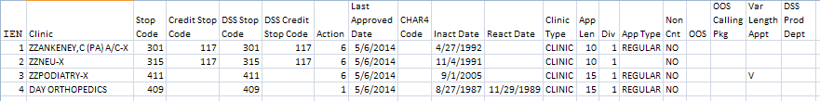

Example: Exported All Active Clinics Spreadsheet

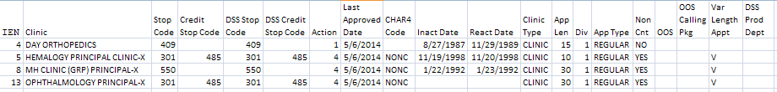

Example: Exported Duplicate Clinics Spreadsheet

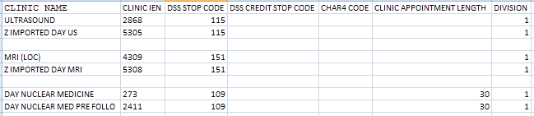

Example: Exported All Inactive Clinics Spreadsheet

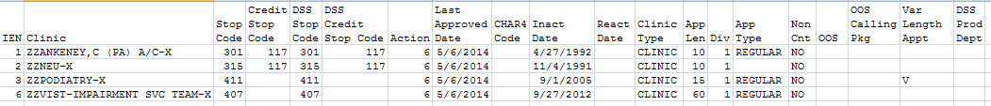

Example: Exported Unreviewed Clinics Spreadsheet

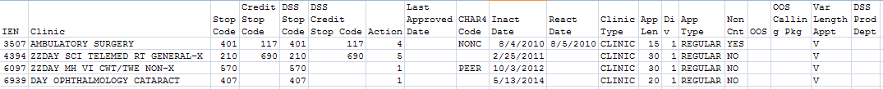

4.3.2.0.4 Enter/Edit DSS Stop Codes for Clinics

Use this option to enter or edit the stop codes, credit stop codes and action to send codes associated with each clinic for the DSS extract. Please note that these codes might be the same as those associated with the clinic by MAS.

Stop codes (also known as DSS Identifiers) are assigned a restriction type of primary, secondary or either.
- Primary types can only be used in the primary stop code position
- Secondary types can only be used in the secondary stop code position
- Either can be used in the primary or secondary stop code position

Stop codes that have a restriction type of primary or secondary will also have a restriction date to track when the stop code is designated as a restricted stop code. Validity checks are performed to restrict data entry to valid values only.

The option to select how the stop codes and/or credit codes are sent can be changed. The default is set to SEND BOTH AS ONE RECORD WITH NATIONAL CODE. The example below shows the options that are available.

Example: Action to Send Description and Menu Choices

ACTION TO SEND: SEND BOTH AS ONE RECORD WITH NATIONAL CODE
// ??
This determines how alternate stop code and alternate credit stop
codes are combined to form a feeder key for this clinic.

Choose from:
1 SEND STOP CODE
4 SEND BOTH AS ONE RECORD WITH NATIONAL CODE
5 SEND BOTH AS ONE RECORD WITHOUT NATIONAL CODE
6 DO NOT SEND

Through prompts, there is the option the option to add or edit the National Code, DSS Unit Identifier and DSS Product Department.

Example: Enter/Edit DSS Stop Codes for a Clinic

Select Setup for DSS Clinic Information Option: Enter/Edit DSS Stop Codes for Clinics

Select CLINICS AND STOP CODES CLINIC NAME: Ambulatory Surgery

EXISTING CLINIC FILE DATA: EXISTING DSS CLINIC FILE DATA:

STOP CODE : 401 DSS STOP CODE : 401
CREDIT STOP CODE :117 DSS CREDIT STOP CODE :117

DSS STOP CODE (3-digit code only): 401// GENERAL SURGERY 401
DSS CREDIT STOP CODE (3-digit code only): 117// NURSING (2ND ONLY) 117

...Validity Checker Complete.
ACTION TO SEND: SEND BOTH AS ONE RECORD WITH NATIONAL CODE
//
NATIONAL CODE: NONC//
DSS UNIT IDENTIFIER:
DSS PRODUCT DEPARTMENT: ??
The nationally defined DSS Intermediate Department Number designated to
the patient care product being provided.

DSS PRODUCT DEPARTMENT: 123

4.3.2.0.5 Approve Reviewed DSS Clinic Worksheet

Use this option to approve all DSS Stop Codes and DSS Credit Stop Codes as defined in the CLINICS AND STOP CODES file (#728.44) and to mark all currently existing entries in this file as reviewed.

Example: Clinics and Stop Code File

This option allows you to mark the current clinic entries in the CLINICS AND
STOP CODES file (#728.44) as "reviewed". Those entries will then be omitted
from the list printed from the "Clinic and DSS Stop Codes Print" when you
choose to print only "unreviewed" clinics.

Are you ready to approve the reviewed information provided by the
"Clinic and DSS Stop Codes Print"? NO// Y YES

Requested Start Time: NOW// <RET> (DEC 06, 1996@10:28:25)

...approval queued

4.3.2.0.6 DSS Identifier Non-Conforming Clinics Report

Stop codes (also known as DSS Identifiers) are assigned a restriction type of primary, secondary or either. Primary types can only be used in the primary stop code position; secondary types can only be used in the secondary stop code position; and those with a type of either can be used in the primary or secondary stop code position. Stop codes that have a restriction type of primary or secondary will also have a restriction date to track when the stop code is designated as a restricted stop code. Clinics are validated to insure that stop codes are in compliance with restriction types.

The DSS Identifier Non-Conforming Clinics Report option is used to print or export a listing of the clinics that do not conform to the stop code and Four Character Code (4CHAR) restriction types. Clinics in the Clinics and Stop Code file (#728.44) are also included on the report when they contain the following:
- A stop code is inactive or has an inactive date in the future.
- A credit stop code is inactive or has an inactive date in the future.
- A DSS stop code is inactive or has an inactive date in the future.
- A DSS credit stop code is inactive or has an inactive date in the future.
- National Code Four Character is inactive

NOTE: National Clinic Four Character code cannot be added, deleted, or modified by users.

You may choose to print or export the report for active clinics, inactive clinics, or both. The report will list the IEN number, clinic name, primary stop code, secondary stop code, DSS primary stop code, DSS secondary stop code, 4CHAR National Code, and the reason for non-conformance.

If all the selected clinics conform to the stop code and Four Character Codes restriction types, "No problem clinics found" is displayed on the report. If necessary, you may use the Enter/Edit DSS Stop Codes for Clinics option to make corrections to the problem clinics.

This option reviews the Primary and Secondary Stop Codes and any existing Four
Character Codes in the Clinics and Stop Codes file #728.44.
It produces a report highlighting any nonconformance reasons that pertain
to the Primary and Secondary Codes, or the Four Character Codes if present.
Please contact the responsible party for corrective action.

4.3.2.0.6.1 DSS Identifier Non-Conforming Active Clinics

Select one of the following:

A Active Clinics
I Inactive Clinics
B Both

Select Report: a Active Clinics
Please be patient, this may take a few moments...

Do you want the output in exportable format? NO// y YES
NOTE: Appendix C contains instructions for exporting a report into an external spreadsheet.

Gathering data for export...

To ensure all data is captured during the export:

1. Select 'Logging...' from the File Menu. Select your file, and where to save.
2. On the Setup menu, select 'Display...',then 'screen' tab and modify 'columns'
setting to at least 225 characters.
3. The DEVICE input for the columns should also contain a large enough
parameter (e.g. 225). The DEVICE prompt is defaulted to 0;225;99999 for you.
You may change it if need be.
Example: DEVICE: 0;225;99999 *Where 0 is your screen, 225 is the margin width
and 99999 is the screen length.

NOTE: In order for all number fields, such as SSN and Feeder Key, to be
displayed correctly in the spreadsheet, these fields must be formatted as Text
when importing the data into the spreadsheet.

DEVICE: 0;225;99999//

Example: Exported DSS Identifier Non-Conforming Clinics Report – Active

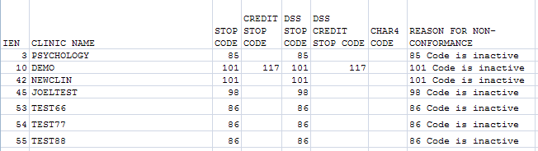

Example: Screen Print of DSS Identifier Non-Conforming Clinics Report - Active

AUG 12, 2014@10:44:15 Page: 1

DSS IDENTIFIER NON-CONFORMING CLINICS REPORT
Active Clinics

CLINICS AND STOP CODES File (#728.44) - (Use 'Enter/Edit DSS Stop Codes for
Clinics' [ECXSCEDIT] menu option to make corrections)

IEN # CLINIC NAME STOP CREDIT DSS STOP DSS CREDIT CHAR4 REASON FOR NON-
CODE STOP CODE CODE STOP CODE CODE CONFORMANCE
-------------------------------------------------------------------------------------------------3 PSYCHOLOGY 85 85 85 Code is inactive
10 DEMO 101 117 101 117 101 Code is inactive
42 NEWCLIN 101 101 101 Code is inactive

4.3.2.0.6.2 DSS Identifier Non-Conforming Inactive Clinics

Select one of the following:

A Active Clinics
I Inactive Clinics
B Both

Select Report: i Inactive Clinics
Please be patient, this may take a few moments...

Do you want the output in exportable format? NO// y YES
NOTE: Appendix C contains instructions for exporting a report into an external spreadsheet.

Gathering data for export...

To ensure all data is captured during the export:

1. Select 'Logging...' from the File Menu. Select your file, and where to save.
2. On the Setup menu, select 'Display...',then 'screen' tab and modify 'columns'
setting to at least 225 characters.
3. The DEVICE input for the columns should also contain a large enough
parameter (e.g. 225). The DEVICE prompt is defaulted to 0;225;99999 for you.
You may change it if need be.
Example: DEVICE: 0;225;99999 *Where 0 is your screen, 225 is the margin width
and 99999 is the screen length.

NOTE: In order for all number fields, such as SSN and Feeder Key, to be
displayed correctly in the spreadsheet, these fields must be formatted as Text
when importing the data into the spreadsheet.

DEVICE: 0;225;99999//

Example: Exported DSS Identifier Non-Conforming Clinics Report – Inactive

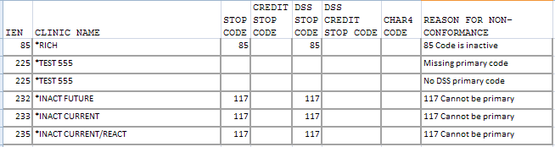

NOTE: The Asterisk (*) before the clinic name denotes an Inactive Clinic.

Example: Screen Print of DSS Identifier Non-Conforming Clinics Report - Inactive

AUG 12, 2014@10:57:37 Page: 1

DSS IDENTIFIER NON-CONFORMING CLINICS REPORT
Inactive Clinics

CLINICS AND STOP CODES File (#728.44) - (Use 'Enter/Edit DSS Stop Codes for
Clinics' [ECXSCEDIT] menu option to make corrections)

IEN # CLINIC NAME STOP CREDIT DSS STOP DSS CREDIT CHAR4 REASON FOR NON-
CODE STOP CODE CODE STOP CODE CODE CONFORMANCE
-----------------------------------------------------------------------------------------
85 *RICH 85 85 85 Code is inactive
225 *TEST 555 Missing primary code
225 *TEST 555 No DSS primary code
232 *INACT FUTURE 117 117 117 Cannot be primary
233 *INACT CURRENT 117 117 117 Cannot be primary
NOTE: The Asterisk (*) before the clinic name denotes an Inactive Clinic.

4.3.2.0.6.3 DSS Identifier Non-Conforming Both Active and Inactive Clinics

Select one of the following:

A Active Clinics
I Inactive Clinics
B Both

Select Report: b Both
Please be patient, this may take a few moments...

Do you want the output in exportable format? NO// y YES
NOTE: Appendix C contains instructions for exporting a report into an external spreadsheet.

Gathering data for export...

To ensure all data is captured during the export:

1. Select 'Logging...' from the File Menu. Select your file, and where to save.
2. On the Setup menu, select 'Display...',then 'screen' tab and modify 'columns'
setting to at least 225 characters.
3. The DEVICE input for the columns should also contain a large enough
parameter (e.g. 225). The DEVICE prompt is defaulted to 0;225;99999 for you.
You may change it if need be.
Example: DEVICE: 0;225;99999 *Where 0 is your screen, 225 is the margin width
and 99999 is the screen length.

NOTE: In order for all number fields, such as SSN and Feeder Key, to be
displayed correctly in the spreadsheet, these fields must be formatted as Text
when importing the data into the spreadsheet.

DEVICE: 0;225;99999//

Example: Exported DSS Identifier Non-Conforming Clinics Report – Both Active and Inactive

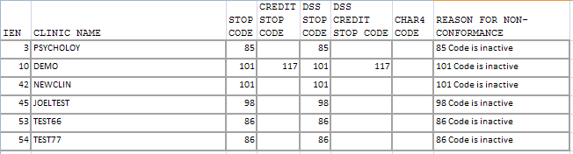

NOTE: The Asterisk (*) before the clinic name denotes an Inactive Clinic.

Example: Screen Print of DSS Identifier Non-Conforming Clinics Report - Both Active and Inactive

AUG 12, 2014@11:05:15 Page: 1

DSS IDENTIFIER NON-CONFORMING CLINICS REPORT
All Clinics

CLINICS AND STOP CODES File (#728.44) - (Use 'Enter/Edit DSS Stop Codes for
Clinics' [ECXSCEDIT] menu option to make corrections)

IEN # (*currently inactive) STOP CREDIT DSS STOP DSS CREDIT CHAR4 REASON FOR NON-
CODE STOP CODE CODE STOP CODE CODE CONFORMANCE
----------------------------------------------------------------------------------------------------
3 PSYCHOLOGY 85 85 85 Code is inactive
10 DEMO 101 117 101 117 101 Code is inactive
42 NEWCLIN 101 101 101 Code is inactive
45 JOELTEST 98 98 98 Code is inactive
53 TEST66 86 86 86 Code is inactive

NOTE: The Asterisk (*) before the clinic name denotes an Inactive Clinic.

4.3.2.0.7 DSS Clinic & Stop Codes Validity Report

The DSS Clinic & Stop Codes Validity Report is used to identify clinic setups that have become invalid due changes that have occurred with stop codes or credit stop codes subsequent to initial clinic setup.

The clinic’s stop codes must be active, valid, and conform to the restriction types. If any of the following six conditions are not met, the clinic will be listed on the report with a descriptive message explaining what needs to be updated.
- Must be active
- Must be three numeric characters in length and be valid
- Must be in the correct position for the restriction type
- Must not have matching codes
- Must not have an inactive date in the future
- Must not have an inactive 4CHAR National Code
NOTE: National Clinic Four-Character cannot be added, deleted, or modified by users.

Example: Exported DSS Clinic and Stop Codes Validity Report

Select Setup for DSS Clinic Information Option: DSS Clinic & Stop Codes Validity Report

This report will display stop code information of the ACTIVE
clinics in the Clinics and Stop Code file (#728.44). It will
display stop codes that do not conform to the Business Rules for
Valid Stop Codes.

Do you want the output in exportable format? NO// y YES

Gathering data for export...

To ensure all data is captured during the export:

NOTE: Appendix C contains instructions for exporting a report into an external spreadsheet.

Gathering data for export...

To ensure all data is captured during the export:

1. Select 'Logging...' from the File Menu. Select your file, and where to save.
2. On the Setup menu, select 'Display...',then 'screen' tab and modify 'columns'
setting to at least 225 characters.
3. The DEVICE input for the columns should also contain a large enough
parameter (e.g. 225). The DEVICE prompt is defaulted to 0;225;9999 for you.
You may change it if need be.
Example: DEVICE: 0;225;99999 *Where 0 is your screen, 225 is the margin width
and 99999 is the screen length.

NOTE: In order for all number fields, such as SSN and Feeder Key, to be
displayed correctly in the spreadsheet, these fields must be formatted as Text
when importing the data into the spreadsheet.

DEVICE: 0;225;99999//

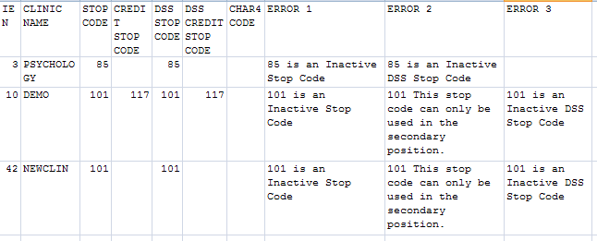

Example: DSS Clinic and Stop Codes Validity Report

Select Setup for DSS Clinic Information Option: DSS Clinic & Stop Codes Validity Report

This report will display stop code information of the ACTIVE
clinics in the Clinics and Stop Code file (#728.44). It will
display stop codes that do not conform to the Business Rules for
Valid Stop Codes.

DEVICE: HOME//

DSS CLINIC & STOP CODES VALIDITY REPORT Page: 1

IEN# CLINIC NAME STOP CREDIT DSS DSS CHAR4
CODE STOP STOP CREDIT CODE
CODE CODE CODE STOP
CODE
-------------------------------------------------------------------------------

1177 DAY FLU SHOT 323 710 323 710 BTEM
ERRORS:
BTEM CHAR4 Code is inactive, please change to an active code.

1921 PCT_G PRINCIPAL-X 323 323 BTEM
ERRORS:
BTEM CHAR4 Code is inactive, please change to an active code.

64 AUDIOLOGY 203 211 110
ERRORS:
110 is an Inactive DSS Credit Stop Code
9999 CHAR4 Code is invalid, please change to a legal value.

3 PROBLEM CLINICS FOUND.

Example: Exported DSS Clinic and Stop Codes Validity Report

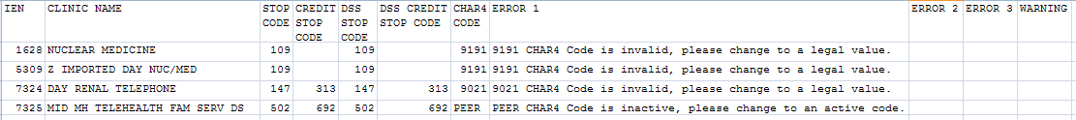

4.3.2.0.8 Clinic Edit Log Report

This option prints a log of changes made to Clinic Locations. The user will select one of the following:
1 USER NAME
2 DATE CHANGED

Example: Clinic Edit log Report

CLINIC EDIT LOG
Page 1
Printed on Apr 17, 2010@08:28:56 for 3/1/10 to 3/30/10
USER NAME DATE/TIME CHANGED CLINIC IEN CLINIC NAME FIELD NAME
OLD VALUE
NEW VALUE
-----------------------------------------------------------------------------
XXXXXXX,XXX MAR 1,2010 08:41 XXXX ZZDAYC&P MARSHALL
IN
ACTIVATE

MAR 01, 2010
XXXXXXX,XXX MAR 1,2010 08:44 XXXX ZZC&P MUNSEE-X
IN
ACTIVATE

MAR 01, 2010

Example: Exported Clinic Edit log Report

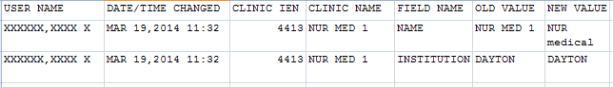

4.3.2.1 Setup for Inpatient Census Information

Choosing the Setup for Inpatient Census Information option from the Maintenance Menu will display the following sub-menu and options.

Example: Patient Census Information Menu Options

Select Setup for Patient Census Information Option: ?

1 Trial for Setup Extract
2 Generate the Inpatient Setup Extract
3 Active MAS Wards for Fiscal Year Print
4 Primary Care Team Print

4.3.2.1.1 Trial for Setup Extract

Use this option to generate a printed report of the inpatient population on a selected date. The report is sorted by inpatient ward. Within each ward, the data is sorted by patient name, SSN and admit date. You can compare this report to reports from MAS to eliminate any problems in the ADMISSION SETUP EXTRACT file (#727.82).

Example: Inpatient Population Report on a Selected Date

WARNING:
This is very resource intensive and should be queued to run at slack time.

This option will print the admission data and data for the last
transfer and treating specialty change for all patients who
were in the hospital on the day you select.

NOTE - This will generate a report of your inpatient population on the
BEGINNING of the day you select, not the end of the day as MAS reports do.
For example, for this report, if you choose October 1, 1994, the report will
start at midnight at the beginning of the day. For the MAS report, you would
choose September 30, 1994. The MAS report begins at midnight at the end
of the day.

Select the date : Dec 02, 1997// <RET>

This report must be queued to a 132-column printer.

DEVICE: HOME// QUEUE TO PRINT ON

Requested Start Time: NOW// <RET> (DEC 03, 1997@13:12:55)

INPATIENT WARD LIST (DSS) FOR Dec 02, 1997 FOR WARD 3E NORTH
PATIENT SSN ADMIT DATE

DSSPATIENT,ONE 000456789 Sep 02, 1997
DSSPATIENT,TWO 666456789 Apr 18, 1995
DSSPATIENT,THREE 666987654 Nov 01, 1997

4.3.2.1.2 Generate the Inpatient Setup Extract

Your site should run this option only if your site has never sent any DSS Extract data to AITC to initialize the setup extract files listed below. Once this is accomplished, the option should not be used again.

Use this option to generate the Inpatient Setup Extract, which creates the hospital population for the selected DSS start date. This data is stored in the following files until it is transmitted to AITC.

ADMISSION SETUP EXTRACT file (#727.82)
PHYSICAL MOVEMENT SETUP EXTRACT file (#727.821)
TREATING SPECIALTY CHANGE SETUP EXTRACT file (#727.822)

Example: Inpatient Setup Extract

WARNING
This is very resource intensive and should be queued to run at slack time.

This option will extract the admission data and data for the last
transfer and treating specialty change for all patients who
were in the hospital on the day you select.

NOTE - This will generate a snapshot of your inpatient population on the
BEGINNING of the day you select, not the end of the day as MAS reports do. For example, for the inpatient setup extract if you choose October 1, 1994, the report will start at midnight at the beginning of the day. For the MAS report, you would choose September 30, 1994. The MAS report begins at midnight at the end of the day.

Select the starting date : Oct 01, 1996// <RET> (OCT 01, 1996)
Requested Start Time: NOW// <RET> (DEC 17, 1996@09:43:16)

4.3.2.1.3 Active MAS Wards for Fiscal Year Print

This option is intended to provide help for building wards in the commercial database at AITC.

Use this option to print a list of all MAS wards that were active at any time during the current fiscal year. The only prompt is for a device. The output is formatted for 132 columns. It is sorted by Medical Center Division and displays the following information:
- Pointer to the HOSPITAL LOCATION file (#44)
- Service and specialty associated with the ward in the WARD LOCATION file (#42)
- DSS Department code associated with the ward in the DSS WARD file (#727.4)

Example: Active MAS Inpatient Census Information

Abbreviated Sample Output

Active Wards for FY1998
Printed on SEP 28,1998@14:42

DSS Pointer Ward Ward
WARD Department to File #44 Service Specialty
--------------------------------------------------------------------------------------

DIVISION: ALBANY
2 WEST 192 MEDICINE GENERAL(ACUTE MEDICINE)
3E NORTH 129 INTERMEDIATE MED INTERMEDIATE MEDICIN
3E SOUTH 219 SURGERY SURGICAL ICU
5 WEST PS 66 PSYCHIATRY LONG TERM PSYCHIATRY(>45 DAYS)
7A GEN MED UEK1 158 MEDICINE GENERAL(ACUTE MEDICINE)
[Svc: NURSING Prod. Unit: WARD GENERAL MEDICINE/ACUTE MEDICINE 1

DOMICILLARY 16 DOMICILIARY DOMICILIARY
NHCU 14 NHCU NHCU
OBSERVATION 234 NON-COUNT NON-DOD BEDS IN VA FACILITY

DIVISION: TROY
3 NORTH GU 6 MEDICINE GASTROENTEROLOGY
3 NORTH SURG UF12 5 SURGERY ORTHOPEDIC
[Svc: NURSING Prod. Unit: WARDS - SURGERY 1 Div: TROY/500B]

7B MED UEK2 81 MEDICINE CARDIOLOGY
[Svc: NURSING Prod. Unit: WARD GENERAL MEDICINE/ACUTE MEDICINE 1 Div: TROY/500B]

Example: Exported Active MAS Inpatient Census Information

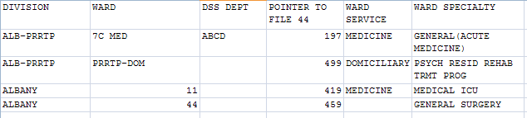

4.3.2.1.4 Primary Care Team Print

Use this option to print a list of all primary care teams. The list is sorted alphabetically by team name and displays the pointer to the TEAM file (#404.51). The intent of this option is to provide help for building primary care teams on the commercial DSS system.

Example: Primary Care Team Print

This option prints a list of all Primary Care Teams. The list is sorted
alphabetically by TEAM name and displays the pointer to the TEAM file (#404.51).

The right margin for this report is 80.

DEVICE: HOME//
DEVICE: HOME// RIGHT MARGIN 80// <RET>

Requested Start Time: NOW// <RET> (DEC 08, 1997@13:16:22)

Primary Care Teams NOV 25,1997 10:22 PAGE 1
TEAM FILE
TEAM NAME POINTER
------------------------------------------------------------------------------

SAMPLE TEAM 1

Example: Exported Primary Care Team Print

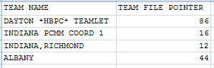

Setup for Inpatient Medications Information

Choosing the Setup for Inpatient Medications Information option from the Maintenance Menu will display the following sub-menu and options.

Example: Inpatient Medications Information Option

Select Setup for Inpatient Medications Information Option: ?

1 Print IV Room Worksheet
2 Enter/Edit IV Room Division
3 Pharmacy NDC Lookup

4.3.2.2.1 Print IV Room Worksheet

Use this option to print a worksheet listing all the entries in the IV ROOM file (#59.5) of the Inpatient Medications package. This worksheet is intended to be used by the DSS Manager to define the DIVISION (as a pointer to the MEDICAL CENTER DIVISION file [#40.8]) for each IV room for DSS purposes. The report can be displayed normally to the screen, or in exported format.

Example: IV Room Worksheet

This option will produce a worksheet listing all entries in the IV Room file
(#59.5). It should be used to help DSS and Pharmacy services define and
review the DIVISION assignments for each IV Room.

Do you want the output in exportable format? NO// NO
DEVICE: HOME// HOME (CRT)

IV Room Worksheet Page: 1
Printed Aug 21, 2014

IV ROOM DIVISION INACTIVE DATE
--------------------------------------------------------------------------------

A DAYTON

Example: Exported IV Room Worksheet
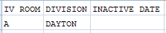

4.3.2.2.2 Enter/Edit IV Room Division

Use this option to create or edit entries in the DIVISION field (#.02) of the IV ROOM file (#59.5). The purpose of the DIVISION field is to provide a way to tie outpatient IV data to a medical center division for DSS purposes.

Example: Option for Editing Room Division

This option allows editing of the DIVISION field for IV Rooms.

Select IV ROOM NAME: 1WEST
DIVISION: ALBANY 500

Select IV ROOM NAME: <RET>

4.3.2.2.3 Pharmacy NDC Lookup

Refer to Appendix A for information about feeder key transmission.

Use this option to perform lookups on the local DRUG file (#50) for NDCs from DSS Pharmacy Feeder Keys that have rejected because the first seven characters are zeros (e.g., "0000000051079014120"). This would occur when a pharmacy item has not been matched to the National Drug File (NDF).

The software prompts you to enter the NDC (last twelve characters) from a rejected feeder key to display the following information from the local DRUG file (#50) for any drug which has that NDC.
- Local Generic Name
- NDC
- Dispense Unit
- VA Classification
- Price Per Dispense Unit

The output will vary slightly, depending on the version of NDF running at your site, as indicated in the following example:

Example: Pharmacy NDC Lookup

Your site is running NATIONAL DRUG FILE (NDF) v4.0.
If Pharmacy data is dated after September 30, 1998,
then PHA Feeder Keys are composed of 17 numeric characters.

Ex. "12006000003073531" where characters:
1-5 (12006) = pointer to VA PRODUCT NAME file (#50.68)
6-17 (000003073531) = NDC from the local DRUG file (#50)

If Pharmacy data is dated prior to October 1, 1998,
then PHA Feeder Keys are composed of 19 numeric characters.

Ex. "0016006000003073531" where characters:

1-4 (0016) = pointer to the NATIONAL DRUG file (#50.6)
5-7 (006) = pointer to VA PRODUCT NAME subfile (#50.68)
of the NATIONAL DRUG file (#50.6)
8-19 (000003073531) = NDC from the local DRUG file (#50)

Enter RETURN to continue or '^' to exit: <RET>

This option will allow lookups on the local DRUG file (#50) using NDCs from DSS Pharmacy Feeder Keys that have been rejected because the first five characters are zeros in a 17 character Feeder Key. (Ex. "00000051079014120") OR the first seven characters are zeros in a 19 character Feeder Key. (Ex. "0000000051079014120")

This would occur when a pharmacy item has not been matched to the National Drug File (NDF).

Enter the NDC (last twelve characters) from a rejected feeder key to display information from the local DRUG file for any drug which has that NDC.

Example: Selecting a NDC

Enter 12 numeric characters at the prompt or <cr> to exit. <RET>

Select NDC: 000469065771 TACROLIMUS 5MG CAP IM600 (PROGRAF) DU=CAP

TACROLIMUS 5MG CAP
------------------
NDC: 00469-0657-71 VA Classification: IM600
Dispense Unit: CAP Price per Dispense Unit: 6.809

Enter 12 numeric characters at the prompt or <cr> to exit. <RET>

Select NDC: <RET>

Surgery

Choosing the Surgery option from the Maintenance Menu will display the following sub-menu and options.

Example: Surgery Menu Options

Select Surgery Option: ?
1 SUR Volume Report
2 Surgery Extracts Unusual Volume Report

4.3.2.3.1 SUR Volume Report

This menu option creates a report that lists all surgical cases that would be generated to the Surgery Extract for transmission to the AITC for review.

Example: SUR Volume Report

SUR Volume Report Page: 1
Start Date: JAN 01, 2004 Report Run Date/Time: DEC 15, 2004
End Date: JAN 15, 2004

Case Encounter Pt. Operation Anesthesia PACU OR Clean
Name SSN Day Number Number Time Time Time Time Time
Pt Holding Principal Procedure
Time
------------------------------------------------------------------------------------

DSS1 666755516 01/14/04 45175 5040157I 41.0 37 42.0 ## ## 2.0 SMALL BOWEL RES
DSS2 666023326 01/08/04 45318 0238460I 28.0 23 31.0 ## ## 4.0 AVR
DSS3 000204422 01/07/04 45420 2204201I 26.0 19 27.0 ## ## ## l4-5 PLIF63047
DSS4 000299215 01/09/04 46333 5219921I 25.0 19 26.0 ## ## 4.0 AAA REPAIR
DSS5 666295035 01/05/04 45776 9290356I 24.0 19 26.0 6.0 ## 4.0 MITRAL VALVE RE
DSS6 000206081 01/13/04 47182 6080910I 24.0 20 25.0 ## ## 12.0 TOTAL LEFT PNEU
DSS7 666641607 01/14/04 36137 1609041I 23.0 19 24.0 ## ## 4.0 RADICAL PANCREA

Example: Exported SUR Volume Report

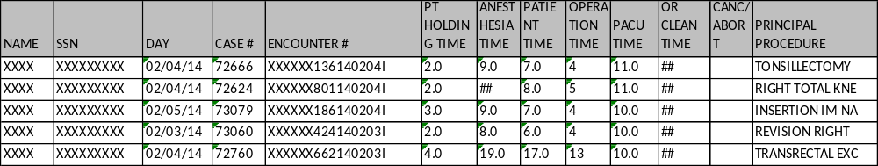

4.3.2.3.2 Surgery Extracts Unusual Volume Report

Surgery Extract Unusual Volume Report prints a listing of high hourly volume surgery cases. The report prints a listing of unusual volumes that would be generated by the Surgery Extract that is determined by a user-defined threshold value. This report shall have the capability to be run prior to running the Surgery extract. The unusual volumes to be provided in the report are defined by the Operation Time field, Patient Time field, or Anesthesia Time field, whichever fields have a value greater than the defined threshold hold value. The default threshold volume shall be 25. The default threshold volume of 25 equates to 6 hours. The report is sorted by descending Volume and Case Number.

The Surgery Extract Unusual Volume Report will now print records if a time segment is missing.

Example: Surgery Extracts Unusual Volume Report

This report prints a listing of unusual volumes that would be
generated by the Surgery extract (SUR) as determined by a
user-defined threshold value. It should be run prior to the
generation of the actual extract(s) to identify and fix, as
necessary, any volumes determined to be erroneous.

Unusual volumes are those where either the Operation Time,
Patient Time, Anesthesia Time, Recovery Room Time, OR Clean Time
or Pt Holding Time field is greater than the threshold value.

Note: The threshold can be set after a report is selected.

Run times for this report will vary depending upon the size of
the extract and could take as long as 30 minutes or more to
complete. This report has no effect on the actual extracts and
can be run as needed.

The report is sorted by descending Volume and Case Number.

Enter RETURN to continue or '^' to exit:

The default threshold volume for the Surgery extract is 25.
The default threshold volume (25) equates to 6 hours.
Would you like to change the threshold?? NO// YES

Volume > threshold

Enter the new threshold volume: (0-99): 5
Enter the date range for which you would like to scan the
Surgery Extract records.

Starting with Date: 03012014 (MAR 01, 2014)
Ending with Date: 03082014 (MAR 08, 2014)
This report requires 132-column format.
DEVICE: HOME// ;132;

Surgery Extract Unusual Volume Report Page: 1
Start Date: MAR 01, 2014 Report Run Date/Time: AUG 28, 2014
End Date: MAR 08, 2014 Threshold Value: 5

Case Encounter Pt Holding Anesthesia Patient Operation PACU OR Clean Canc/ Principal
Name SSN Day Number Number Time Time Time Time Time Time Abort Procedure
-----------------------------------------------------------------------------------------------------------------------------------

XXXX XXXXXXXX 03/05/14 73319 xxxxxxxxx140304I 1.0 ## 8.0 7 9.0 ## ILEOCECECTOMY W
XXXX XXXXXXXX 03/03/14 73064 xxxxxxxxx140303I 4.0 13.0 9.0 7 9.0 ## LEFT FEMORAL AN
XXXX XXXXXXXX 03/07/14 73353 xxxxxxxxx4064291 2.0 10.0 9.0 7 8.0 ## GASTROJEJUNOSTO
XXXX XXXXXXXX 03/03/14 73306 xxxxxxxxx140227I ## ## 9.0 7 8.0 ## PARTIAL LEFT CO

Example: Exported Surgery Unusual Volume Report

Package Extracts

Please refer to the current DSS Extracts v3.0 Data Definitions Guide and Extract File Formats Manual for more information about the record layout for the extracted fields.

The Package Extracts Option was modified so that users with the Security Key ECXMGR may rerun an extract without Information Resources Management (IRM) assistance. The user can reschedule an extract to run again when it has already been scheduled to run, rerun an extract that was previously run, or cancel an extract that is (already) currently running and set it up to run again. Use caution (and read the information being provided to you) when rerunning an extract as it would be possible to have multiples of the same extract running simultaneously.

Example: Prompt for Rerunning an Extract

Select Package Extracts Option: PRO Prosthetics Extract

Starting with Date: 02012013 (FEB 01, 2013)
Ending with Date: 02282013 (FEB 28, 2013)

The Prosthetics information has already been extracted through Feb 28, 2013.

Do you want to continue processing the PRO extract? NO// YES

Make sure you have checked that your selected dates are correct
before answering yes to the next question.

Are you SURE you want to run the PRO extract? N// YES

Requested Start Time: NOW// (JUN 12, 2013@12:02:16)

Request queued as Task #12804.

Choosing the Package Extracts option from the Extract Managers Menu will display the following menu and options.
NOTE: The DSS application will remove tildes (~) from extract record data prior to transmitting them in order to avoid sending extract record data that would be recognized as an end-of-record indicator to the AITC, except where the end-of-record is intended.

Example: Package Extracts Options on Extract Managers Menu

Select Extract Manager's Options Option: P Package Extracts
ADM Admissions Extract
BCM BCMA Extract
LBB Blood Bank Extract
CLI Clinic Visit Extract
ECS Event Capture Extract
IVP IV Extract
LAB Lab Extract
LAR Lab Results Extract
PRE Prescription Extract
ECQ QUASAR Extract
PRO Prosthetics Extract
RAD Radiology Extract
SUR Surgery Extract
MOV Transfer and Discharge Extract
TRT Treating Specialty Change Extract
UDP Unit Dose Extract
Fiscal Year Logic – DSS Testing Only

Select Package Extracts Option: Lab Extract

Extract Laboratory Information for DSS
Starting with Date: 7/1/14 (JUL 01, 2014)
Ending with Date: 7/31/14 (JUL 31, 2014)
Requested Start Time: NOW//<RET>(AUG 01, 2014@13:26:18)
Request queued as Task #300.

Admissions Extract (ADM)

Use this option to extract the patient admissions data for a selected date range. This data is stored in the ADMISSION EXTRACT file (#727.802) until it is transmitted to AITC.

The mail group for this extract is DSS-ADMS. The purpose of this mail group is to receive messages when extract is complete and when the data is transmitted to the AITC.

BCMA Extract (BCM)

Use this option to extract data for a selected date range. This data is stored in the BCMA EXTRACT file (#727.833) until it is transmitted to AITC.

The mail group for this extract is DSS-BCM. The purpose of this mail group is to receive messages when extract is complete and when the data is transmitted to the AITC.

Clinic Visit Extract (CLI)

Use this option to extract data for all scheduled clinic visits, add/edits and walk-ins for the selected date range, with the following exceptions.

Non-count clinics are excluded unless specifically assigned a DSS Action Code other than 6.
Canceled clinic appointments are excluded. Clinics with an ACTION TO SEND code of 6 in CLINICS AND STOP CODES file (#728.44) are excluded.

This data is stored in the CLINIC EXTRACT file (#727.827) until it is transmitted to AITC.

The mail group for this extract is DSS-SCX. The purpose of this mail group is to receive messages when extract is complete and when the data is transmitted to the AITC.

Event Capture Extract (ECS)

Use this option to extract the event capture data for a selected date range. This data is stored in the EVENT CAPTURE LOCAL EXTRACT file (#727.815) until it is transmitted to AITC.

The mail group for this extract is DSS-EC. The purpose of this mail group is to receive messages when extract is complete and when the data is transmitted to the AITC.

IV Extract (IVP)

Use this option to extract the pharmacy IV data for a selected date range. This data is stored in the IV DETAIL EXTRACT file (#727.819) until it is transmitted to AITC.

The mail group for this extract is DSS-IV. The purpose of this mail group is to receive messages when extract is complete and when the data is transmitted to the AITC.

Lab Extract (LAB)

Use this option to extract the laboratory data, including referrals and research tests, for a selected date range. This data is stored in the LABORATORY EXTRACT file (#727.813) until it is transmitted to AITC.

All inpatient, outpatient, and referral lab tests accessioned within the selected date range are extracted. Lab tests can be performed on a patient in the PATIENT file (#2) or a referral patient in the REFERRAL PATIENT file (#67). The identifying number is the SSN for in-house patients or a selected non-SSN ID constant for referrals and research.

The mail group for this extract is DSS-LAB. The purpose of this mail group is to receive messages when extract is complete and when the data is transmitted to the AITC.

Lab Results Extract (LAR)

Use this option to extract the laboratory results data for a selected date range. This data is stored in the LAB RESULTS EXTRACT file (#727.824) until it is transmitted to AITC.

The mail group for this extract is DSS-LAB. The purpose of this mail group is to receive messages when extract is complete and when the data is transmitted to the AITC.

Prescription Extract (PRE)

Use this option to extract the prescription (pharmacy outpatient) data for a selected date range. This data is stored in the PRESCRIPTION EXTRACT file (#727.81) until it is transmitted to AITC.

The mail group for this extract is DSS-PRES. The purpose of this mail group is to receive messages when extract is complete and when the data is transmitted to the AITC.

QUASAR Extract (ECQ)

Use this option to extract audiology and speech pathology clinic visit data for a selected date range. This data is stored in the QUASAR EXTRACT (#727.825) file until it is transmitted to AITC.

The mail group for this extract is DSS-QSR. The purpose of this mail group is to receive messages when extract is complete and when the data is transmitted to the AITC.

Prosthetics Extract (PRO)

Use this option to extract the prosthetics data for a selected date range. The data is stored in the PROSTHETICS EXTRACT file (#727.826) until it is transmitted to AITC.

The following information is required to extract a prosthetics record.
- Station Requesting Station
- Patient Name (in Prosthetics)
- SSN
- Receiving Station
- Name (in PATIENT file (#2))
- Type of Transaction
- Delivery Date
- Source
- HCPS

For prosthetics records that could not be extracted, you will receive a Prosthetics DSS Exception message indicating the record IEN in the record of pros appliance/repair file (#660) and the critical information that is missing.

The records identified in this message were not extracted and should be reviewed to determine if they must be corrected and the extract regenerated to assure proper DSS credit is received.
If you are extracting data for a division, you can only select a primary division (as defined for your entries in the PROSTHETICS SITE PARAMETERS file (#669.9) and the NEW PERSON file (#200)).

The mail group for this extract is DSS-PRO. The purpose of this mail group is to receive messages when extract is complete and when the data is transmitted to the AITC.

Radiology Extract (RAD)

Use this option to extract the radiology data for a selected date range. This data is stored in the RADIOLOGY EXTRACT file (#727.814) until it is transmitted to AITC.

The mail group for this extract is DSS-RAD. The purpose of this mail group is to receive messages when extract is complete and when the data is transmitted to the AITC.

Surgery Extract (SUR)

Use this option to extract the surgery data for a selected date range. This data is stored in the SURGERY EXTRACT file (#727.811) until it is transmitted to AITC. Secondary procedures and prostheses are also extracted.

The mail group for this extract is DSS-SURG. The purpose of this mail group is to receive messages when extract is complete and when the data is transmitted to the AITC.

Transfer and Discharge Extract (MOV)

Use this option to extract all patient movement (transfers and discharge) data for the selected date range. This data is stored in the PHYSICAL MOVEMENT EXTRACT file (#727.808) until it is transmitted to AITC.

The mail group for this extract is DSS-MOVS. The purpose of this mail group is to receive messages when extract is complete and when the data is transmitted to the AITC.

Treating Specialty Change Extract (TRT)

Use this option to extract treating specialty change data for a selected date range. This data is stored in the TREATING SPECIALTY CHANGE EXTRACT file (#727.817) until it is transmitted to AITC.

The mail group for this extract is DSS-TREAT. The purpose of this mail group is to receive messages when extract is complete and when the data is transmitted to the AITC.

Unit Dose Extract (UDP)

Use this option to extract all unit dose orders for the selected date range. Data is extracted from UNIT DOSE EXTRACT DATA file (#728.904) which is populated by the Inpatient Medications package when a pick list is filed. This data is stored in the UNIT DOSE LOCAL EXTRACT file (#727.809) until it is transmitted to AITC.

The mail group for this extract is DSS-UD. The purpose of this mail group is to receive messages when extract is complete and when the data is transmitted to the AITC.

Blood Bank Extract (LBB)

Use this option to extract blood bank data for a selected date range. This data is stored in the BLOOD BANK EXTRACT file (#727.829) until the data is transmitted to AITC. This extract enables DSS staff to see and manage the true economic costs of blood product use in Veterans Health Administration (VHA).

The mail group for this extract is DSS-LBB. The purpose of this mail group is to receive messages when extract is complete and when the data is transmitted to the AITC.

Fiscal Year Logic – DSS Testing Only

The Fiscal Year Logic - DSS Testing Only option allows selection of a fiscal year that may not have the DSS logic implemented for that year. If a future year (e.g. 2015) is entered and the user does not have the ECX DSS TEST security key, the software does not allow selection of a future fiscal year.

****************************************************************
* *
* Use this option with caution since it will allow you to *
* run any supported DSS extract using specific fiscal year *
* logic. By running this option you may negatively impact *
* your extract data. *
* *
* DO NOT USE this option unless you are an official test site *
* for the DSS Fiscal Year Conversion. *
*--------------------------------------------------------------*
* *
* Note that this option does not update the last date used for *
* the given extraction. It also does not verify that the time *
* frame selected is after the last date used for the extract. *
* *
****************************************************************

Enter RETURN to continue or '^' to exit:

Select DSS Extract to queue: ClINIC I (CLI)
Starting with Date: 3/1 (MAR 01, 2013)
Ending with Date: 3/31/2013// (MAR 31, 2013)

Select one of the following:

2012 Fiscal Year 2012
2013 Fiscal Year 2013
2014 Fiscal Year 2014
2015 Fiscal Year 2015

Select fiscal year logic to use for extract: 2015 Fiscal Year 2015

WARNING: Logic has not been released for this year. Do not use unless directed by DSO. Do you want to continue? YES//

SAS Extract Audit Reports

This section contains a brief description followed by a sample output for each SAS Extract Audit Reports option. To execute any of the SAS Extract Audit Reports options, enter the DSS Extract Log Record Number and a printer device. Please note that in an effort to streamline the documentation, only a portion of the output might be provided for some reports.

Please refer to the Current DSS Extracts Data Definitions Guide and Extract File Formats Manual for more information about the record layout for the extracted fields.

4.5.1 SAS Extracts Audit Reports Menu

Choosing the SAS Extracts Audit Reports option from the Extract Managers Menu will display the following menu and options.

Example: SAS Extract Audit Reports Menu on Extract Managers Menu

Select Extract Manager's Options Option: s SAS Extract Audit Reports

PRE SAS Prescription Audit Report
RAD SAS Radiology Audit Report
SUR SAS Surgery Audit Report

Select SAS Extract Audit Reports Option:

All of the SAS Extract Audit Reports options can be executed in the following manner:

Select SAS Extract Audit Reports Option: PRE SAS Prescription Audit Report

Prescription Extract SAS Report

Select DSS EXTRACT LOG RECORD NUMBER: 187 10-06-97 Prescription

Extract: Prescription #187

Start date: JAN 01, 1997
End date: JAN 31, 1997
# of Records: 6

DEVICE: HOME//
DEVICE: HOME// RIGHT MARGIN: 80// <RET>

Requested Start Time: NOW// <RET> (DEC 02, 1997@10:48:25)
Request queued as Task #188047.

4.5.2 SAS Prescription Audit Report

This option emulates the SAS routine at the AITC, which creates new records from the Prescription (pharmacy outpatient) Extract. You can use it to print a summary report for all records sorted by feeder location and feeder key.

Refer to Appendix A for information about feeder key transmission.

Example: SAS Audit Report for Prescription (PRE) Extract

SAS Audit Report for Prescription (PRE) Extract
DSS Extract Log #: 187
Date Range of Audit: JAN 01, 1997 to JAN 31, 1997
Report Run Date/Time: NOV 25, 1997@11:27
Division/Site: TEMPLE (1) Page: 1

Feeder Location Feeder Key Quantity
------------------------------------------------------------------------------

CMOPDSU1 10002000168035755 125
10070054162081019 18000
10140054629001162 5290

Example: Exported SAS Audit Report for Prescription (PRE) Extract

EXTRACT LOG # | DIVISION/SITE | FEEDER LOCATION | FEEDER KEY | QUANTITY
4733 | TEMPLE(1) | CMOPDSU1 | 10002000168035755 | 225
4733 | TEMPLE(1) | CMOPDSU1 | 10070054162081019 | 18000
4733 | TEMPLE(1) | CMOPDSU1 | 10140054629001162 | 5290

4.5.3 SAS Radiology Audit Report

This option emulates the SAS routine at the AITC, which creates new records from the radiology extract. You may use it to print a summary report for all records sorted by feeder location and feeder key. Note that bilateral modifiers will increase volumes.

Refer to Appendix A for information about feeder key transmission.

Example: SAS Audit Report for Radiology (RAD) Extract

SAS Audit Report for Radiology (RAD) Extract
DSS Extract Log #: 197
Date Range of Audit: JAN 01, 1990 to JAN 31, 1990
Report Run Date/Time: NOV 25, 1997@11:32
Division/Site: TOGUS, ME (402) Page: 1

Feeder Location Feeder Key Quantity
------------------------------------------------------------------------------

402-1 70100 1
402-1 70470 1
402-1 71020 5
402-1 73120 1
402-1 73620 3
402-1 73660 1
402-1 74000 1
402-1 75712 1
402-1 888888 2
402-1 999999 2
----------------------------------
Total for Feeder Location 402-GENERAL RADIOLOGY (402-1): 18

Grand Total for Division 402: 18

Example: SAS Audit Report for Radiology (RAD) Extract

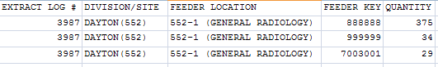

4.5.4 SAS Surgery Audit Report

This option emulates the SAS routine at the AITC, which creates new records from the surgery extract. You can use it to print a summary report for all records sorted by feeder location and feeder key.

Refer to Appendix A for information about feeder key transmission.

Example: SAS Audit Report for Surgery (SUR) Extract

SAS Audit Report for Surgery (SUR) Extract
DSS Extract Log #: 255
Date Range of Audit: MAY 01, 1997 to MAY 31, 1997
Report Run Date/Time: NOV 25, 1997@11:35
Division/Site: ALBANY (500) Page: 1

Feeder Location Feeder Key Quantity
------------------------------------------------------------------------------

500ORCN CARDIAC/NEURO OR 062-10 5
062-30 2

500ORCNA CARDIAC/NEURO OR - ANESTHESIA 062-23 7

500ORCNS CARDIAC/NEURO OR - SURGERY 062-40 3

Example: Exported SAS Audit Report for Surgery (SUR) Extract

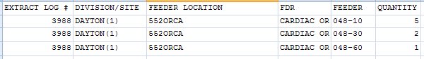

Extract Audit Reports

This section contains a brief description followed by a sample output for each Extract Audit Reports option. To execute any of the Extract Audit Reports options, enter the DSS Extract Log Record Number, starting and ending dates, divisions, locations, or accession areas (as appropriate), and a printer device. There is also a narrative portion of each report that prints only if the report is sent to a printer device. The format of the narrative is the same for all extract audit reports, but the content will vary for each report. Please note that in an effort to streamline the documentation, only a portion of the output might be provided for some reports.

Please refer to the current DSS Extracts Version 3.0 Data Definitions Guide for more information about the record layout for the extracted fields.

4.6.1 Extract Audit Reports Menu

Choosing the Extract Audit Reports option from the Extract Managers Menu will display the following menu and options.

Example: Extract Audit Reports Menu on Extract Managers Menu

Select Extract Manager's Options Option: E Extract Audit Reports Menu

ADM Admission (ADM) Extract Audit
ECQ QUASAR (ECQ) Extract Audit
ECS Event Capture (ECS) Extract Audit
LAB Laboratory (LAB) Extract Audit
LAR Laboratory Results (LAR) Extract Audit
LBB Laboratory Blood Bank (LBB) Audit Reports…
MOV Physical Movement (MOV) Extract Audit
PRO Prosthetics (PRO) Extract Audit
RAD Radiology (RAD) Extract Audit
SUR Surgery (SUR) Extract Audit
TRT Treating Specialty Change (TRT) Extract Audit

The following dialog for the Admission (ADM) Extract Audit Report is typical of all the audit reports and is provided as an example.

Example: Setup for ADM Extract Audit Report

Select DSS EXTRACT LOG RECORD NUMBER: 193 10-06-97 Admission

Extract: Admission #193

Start date: DEC 01, 1996
End date: DEC 31, 1996
# of Records: 3

You can narrow the date range, if you wish.

The Start Date can't be earlier than DEC 01, 1996,
or later than DEC 31, 1996.

Select Start Date: DEC 01, 1996// <RET> (DEC 01, 1996)

The End Date can't be earlier than DEC 01, 1996
(the Start Date you selected), or later than DEC 31, 1996.

Select End Date: DEC 31, 1996// <RET> (DEC 31, 1996)

Do you want the ADM extract audit report for all divisions? NO// Y YES

DEVICE: HOME// QUEUE TO PRINT ON
DEVICE: HOME// A700 RIGHT MARGIN: 133// <RET>

Requested Start Time: NOW// <RET> (NOV 25, 1997@13:40:18)
Request queued as Task #186962.

Example: Admission (ADM) Extract Audit Report

DSS Extract Log #: 193
Date Range of Audit: DEC 01, 1996 to DEC 31, 1996
Report Run Date/Time: NOV 25, 1997@13:34 Page 3

------------------------------------------------------------------------------

AUDIT DESCRIPTION:

Verify against: Gains and Losses Sheet/Bed Status Report
Menu Option: Gains and Losses (G&L) Sheet [DG G&L SHEET]

The Gains and Losses Sheet is the primary VistA report against which ADM
extract data should be verified. However, if starting the verification
process at the beginning of the fiscal year, the Bed Status Report can also
be used. Copies of these reports are readily available from patient
administration services at most medical centers.

The G&L Sheet shows admissions by ward for a specific day. To verify the
data on the extract audit report, the verifier must accumulate the data
given on the G&L Sheet either manually or through use of a spreadsheet
application. For example, if the Admission Extract Audit Report covers
the period July 1 to July 15, then accumulate the admission data from the
G&L Sheet for each day from July 1 through July 15. The accumulated data
for a given ward (e.g., total number of admissions for Ward A during the
period) should match the figure reported on the extract audit for the same
ward and date range.

If verification is done through the Bed Status Report, simply use the
"Cumulative Totals" table which displays fiscal year-to-date totals of
interward losses and discharges by ward group. The Admission (ADM) Extract
Audit also displays totals by ward group. Some arithmetic manipulation is
needed here in order to compare the figures on the two reports. For
example, to verify data for the month of July, the user must first develop
a "Cumulative Totals" table for the month of July. This is done by
subtracting the figures contained in the "Cumulative Totals" table of
June 30 from the figures contained in the "Cumulative Totals" table of
July 31. (Again, this can be accomplished manually, or with the aid of a
spreadsheet application.) The resulting month of July table can then be
compared directly to the ward group totals shown on the extract audit
report generated for the period July 1 to July 31.

4.6.2 Admission (ADM) Extract Audit

Use this option to print a summary report from the ADMISSION EXTRACT file (#727.802) that displays the number of patient admissions by ward and ward group.

Example: Admission Extract Audit Report

Admission (ADM) Extract Audit Report
DSS Extract Log #: 193
Date Range of Audit: DEC 01, 1996 to DEC 31, 1996
Report Run Date/Time: NOV 25, 1997@13:34
Medical Center Division: TROY (500B) Page: 1

Ward # of Admissions
------------------------------------------------------------------------------

SURGERY 0
----------
Ward group SURGERY TOTALS subtotal: 0

3 NORTH SURG 0
----------
Ward group NHCU TOTALS subtotal: 0

ICU/CCU 0
GEN MED 2
----------
Ward group MEDICINE TOTALS subtotal: 2

Division TROY Grand Total: 2

Example: Exported Admission Extract Audit Report

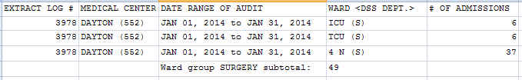

4.6.3 QUASAR (ECQ) Extract Audit

Use this option to print a report from the QUASAR EXTRACT file (#727.825) file. The report displays the number of procedures performed for patient visits to Audiology and Speech Pathology.

Example: QUASAR Extract Audit Report

QUASAR (ECQ) Extract Audit Report
DSS Extract Log #: 192
Date Range of Audit: MAY 01, 1997 to MAY 31, 1997
Report Run Date/Time: NOV 26, 1997@10:39
QUASAR Site: ALBANY (500) Page: 1
DSS Unit Procedure Volume
------------------------------------------------------------------------------
Audiology
92506 SPEECH & HEARING EVALUATION 1
92508 SPEECH/HEARING THERAPY 2
------------------------------------------------------
Total Volume for Audiology: 3
DSS Unit Procedure Volume
------------------------------------------------------------------------------
Speech Pathology
92520 LARYNGEAL FUNCTION STUDIES 1
92531 SPONTANEOUS NYSTAGMUS STUDY 1
------------------------------------------------------
Total Volume for Speech Pathology: 2
Grand Total for Site ALBANY (500): 5

Example: Exported QUASAR Extract Audit Report

EXTRACT LOG # | QUASAR SITE | DIVISION | DSS UNIT | PROCEDURE | PROCEDURE DESCRIPTION | VOLUME
4727 | CENTRAL TEXAS HCS (674) | AUSTIN (674BY) | Audiology | 69210 | REMOVE IMPACTED EAR WAX UNI | 50
4727 | CENTRAL TEXAS HCS (674) | AUSTIN (674BY) | Audiology | 92540 | BASIC VESTIBULAR EVALUATION | 2
 |  |  |  | Volume for Audiology |  | 1605
4727 | CENTRAL TEXAS HCS (674) | AUSTIN (674BY) | Speech Pathology | 92507 | SPEECH/HEARING THERAPY | 26
4727 | CENTRAL TEXAS HCS (674) | AUSTIN (674BY) | Speech Pathology | 92522 | EVALUATE SPEECH PRODUCTION | 2
4727 | CENTRAL TEXAS HCS (674) | AUSTIN (674BY) | Speech Pathology | V5363 | LANGUAGE SCREENING | 1
 |  |  |  | Volume for Speech Pathology |  | 38

4.6.4 Event Capture (ECS) Extract Audit

Use this option to print a summary report from the EVENT CAPTURE LOCAL EXTRACT file (#727.815) that displays the number of procedures performed within each DSS Unit.

Select Extract Audit Reports Menu Option: ECS Event Capture (ECS) Extract Audit

Setup for ECS Extract Audit Report --

Select DSS EXTRACT LOG RECORD NUMBER: 3846 04-24-13 Event Capture

Extract: Event Capture #3846

Start date: MAR 01, 2013
End date: MAR 31, 2013
# of Records: 25554

The extract which you have chosen to audit
was transmitted to Austin/DSS on MAY 07, 2013.

Do you want to continue with this audit report? NO// y YES

You can narrow the date range, if you wish.

The Start Date can't be earlier than MAR 01, 2013,
or later than MAR 31, 2013.

Select Start Date: MAR 01, 2013// <RET> (MAR 01, 2013)

The End Date can't be earlier than MAR 01, 2013
(the Start Date you selected), or later than MAR 31, 2013.

Select End Date: MAR 31, 2013// <RET> (MAR 31, 2013)

Do you want the ECS extract audit report for all Locations? NO// y YES

Do you want the output in exportable format? NO// y YES
NOTE: Appendix C contains instructions for exporting a report into an external spreadsheet.

Gathering data for export...

To ensure all data is captured during the export:

1. Select 'Logging...' from the File Menu. Select your file, and where to save.
2. On the Setup menu, select 'Display...',then 'screen' tab and modify 'columns'
setting to at least 225 characters.
3. The DEVICE input for the columns should also contain a large enough
parameter (e.g. 225). The DEVICE prompt is defaulted to 0;225;9999 for you.
You may change it if need be.
Example: DEVICE: 0;225;99999 *Where 0 is your screen, 225 is the margin width
and 99999 is the screen length.

NOTE: In order for all number fields, such as SSN and Feeder Key, to be
displayed correctly in the spreadsheet, these fields must be formatted as Text
when importing the data into the spreadsheet.

DEVICE: 0;225;99999//

Example: Exported ECS Extract Audit Report

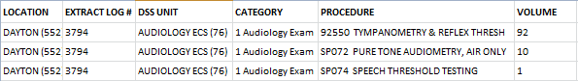

Example: ECS Extract Audit Report Screen Print

Event Capture (ECS) Extract Audit Report
DSS Extract Log #: 182
Date Range of Audit: JUN 01, 1997 to JUN 30, 1997
Report Run Date/Time: NOV 26, 1997@08:46
Event Capture Location: TROY (515.6) Page: 1

DSS Unit
Category Procedure Volume
------------------------------------------------------------------------------
DSS TEST UNIT (3)
DSS TEST ASSIGNMENT SW001N CASE MANAGEMENT, 15 MIN 250

-------------------------------------------------------------------------
Total Volume for Unit DSS TEST UNIT (3): 250

Grand Total for Location TROY (515.6): 250

Example: Exported ECS Extract Audit Report Screen Print

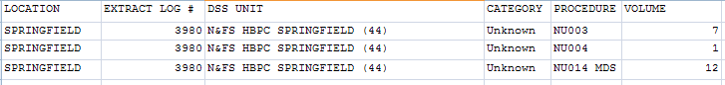

4.6.5 Laboratory (LAB) Extract Audit

Use this option to print a summary report from the LABORATORY EXTRACT file (#727.813) that displays the volume of tests performed within each laboratory accession area.

Example: Laboratory Extract Audit Report

Laboratory (LAB) Extract Audit Report
DSS Extract Log #: 273
Date Range of Audit: APR 01, 1996 to APR 30, 1996
Report Run Date/Time: NOV 26, 1997@09:04
DSS Site: ALBANY (500) Page: 1

Accession Area (Feeder Location) LMIP LOINC # of Tests # of Tests
Procedure Code Code (Patients) (Referrals)
--------------------------------------------------------------------------------

SURGICAL PATHOLOGY (SP)
SP Specimen 88000.0000 1234-5 1 0
-----------------------------------------------------------------------------
Total for SURGICAL PATHOLOGY: 1 0

Example: Exported Laboratory Extract Audit Report

EXTRACT LOG # | DSS SITE | ACCESSION AREA (FEEDER LOCATION) | PROCEDURE | LMIP CODE | # OF TESTS (PATIENTS) | # OF TESTS (REFERRALS)
4065 | DAYTON (552) | ANCILLARY (ANC) | Base Excess~DSS ACC | 81246.9999 | 1 | 0
4065 | DAYTON (552) | ANCILLARY (ANC) | Bicarbonate~DSS ACC | 81216.9999 | 1 | 0
4065 | DAYTON (552) | ANCILLARY (ANC) | Chloride~DSS ACC | 82435.9999 | 10 | 0
4065 | DAYTON (552) | ANCILLARY (ANC) | Creatinine~DSS ACC | 82565.9999 | 10 | 0
4065 | DAYTON (552) | ANCILLARY (ANC) | Glucose POC~DSS ACC | 82115.9999 | 1124 | 0

4.6.6 Laboratory Results (LAR) Extract Audit

DSS collects 75 unique LAR tests. The DSS LAR Test Number range from 0001 to 0076 (NOTE: 0012 is missing). Not in extract will display in the Total Count column if there has been no workload for a particular DSS LAR test.

Example: Laboratory Results Extract Audit Report (report abbreviated to save space)

Lab Results (LAR) Extract Audit Report
DSS Extract Log #: 4071
Date Range of Audit: AUG 01, 2011 to AUG 31, 2011
Report Run Date/Time: JUN 13, 2012@04:57
Division: CHEYENNE VAMC (442) Page: 1

Test Code DSS TEST NAME Month Year Total Count
0001 Hemoglobin AUG 2011 1842
0002 Potassium (Serum) AUG 2011 2232
0003 Sodium (Serum) AUG 2011 2174
0004 Lithium (Serum) AUG 2011 9
0005 BUN (Blood Urea Nitrogen) AUG 2011 2125
0006 WBC (Total WBC Count) AUG 2011 1751
0007 Digoxin AUG 2011 15
0008 Theophylline AUG 2011 5
0009 AST (Aspartate Transferase) AUG 2011 1494
0010 Glucose (Serum) AUG 2011 2214
0011 Creatinine Clearance AUG 2011 7
0013 GGTP (Gamma GT) AUG 2011 576
0014 Dilantin (Phenytoin) AUG 2011 23
0015 Valproic Acid AUG 2011 8
0016 Carbamazepine (Tegretol) AUG 2011 6

Example: Exported Laboratory Results Extract Audit Report (abbreviated to save space)

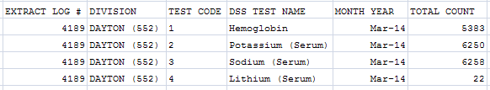

4.6.7 Laboratory Blood Bank (LBB) Audit Reports

There are two reports to choose from under the LBB Audit Reports. The LBB Comparative Report can be run after the extract has run. The LBB Pre-Extract Audit Report, however, can only be run prior to the extract which causes some sites to bypass this audit. If a discrepancy exists, sites can correct the data and run the extract again prior to transmitting the data to AITC.

Example: LBB Audit Reports

Select Extract Audit Reports Menu Option: Laboratory Blood Bank (LBB) Audit Reports

1 Laboratory Blood Bank (LBB) Comparative Report
2 Laboratory Blood Bank (LBB) Pre-Extract Audit

4.6.7.1 Laboratory Blood Bank (LBB) Comparative Report

Select Laboratory Blood Bank (LBB) Audit Reports Option: Laboratory Blood Bank (LBB) Comparative Report

Setup for LBB Extract Audit Comparative Report…

Select DSS EXTRACT LOG RECORD NUMBER: 2587 06-15-09 Blood Bank
Extract: Blood Bank #2587

Start date: MAR 01, 2009
End date: MAR 31, 2009
# of Records: 139

You can narrow the date range, if you wish.

The Start Date can't be earlier than MAR 01, 2009,
or later than MAR 31, 2009.

Select Start Date: MAR 01, 2009// (MAR 01, 2009)

The End Date can't be earlier than MAR 01, 2009
(the Start Date you selected), or later than MAR 31, 2009.

Select End Date: MAR 31, 2009// (MAR 31, 2009)
Do you want the LBB extract comparative report to sort by COMP? NO// YES

This report requires a print width of 132 characters.
DEVICE: HOME//

Example: LBB Extract Comparative Audit Report

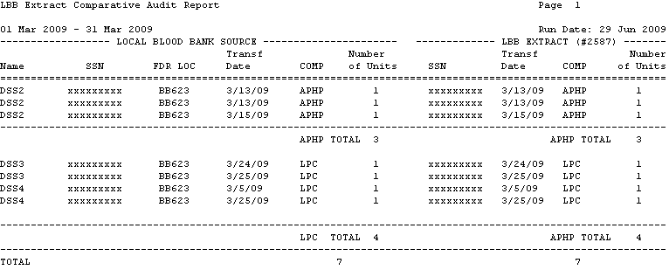

4.6.7.2 Laboratory Blood Bank (LBB) Pre-Extract Audit

This report provides DSS on-site support staff with a list of unmatched blood products. The report will contain those records that do not have a value in either the DSS Product Dept or DSS IP # fields. The resulting report will enable the DSS on-site support team to correct the unmatched blood products prior to running the LBB Extract.

Example: LBB Pre-Extract Audit Report

Select Extract Audit Reports Menu Option: LBB Laboratory Blood Bank (LBB) Audit Reports

Laboratory Blood Bank (LBB) Comparative Report
Laboratory Blood Bank (LBB) Pre-Extract Audit

Select Laboratory Blood Bank (LBB) Audit Reports Option: 2 Laboratory Blood Bank (LBB) Pre-Extract Audit

LBB Pre-Extract Audit Report Information for DSS

**NOTE: This audit can only be run prior to the LBB Extract being generated.
If you have already generated your LBB Extract, refer to the Processing
Guide Chapter 4 section on Regenerating.**

Starting with Date: 2/1/2012 (FEB 01, 2012)
Ending with Date: 2/29/2012 (FEB 29, 2012)

Previously, you have selected queuing.
Do you STILL want your output QUEUED? Yes// N (No)
DEVICE: HOME// Right Margin: 80//

Retrieving records...

LBB Extract Audit Report Page 1
01 Feb 2012 - 29 Feb 2012 Run Date: 07 Jan 2012
Transf Number
Name SSN FDR LOC Date COMP of Units
==============================================================================
DSSA 000054102 BB523A4 2/6/12 LRB3 1
DSSA 000054102 BB523A4 2/6/12 LRB3 1
DSSB 000224430 BB523A4 2/21/12 LRB3 1
DSSC 000403825 BB523A4 2/16/12 LRB3 1
DSSC 000403825 BB523A4 2/13/12 LPAX 1
DSSC 000403825 BB523A4 2/12/12 LPAX 1
DSSC 000403825 BB523A4 2/12/12 CR-P 10

Example: Exported LBB Pre-Extract Audit Report

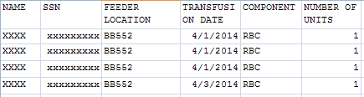

4.6.8 Physical Movement (MOV) Extract Audit

Use this option to print a summary report from the PHYSICAL MOVEMENT EXTRACT file (#727.808). The report displays the total count of each MAS movement type (transfers and discharges) by ward and ward group.

Example: Movement Extract Audit Report

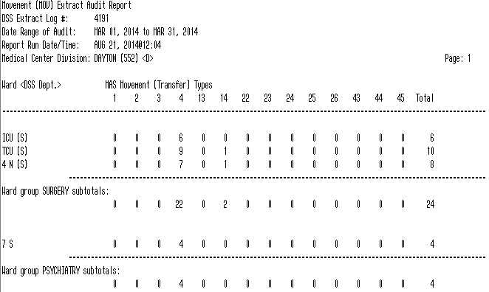

Example: Exported Movement Extract Audit Report

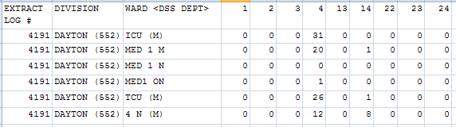

4.6.9 Prosthetics (PRO) Extract Audit

Use this option to print the PSAS HCPCS Cost Report from the PROSTHETICS EXTRACT file (#727.826). Sites that are multidivisional prosthetics sites may choose to generate a specific report for one division or a combined report for all divisions.

The report is divided into two parts and includes the following:

Summary | Detail
NPPD group summary.  Data is reported in two sections: New and Repair | Individual patient detail within an NPPD Line Item.
VA, Commercial, and Total quantities.  Total Cost and Average Commercial Cost. | HCPCS code and description.  Delivery Date, Quantity, and Cost.  Type (i.e., VA or Commercial, Initial or Repair).  Station Number is also displayed for multidivisional Prosthetics sites.
Within each NPPD Group, the summary data for each NPPD Line Item is displayed, followed by the group totals. Summary totals are also provided for New and Repair sections. | Sort order is by Delivery Date.

Example: Exported Summary Report for PRO Extract Audit

Select Extract Audit Reports Menu Option: PRO Prosthetics (PRO)Extract Audit

Setup for PRO Extract Audit Report --

Select DSS EXTRACT LOG RECORD NUMBER: 3897 05-22-13 Prosthetics

Extract: Prosthetics #3897

Start date: FEB 01, 2013
End date: FEB 28, 2013
# of Records: 5748
Station: DAYTON

The extract which you have chosen to audit
was transmitted to Austin/DSS on MAY 22, 2013.

Do you want to continue with this audit report? NO// y YES

You can narrow the date range, if you wish.

The Start Date can't be earlier than FEB 01, 2013,
or later than FEB 28, 2013.

Select Start Date: FEB 01, 2013// (FEB 01, 2013)

The End Date can't be earlier than FEB 01, 2013
(the Start Date you selected), or later than FEB 28, 2013.

Select End Date: FEB 28, 2013// (FEB 28, 2013)

Select one of the following:

D DETAIL
S SUMMARY

Type of Report: SUMMARY// s SUMMARY

Do you want the output in exportable format? NO// YES

NOTE: Appendix C contains instructions for exporting a report into an external spreadsheet.

Gathering data for export...

To ensure all data is captured during the export:

1. Select 'Logging...' from the File Menu. Select your file, and where to save.
2. On the Setup menu, select 'Display...',then 'screen' tab and modify 'columns'
setting to at least 225 characters.
3. The DEVICE input for the columns should also contain a large enough
parameter (e.g. 225). The DEVICE prompt is defaulted to 0;225;9999 for you.
You may change it if need be.
Example: DEVICE: 0;225;99999 *Where 0 is your screen, 225 is the margin width
and 99999 is the screen length.

NOTE: In order for all number fields, such as SSN and Feeder Key, to be
displayed correctly in the spreadsheet, these fields must be formatted as Text
when importing the data into the spreadsheet.

DEVICE: 0;225;99999//

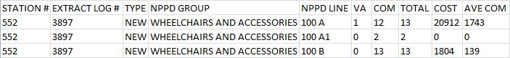

Example: Summary Report Screen Print for PRO Extract Audit

Prosthetics (PRO) Extract Audit Report Page 1
DSS Extract Log #: 3897
Date Range of Audit: FEB 01, 2013 to FEB 28, 2013
Station (#): 552 (DAYTON)
Report Run Date/Time: AUG 19, 2013@16:25

REPORT OF NEW PROSTHETICS ACTIVITIES
Line Item VA Com Total Cost ($) Ave Com ($)
-------------------------------------------------------------------------------

WHEELCHAIRS AND ACCESSORIES
100 A 1 12 13 20912 1743
100 A1 0 2 2 0 0
100 B 0 13 13 1804 139

Example: Exported Detail Report for PRO Extract Audit

Select Extract Audit Reports Menu Option: Prosthetics (PRO) Extract Audit

Setup for ECS Extract Audit Report --

Select DSS EXTRACT LOG RECORD NUMBER: 3969 06-20-13 Prosthetics

Extract: Event Capture #3969

Start date: FEB 01, 2013
End date: FEB 28, 2013
# of Records: 17419

The extract which you have chosen to audit
was transmitted to Austin/DSS on JUN 20, 2013.

Do you want to continue with this audit report? NO// YES

You can narrow the date range, if you wish.

The Start Date can't be earlier than FEB 01, 2013,
or later than FEB 28, 2013.

Select Start Date: FEB 01, 2013// (FEB 01, 2013)

The End Date can't be earlier than FEB 01, 2013
(the Start Date you selected), or later than FEB 28, 2013.

Select End Date: FEB 28, 2013//02102013 (FEB 10, 2013)

Do you want the ECS extract audit report for all Locations? NO// YES

Select one of the following:
D DETAIL
S SUMMARY
Type of Report: SUMMARY// DETAIL

1. WHEELCHAIRS AND ACCESSORIES
2. ARTIFICAL LEGS
3. ARTIFICAL ARMS AND TERMINAL DEVICES
4. BRACES AND ORTHOTICS
5. SHOES/ORTHOTICS
6. NEUROSENSORY AIDS
7. RESTORATIONS
8. OXYGEN AND RESPIRATIORY
9. MEDICAL EQUIPMENT, MISC., ALL OTHER NEW
10. REPAIR

Select NPPD Group : (1-10): 1

1. 100 A MOTORIZED
2. 100 A1 SCOOTERS
3. 100 B MANUAL CUSTOM
4. 100 C MANUAL A/O
5. 100 D ACCESSORIES
6. 100 E CUSHION FOAM
7. 100 F CUSHION SPEC
8. 100 G CARRIERS
9. 100 H NSC VAN MODS
10. 100 I SCOOTER ACCESSORIES

Select NPPD Line : (1-10): 1

Do you want the output in exportable format? NO// Y

NOTE: Appendix C contains instructions for exporting a report into an external spreadsheet.

Gathering data for export...

To ensure all data is captured during the export:

1. Select 'Logging...' from the File Menu. Select your file, and where to save.
2. On the Setup menu, select 'Display...',then 'screen' tab and modify 'columns'
setting to at least 225 characters.
3. The DEVICE input for the columns should also contain a large enough
parameter (e.g. 225). The DEVICE prompt is defaulted to 0;225;9999 for you.
You may change it if need be.
Example: DEVICE: 0;225;99999 *Where 0 is your screen, 225 is the margin width
and 99999 is the screen length.

NOTE: In order for all number fields, such as SSN and Feeder Key, to be
displayed correctly in the spreadsheet, these fields must be formatted as Text
when importing the data into the spreadsheet.

DEVICE: 0;225;99999//
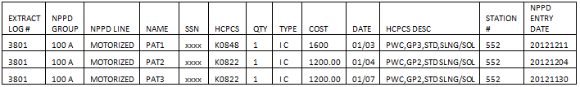

Example: Detail Report Screen Print for PRO Extract Audit

Prosthetics (PRO) Extract Audit Report Detail Page 1
DSS Extract Log #: 3969
Date Range of Audit: FEB 01, 2013 to FEB 28, 2013
Station: 552 (DAYTON)
Report Run Date/Time: AUG 23, 2013@14:40
--------------------------------------------------------------------------------
100 A -- MOTORIZED NPPD
NAME SSN HCPCS QTY TYP COST DATE HCPCS DESC STN# ENTRY DT
--------------------------------------------------------------------------------

PAT5 XXXX K0848 1 I C 1600 02/01 PWC,GP3,STD,SLNG/SOL 552 20130108
PAT6 XXXX K0856 1 I C 4057 02/01 PWC,GP3,STD,SNGL PWR 552 20130117
PAT7 XXXX K0856 1 I C 2038.1502/05 PWC,GP3,STD,SNGL PWR 552 20130114

4.6.10 Radiology (RAD) Extract Audit

Use this option to print a summary report from the RADIOLOGY EXTRACT file (#727.814) which displays the total count of each radiological procedure within a Feeder Location.

Example: Radiology Extract Audit Report

Radiology (RAD) Extract Audit Report
DSS Extract Log #: 195
Date Range of Audit: JAN 01, 1990 to JAN 31, 1990
Report Run Date/Time: NOV 26, 1997@10:47
Radiology Division: TOGUS, ME (402) Page: 1

Imaging Type (Feeder Location) # of Procedures
CPT Code Procedure Inpt. Outpt.
------------------------------------------------------------------------------

GENERAL RADIOLOGY (402-1)
70470 CT HEAD W&WO CONT 1 0
71020 CHEST 2 VIEWS PA&LAT 1 2
73120 HAND 1 OR 2 VIEWS 0 1
--------------------------------------------------------------------------
Sub-totals for GENERAL RADIOLOGY (402-1): 4 3

Grand Total for Division TOGUS, ME (402): 4 3

Example: Exported Radiology Extract Audit Report

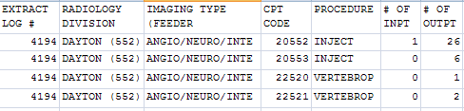

4.6.11 Surgery (SUR) Extract Audit

Use this option to print a summary report from the SURGERY EXTRACT file (#727.811). The report displays the number of surgical procedures and surgical cases performed in O.R. and Non-O.R. locations.

Example: Surgery Extract Audit Report

Surgery (SUR) Extract Audit Report
DSS Extract Log #: 255
Date Range of Audit: MAY 01, 1997 to MAY 31, 1997
Report Run Date/Time: NOV 26, 1997@10:50
Surgery Division: ALBANY (500) Page: 1

O.R. Surgical Procedures
CPT Code Procedure # of Procedures
------------------------------------------------------------------------------

11041 DEBRIDE SKIN FULL 1
00100 ANESTH, SKIN SURGERY 1
00103 ANESTH, BLEPHAROPLASTY 1
-----------------------------------------------------------------

For Division ALBANY (500)--
Total O.R. Surgical Procedures: 3
Total O.R. Surgical Cases: 1
-----------------------------------------------------------------

For Division ALBANY (500)--
Total Non-O.R. Surgical Procedures: 0
Total Non-O.R. Surgical Cases: 0

Example: Exported Surgery Extract Audit Report

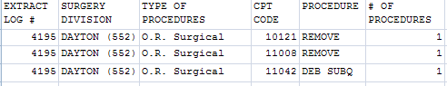

4.6.12 Treating Specialty Change (TRT) Extract Audit

Use this option to print a summary report from the TREATING SPECIALTY CHANGE EXTRACT file (#727.817) which displays the total number of losses within each treating specialty of a medical center service.

Example: Treating Specialty Change Extract Audit Report

Treating Specialty Change (TRT) Extract Audit Report
DSS Extract Log #: 247
Date Range of Audit: NOV 01, 1996 to NOV 30, 1996
Report Run Date/Time: NOV 26, 1997@11:09
DSS Site: ALBANY (500) Page: 1

Service Facility Treating Specialty # of Losses
Specialty (DSS Code)
------------------------------------------------------------------------------

DOMICILIARY DOMICILIARY PTSD
DOMICILIARY PTSD (88) 0
DOMICILLARY
DOMICILIARY (85) 0
------------------------------------------------------
Total for DOMICILIARY: 0

INTERMEDIATE MED GEM INTERMEDIATE
GEM INTERMEDIATE CARE (32) 0
INTERMEDIATE MED
INTERMEDIATE MEDICINE (40) 0
------------------------------------------------------
Total for INTERMEDIATE MED: 0

Example: Exported Treating Specialty Change Extract Audit Report

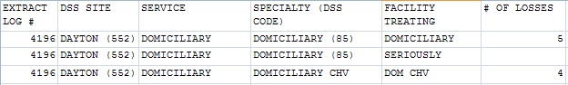

Transmission Management

This section initiates and controls the transmission of data from the extract files to AITC. This menu provides users with the functionality to purge the IVP, UDP, or VBECS holding files. It also provides users with the functionality to delete an individual or range of DSS extract files.

Choosing the Transmission Management option from the Extract Managers Menu will display the following menu and options.

Example: Transmission Management Options on Extract Managers Menu

Select Extract Manager's Options Option: T Transmission Management

Review a Particular Extract for Transmission
Transmit Data from Extract Files
Summary Report of Extract Logs
Delete Extract Files
Purge Extract Holding Files
Recreate Extract Holding Files ...

Review a Particular Extract for Transmission

Use this option to review a particular extract to verify the transmission of messages to the AITC. The only prompts are for the extract log record number and a print device. The output includes the following information:

- Extract log record number
- Extract name
- Run date
- Division
- Transmission message numbers
- Whether or not the extract was purged
- Message status

Example: Extract for Transmission

Select DSS EXTRACT LOG RECORD NUMBER: 465 08-13-98 Admission ALBANY

ADM Extract (#465) Records: 2
Generated: AUG 13, 1998 Start date: APR 01, 1998
Division: ALBANY End date: APR 30, 1998
DEVICE: HOME//

Status Report for DSS Extract #465 (Admission)
------------------------------------------------------------------------------

ADM Extract (#465) Records: 2
Generated: AUG 13, 1998 Start date: APR 01, 1998
Division: ALBANY End date: APR 30, 1998
Purged: (Not purged)
Transmitted: AUG 17, 1998
Unconfirmed transmission message numbers --

202 208 209
200100 200101 200102
200103 200104 200105
200106 200107 200108
200109 200110 200111
200112 200113 200114
200115 200116 200117
200118 200119 200120
200121 200122 200123
200124 200125 200126
200127 200128 200129
200130 200131 200132
200133 200134 200135

Transmit Data from Extract Files

To receive mail messages confirming transmission of extract data, you must be enrolled in the DSS mail group associated with the extract being transmitted.

Use this option to transmit a series of mail messages containing data from an individual extract to the AITC. Members of the associated mail group(s) will receive confirmation messages indicating that an extract was completed, transmitted, and received in Austin. You can only transmit extracts for your division.

Example: Transmit Data from Extract Files
Select Transmission Management Option: T Transmit Data from Extract Files

Your user setup will only allow you to transmit extracts from the following divisions:
SITE LOCATION NAME

If you can't select an extract, it is probably from another division.
Transmit which extract: 2604 08-09-06 Admission
ADM Extract (#2604) Records: 117
Generated on: AUG 09, 2006 Start date: MAR 01, 2006
Division: DIVISION NAMR End date: MAR 31, 2006

The data was extracted using fiscal year 2006 logic.
MailMan transmission of the Admission extract is set to a
Limit of 131,000 bytes per message. Each extract record ends with a ^~.

** This extract is being sent from a field office domain. **
** Extract message(s) will only be delivered to you and **
** will be placed into your 'DSSXMIT' mail basket. **
Requested Start Time: NOW// (OCT 24, 2006@15:09:49)
Request queued as Task #33798.

Example: Sample Mail Message - Completed Extracted Data

Subj: ADMS 444 - ADM DSS EXTRACT MESSAGE 1 OF 2 [#7058653] 14 Sep 99 19:03 8 lines
From: DSS SYSTEM In 'IN' basket. Page 1
---------------------------------------------------------------------------
The DSS-Admission extract (#759) for Jul 01, 1999
through Jul 31, 1999 was begun on Sep 14, 1999 at 19:02
and completed on Sep 14, 1999 at 19:03.

A total of 489 records were written.

Extract time was [HH:MM:SS] 0:00:48

Enter message action (in IN basket): IGNORE//

Sample Mail Message - Transmission of Extracted Data

Subj: QSR 444 - QSR DSS EXTRACT MESSAGE 1 OF 2 [#7058779] 05 Oct 99 03:16 10 lines
From: DSS SYSTEM In 'IN' basket. Page 1
--------------------------------------------------------------------------
The DSS QUASAR (ECQ) extract, #786,
was transmitted on Oct 05, 1999 at 03:15.

Maximum number of lines (records) per message: 200

A total of 861 records were written.
A total of 5 messages were sent.
Message numbers :
7058774 7058775 7058776 7058777
7058778

Enter message action (in IN basket): IGNORE//

Sample Mail Message - Confirmation of Extracted Data

Subj: DRS1928 DMS Confirmation [#415417] 03 Dec 97 20:10 CST 2 Lines
From: <XXXXXXXX@XXXXXXXX.VA.GOV> in 'IN' basket. Page 1
------------------------------------------------------------------------
Ref: Your DMS message #841928 with Austin ID #80378631,is assigned confirmation number 942512003079972.

Enter message action (in IN basket): IGNORE//

Summary Report of Extract Logs

Use this option to print a summary report from the EXTRACT LOG file (#727). The only prompts are for starting and ending dates and a print device. The output includes the following information:

- Extract number
- VistA Package
- Data set dates (date range)
- Record count
- Date transmitted
- Date purged
- Date Extracted
- Data Month
- Msg Unconf (Message Number)
- Requestor

The report prints properly to a 132-column output

Example: Summary Report Extract Logs

Select Transmission Management Option: s Summary Report of Extract Logs
Enter Report Start Date: 030106 (MAR 01, 2006)
Enter Report Ending Date: (3/1/2006 - 10/26/2006): 060106 (JUN 01, 2006)

** REPORT REQUIRES 132 COLUMNS TO PRINT CORRECTLY **

DEVICE: HOME// ;132;

DSS EXTRACT LOG STATISTICS Page: 1

EXTRACT NUMBER VISTA PACKAGE DATA SET DATES RECORD COUNT DATE DATE PURGED
DATE EXTRACTED DATA MONTH MSG UNCONF REQUESTOR TRANSMITTED
-------------------------------------------------------------------------------------
2179 Admission 060301-060331 0
Jul 26, 2006 Mar 2006 0 USER,ONE
2186 Prescription 060601-060630 0
Jul 27, 2006 Jun 2006 0 USER,TWO
2185 Unit Dose 060601-060630 0
Jul 27, 2006 Jun 2006 0 USER,TWO

Example: Exported Summary Report Extract Logs

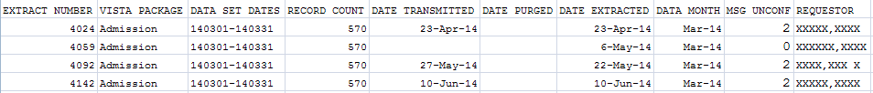

Delete Extract Files
This option can be used to delete individual extracts residing in files (#727.802) through (#727.833) or a range of extracts. Also, holders of the ECXMGR Security Key may only delete extracts that are associated with a division assigned in the NEW PERSON file (#200).

Any existing extract may be deleted (including transmitted and untransmitted) and extracts that did not run to completion due to errors or system problems.

Choosing a range of extracts could mean an excessively large number of records to be deleted and it may be very resource intensive. Please be sure to queue this for non-peak hours and limit the number of extracts to be deleted in a single queued session.

Example: Delete Extract File Option

This option will allow you to delete an
individual or a range of DSS extracts files.

Care must be taken for several reasons:

- You can delete ANY existing extract. This includes transmitted and non-
transmitted extracts as well as extracts that did not run to completion
due to errors or system problems.
- Choosing a range of extracts could mean an excessively large number
of records and be very CPU intensive.
Please be sure to queue this deletion for off-hours and
limit the number of extracts to be deleted per a single queued session.

Delete Extract Files?? NO// y YES

...one moment please

Do you want to print a list of extracts that can be deleted? NO//
You will not be able to select an extract that is not from your division.

Select extracts to be deleted: (3794-4071): 3794

I will delete the following extract(s):
#3794 - Event Capture 01/01/2013 to 01/31/2013

Is this OK? NO// YES

Purge Extract Holding Files

Use this option to purge the data that resides in the holding files for the IVP, UDP, or VBECS extracts. A prompt will appear for the start and end dates. Dates can be entered as 10 15 08, 10/15/08, or 10/15/2008.

The IV EXTRACT DATA file (#728.113) and UNIT DOSE EXTRACT DATA file (#728.904) can become quite large if appropriate purging is not performed. This option will purge the data from these files by date range. It is recommended that records over two fiscal years old be purged from IV EXTRACT DATA file (#728.113) and UNIT DOSE EXTRACT DATA file (#728.904).

VBECS holding files can also be purged. Once purged, these files cannot be recreated for that time period.

Purging of any local VistA extract data or VistA source of extract data (i.e., lab data, etc.) is not recommended until your facility has successfully created extracts, transmitted them to the AITC, audited the counts, loaded the data into DSS, and is content with the results.

When the Purge ends, a confirmation message will be created on MailMan.

Example: Purge Holding Files

Select Transmission Management Option: Purge Extract Holding Files

This option will allow you to purge:
1. data that resides in the "holding files" for the IVP and UDP extracts.
2. data that resides in the "holding file" for the VBECS extract

Care must be taken for several reasons:
- The IVP, UDP and VBECS "holding" files are intermediate files that
are populated "realtime" by inpatient pharmacy and VBECS activity.
These files are then used to generate the IVP, UDP and VBECS extracts.
NOTE: The VBECS files CANNOT be regenerated.
Once it is purged for a date range, extracts can no longer be
generated for that time period.

Purge (I)VP data, (U)DP data or (V)BECS data? IVP Holding File

This file currently holds IVP data from <Oct 13, 1999> to <Apr 01, 2013>.

Beginning date for purge: 1/1/13 (JAN 01, 2013)
Ending date for purge: 1/31/13 (JAN 31, 2013)

I will purge the IVP holding file from <Jan 01, 2013> to <Jan 31, 2013>.

Is this OK? NO// y YES

Example: Confirmation Message

Select Transmission Management Option: MailMan Menu

VA MailMan 8.0 service for XXXXXXX@XXXXX.PRE-PROD.VISTA.MED.VA.GOV
You last used MailMan: 10/28/08@11:57
You have 1 new message.

NML New Messages and Responses
RML Read/Manage Messages
SML Send a Message
Query/Search for Messages
AML Become a Surrogate (SHARED,MAIL or Other)
Personal Preferences ...
Other MailMan Functions ...
Help (User/Group Info., etc.) ...
Super Search Message File

You have 1 new message. (Last arrival: 10/28/08@15:01)
Select MailMan Menu Option: n New Messages and Responses

Subj: DSS - Purge of IVP Holding File [#560578] 10/28/08@15:01 3 lines
From: DSS SYSTEM In 'IN' basket. Page 1 *New*
------------------------------------------------------------------------------
The information has been successfully PURGED
from Feb 01, 2007 to Feb 02, 2007

Enter message action (in IN basket): Ignore// <RET>

Select Transmission Management Option: ?

Recreate Extract Holding Files

Use this option to recreate an IVP or UDP Extract holding file which has been purged at the AITC. You will be prompted for the start and end dates. A background task will be launched. When that task ends, it will create a confirmation message on MailMan.

It is unusual to purge and recreate these files. They normally are NOT purged.

The Recreate applies to the entire parent station.

To recreate an IVP or UDP extract,
- Run the Purge for the desired date range.
  - Dates can be entered as 10 15 08 or 10/15/08 or 10/15/2008.
- Check MailMan for a confirmation message that the Purge has completed successfully.
- Run the Recreate for the same date range.
  - If you did not run the Purge and data exists for the requested time period, you will be prompted to do so.
- Check MailMan for a confirmation message that the Recreate has completed successfully.
- Run the IVP or UDP Extract.
- Compare the record count from the recreated extract to the record count of the original extract. The counts should be close but may be slightly different due to timing issues.

Example: Example of Recreate

Select Transmission Management Option: Q Recreate Extract Holding Files

Select File to Recreate: ?

I Recreate IVP Extract Holding File (#728.113)
U Recreate UDP Extract Holding File (#728.904)

Select Recreate Extract Holding Files Option: I Recreate IVP Extract Holding File (#728.113)
Enter Start Date: 2 1 07
Enter Stop Date: 2 1 07
Requested Start Time: NOW//<RET> (SEP 09, 2008@13:31:43)
Request queued as Task #155353.
Requested Start Time: NOW//<RET> (OCT 28, 2008@15:04:37)
Request queued as Task #2607.

When the Recreate is complete, a MailMan message will be sent to you. To view the message, type “MailMan Menu” at the prompt. You will see the following lines.

Example of Confirmation Message for Recreate

Select Transmission Management Option: MailMan Menu

VA MailMan 8.0 service for XXXXX.XXXXX@XXXXX.XXXXXX.VISTA.MED.VA.GOV
You last used MailMan: 10/28/08@11:57
You have 1 new message.

NML New Messages and Responses
RML Read/Manage Messages
SML Send a Message
Query/Search for Messages
AML Become a Surrogate (SHARED,MAIL or Other)
Personal Preferences ...
Other MailMan Functions ...
Help (User/Group Info., etc.) ...
Super Search Message File

You have 1 new message. (Last arrival: 10/28/08@15:01)
Select MailMan Menu Option: n New Messages and Responses

Subj: IV INTERMEDIATE DATA FOR DSS [#560579] 10/28/08@15:05 5 lines
From: DSS SYSTEM In 'IN' basket. Page 1 *New*
-------------------------------------------------------------------------------
The IV information has been successfully regenerated
from Feb 01, 2007 to Feb 01, 2007@99:99

A total of 151 records were written.

Enter message action (in IN basket): Ignore// <RET>

Select Transmission Management Option: ?

Glossary
Term | Definition
Action to Send Code | Indicates which code should be sent to the DSS commercial software (e.g., stop code, credit stop code, or both).
ADPAC | Acronym for Automated Data Processing Application Coordinator
ADM | Abbreviation for Admission Extract
AITC | Acronym for Austin Information Technology Center
BCM | Abbreviation for BCMA Extract
BCMA | Acronym for Bar Code Medication Administration
CBOC | Acronym for community Based Outpatient Clinic
CLI | Abbreviation for Clinic Extract
CPT | Acronym for Common Procedure Terminology
Credit Stop Code | The credit stop code (from the HOSPITAL LOCATION file [#44]) as determined by Medical Administration Service (MAS).
CSHD | Acronym for Customer Support Help Desk
DSO | Acronym for Decision Support Office
DSS | Acronym for Decision Support System
DSS Credit Stop Code | The credit stop code as determined by DSS.
DSS Department Code | A code associated with products or services, which assists in the categorization and costing of those products. At this time, only medical center wards are being associated with a DSS Department code in the DSS WARD file (#727.4). The DSS Department code consists of a minimum of 4 characters as:  ABBCxxx  A = DSS CODE in NATIONAL SERVICE file (#730)  BB = DSS PRODUCTION UNIT CODE in DSS PRODUCTION UNIT file (#729)  C = DSS DIVISION IDENTIFIER in DSS DIVISION IDENTIFIER file (#727.3)  xxx = A suffix of not more than three characters which must be numeric digits or uppercase alpha characters. The first character of the string may be "-", but that is not recommended.
DSS Division Identifier | A single character code, either numeric (but not zero) or an uppercase alpha character. The character used in VistA file #727.3 (DSS DIVISION IDENTIFIER) as division identifier should exactly match the identifier associated with a medical center division in DSS/Austin.
DSS Production Unit | A two character code which may contain both numeric and uppercase alpha characters. These DSS-compatible codes are based on the FMS sub-cost center scheme to categorize production unit output. The DSS PRODUCTION UNIT file (#729) holds the production unit codes approved for use by DSS.
DSS Stop Code | The stop code as determined by DSS.
ECS | Abbreviation for Event Capture Extract
ECQ | Abbreviation for QUASAR Extract
Extract | Management tool used to track and account for procedures and delivered services, which are not handled in any existing VistA package.
Extract Files | The files that hold the data that has been extracted via the DSS Extract software.
Feeder Key | The product for workload extracted.
Feeder Location | The site location of data extracted.
IVP | Abbreviation for IV Detail Extract
LAB | Abbreviation for Laboratory Extract
LAR | Abbreviation for Lab Results Extract
LBB | Abbreviation for Blood Bank Extract
MAS | Acronym for Medical Administration Service
MOV | Abbreviation for Transfer and Discharge Extract
NDC | Acronym for National Drug Code
NDF | Acronym for National Drug File
PRE | Abbreviation for Prescription Extract
PRO | Abbreviation for Prosthetics Extract
Provider | The actual provider of care performing the procedure. This provider can be a doctor, nurse, technician, or any designated team of medical professionals.
QUASAR | Acronym for Quality: Audiology and Speech Pathology Audit & Review
RAD | Abbreviation for Radiology Extract
SSN | Acronym for Social Security Number
Stop Code | The stop code (from the HOSPITAL LOCATION file [#44])as determined by Medical Administration Service (MAS).
SUR | Abbreviation for Surgery Extract
TRT | Abbreviation for Treating Specialty Change Extract
UDP | Abbreviation for Unit Dose Local Extract
VA | Acronym for Department of Veterans Affairs
VHA | Acronym for Veterans Health Administration
VistA | Acronym for Veterans Health Information Systems and Technology Architecture
Volume | Volume is associated with the number of procedures performed or the length of time actually spent performing the procedures.
YTD | Acronym for Year-to-Date

Index

Accessing DSS Options 5
Before You Start Using the Software 2
Components of this User Manual 2
Cost by PSAS HCPC Report 39
Extract Audit Reports 81
Extract Manager’s Menu 5
Glossary 105
Introduction 1
Laboratory 11
Maintenance Menu 6
Online Help 2
Orientation 2
Package Extracts 72
Pharmacy 16
Pharmacy Extracts Incomplete Feeder Key Report 19
Print Feeder Keys 37, 38, 39
Prosthetics (PRO) YTD Laboratory Report 44
Prosthetics (PRO) YTD PSAS HCPCS Report 42
Related DSS Manuals 1
SAS Extract Audit Reports 78
Security Keys Structure 5
Set up QUASAR 3
Set up Required DSS Information 2
Setup for DSS Clinic Information 46
SUR Volume Report 69
Transmission Management 97
User Responses 2
Using the Software 5

Appendix A - Feeder Key Transmission

The Feeder Key for the Clinic Extract is transmitted in the following format.

SSSCCCTTTPPPP

These characters are determined by the Action To Send code as indicated in the following table.

Action to Send Code | Description
1 | SSS is the stop code.  CCC=000.  TTT is the length of appointment.  PPPP=0000.
2 | SSS is the credit stop code.  CCC=000.  TTT is the length of appointment.  PPPP=0000.
3 | Two records are sent:
 | For the first:  SSS is the stop code.  CCC=000.  TTT is the length of appointment.  PPPP=0000. | For the second:  SSS is the credit stop code.  CCC=000.  TTT is the length of the appointment.  PPPP=0000.
4 | SSS is the larger of the stop code or the credit stop code.  CCC is the smaller of the stop code or the credit stop code.  TTT is the length of appointment.  PPPP is the pointer to the HOSPITAL LOCATION file.
5 | SSS is the larger of the stop code or the credit stop code.  CCC is the smaller of the stop code or the credit stop code.  TTT is the length of appointment.  PPPP=0000.

Appendix B - Create a LAR Translation Table

A translation table is required to convert entries in the results field of the LAR extract from a free text to a numeric value for all types of lab tests. The translation table is a new table for the DSS VistA Extract Package. LAR TRANSLATION TABLE will convert free text results to a numeric value for all lab tests.

The translated numeric values are:

0- Negative, Non-Reactive.
1- Positive, Reactive.
2- Borderline, Indeterminate.
3- Test not Performed, Qty not sufficient or other reason.
5- Result cannot be translated.

The Lab results free text field contains many different coding schemes to indicate whether the results are negative or positive. The list of text with the translated values is as follows:

RAW Translation RAW Translation
Negative 0 EQUIV 2
Positive 1 NRG 5
NEGATIVE 0 N 0
POSITIVE 1 R 1
Neg 0 Borderline 2
Pos 1 NEG. 0
nonreactive 0 POS. 1
NONREATIVE 0 ND 0
reactive 1 Reactive 1
REACTIVE 1 Detected. 1
NEG 0 React 1
POS 1 Nonreact 0
NOTDET 0 WK POS 1
DETEC 1 +/-=pos 2
NON REAC 0 LSG 5
REAC 1 Reactive* 1
WK.POS 1 =+pos 1
WK.POS. 1 NEGATIV 0
NEG# 0 ND 0
POS# 1 INCONC. 2
BRDLINE 2 DONE 5
NR 0 NEH 5
Non-react 0 MEG 5
BRDLNE 2 P 1
**pos 1 NRG 5
***pos 1 Repeat 2
BDL 2 NE 5
EQUIVOCAL 2 NGE 5
RAW Translation
REM 5
ND 0
NRE 5
See com 5
See rpt 5
Reac 1
NREACT 0
Type 1 5
2b 5
3a 5
BAS 5
N-I 5
Pend 5
RPC 5
QNS 3
P 1
FFT 5
+ 1
- 0

Note:

Any value not in the table should return a “5”.

The sites will be responsible for maintaining/updating the table.

Translations cannot change the meaning of the free text field.

Non-numeric reported values for all tests would be stored in the translation field and available to Ad Hoc and SQL.

In many cases, it may take a long time to run this report (possibly more than an hour or two). Your screen may be tied up for some time once you set the report to run.

Appendix C – Exporting a Report to a Spreadsheet

- Select Display from the Setup menu.

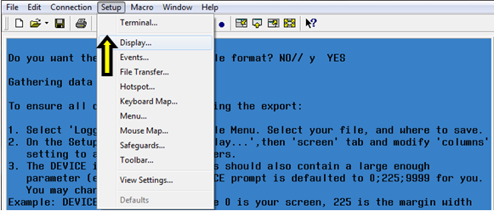

- On the Screen tab, modify the number of Columns to at least 225. Click OK.

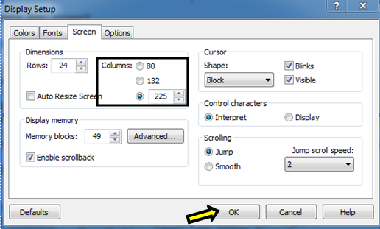

- Select Logging… on the File menu.

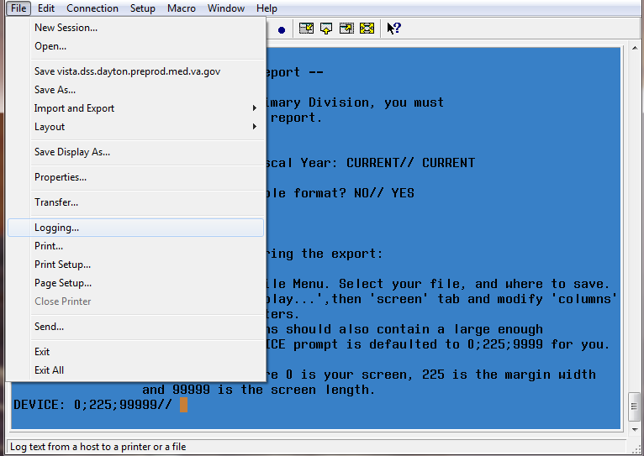

- On the Logging popup, click to select Logging on. Then, select the Disk option and name the file. Click Browse…

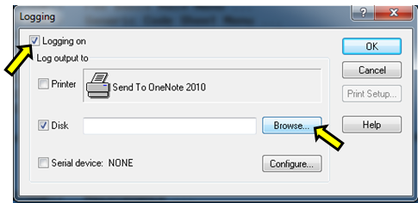

- Select the folder where the text file will be saved and click Save.

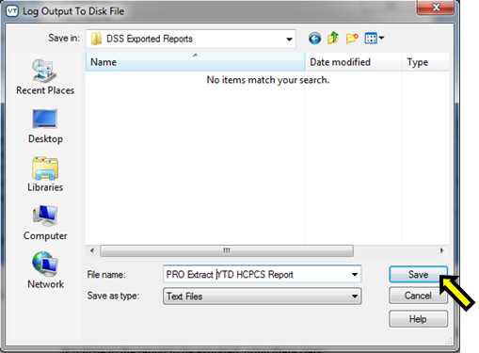

- The file will be created in the folder identified.

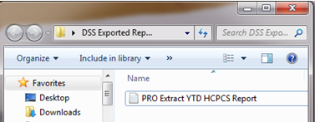

- Press Enter on your keyboard to keep the parameters at the DEVICE: 0;225;99999// prompt.

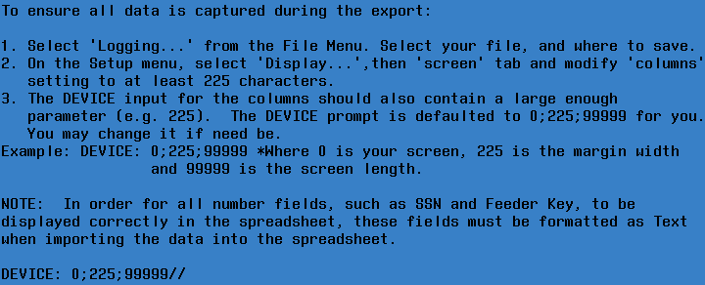

- Once the running of the report has completed, to turn off the logging select Logging… on the File menu. On the Logging popup, click to deselect Logging on.

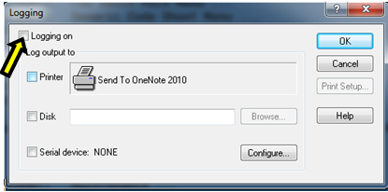

- Open a new Excel workbook. Click the Data tab and select From Text.

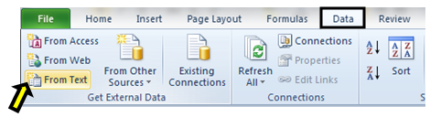

- Navigate to the folder where the file was created. Select the text file that was created and click Import.

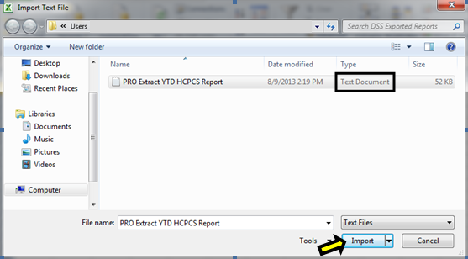

- Chose Delimited as the data type on the Text Import Wizard – Step 1 of 3 screen. Click Next.

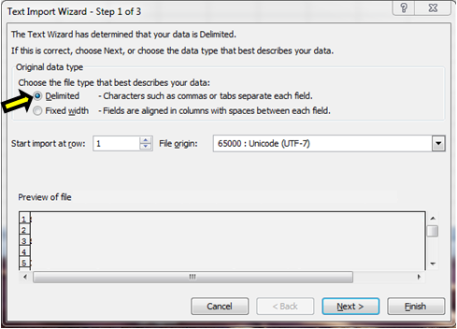

- Under delimiters, uncheck Tab, then check Other and type a caret (^) as your delimiter on the Text Import Wizard – Step 2 of 3 screen. Click Next.

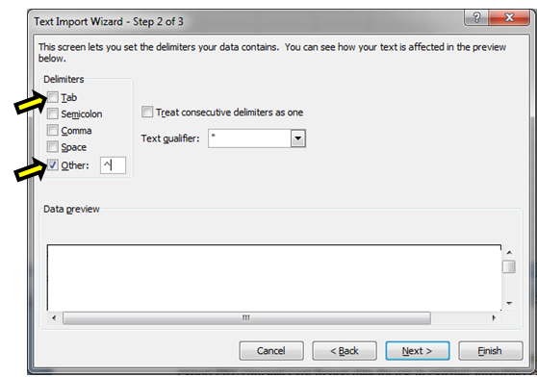

- Text will be chosen as the format for each column on the Text Import Wizard – Step 3 of 3 screen. In the Data Preview section of the screen, click to highlight the column and select Text as the data format. (Note: All columns can be selected at once if the first column is selected and then hold the shift key and move the scroll bar to the far right and select the last column). Click Finish after each column has been formatted.

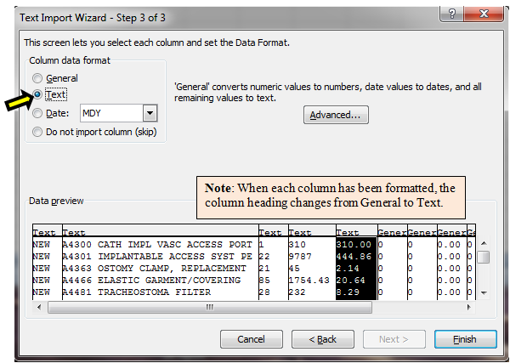

- Click OK when the Import Data screen appears.

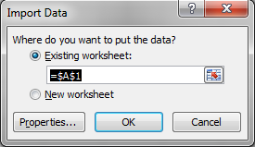

- The report will be created and displayed in Excel.

